Study Guide Answers

1. Which of the following statements is true?
A A relation includes both domain and range.
B Dependent variables directly affect the value of the independent variable.
C The input is the range and the output is the domain.
D The vertical line test is a test to see if graph is linear.

2. Identify which of the following are functions.
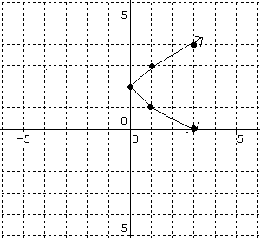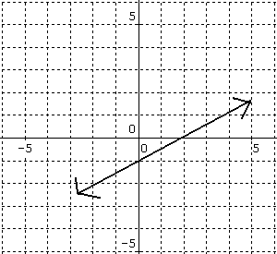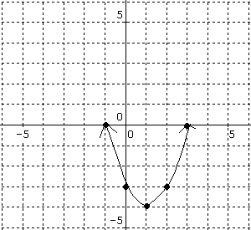
i. ii. iii. C

A graph i B graphs ii and iii
C graphs i and ii D graph iii

3. Which graph from question 2 is linear?
In | Out
-3 | 5
-2 | 6
-1 | 7
0 | 8
1 | 9
2 | 10
3 | 11
A graph i B graphs ii and iii
C graphs i and ii D graph iii

4. Which of the following equations produces a linear function?

A $y=x^{2}$
B y = 2x + 3
C $y=\left|x\right|$
D $y=2x^{2}+3x−2$
5. Which table of values is NOT a function?

In | Out
-3 | -10
-2 | -8
-1 | -6
0 | -4
-1 | -2
-2 | 0
-3 | -2
A) B) C) D)
In | Out
-3 | 7
-2 | 5
-1 | 3
0 | -1
1 | -3
2 | -5
3 | -7
In | Out
-3 | -2
-2 | -2
-1 | -2
0 | -2
1 | -2
2 | -2
3 | -2

6. Which of the following does NOT represent a way to determine if something is a function or not.

A The graph passes the vertical line test.
B The table of values has one input for every output.
C The table of values has one output for every input.
D None of the above.

7.. Which represents the domain of the following relation? {(-6, 5), (-4, 3), (-1, 0), (4, 3)}
A 5, 3, 0, 3
B -6, 4, 1, -4
C 6, 4, 1, 4
D –6, -4, -1, 0

None of the above

8. Which of the following statements are FALSE when identifying the type of slope of a line.

A Positive slope increases from left to right.
B Negative slope decreases from left to right.
C Undefined slope is when there is no vertical change.
D No or Zero slope is a horizontal line.

9. How do you find the slope of a line?
A Divide the difference of the y values by the differences of the x values.
B Divide the difference of the x values by the differences of the y values.
C Divide the rise of the line by the run of the line.
D Both A and C.
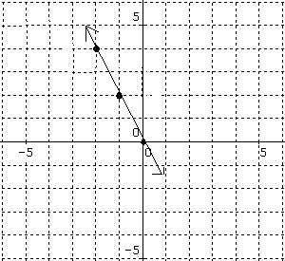

10. Using the graph to the right, what is the rise
and the run?

A The rise is 2 and the run is 1.
B The rise is –1 and the run is 2.
C The rise is 1 and the run is 2.
D The rise is –2 and the run is 1.

11. Using graph the graph on the right,
what is the slope?
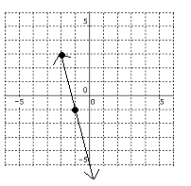
A. $\frac{−1}{4}$ B. – 4 C. $\frac{1}{4}$

D. 4 E. Not Here

12. Find the slope & y-intercept of the line.
A. m = -4 y-intercept = (-1, 2)

B. m = 2 y-intercept = (0,0)

C. m = $\frac{1}{2}$ y-intercept = (-2,4)

D. m = -2 y-intercept = (0,0)

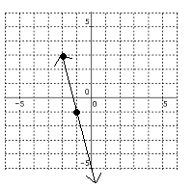13. Find the slope & y-intercept of the line.

A. m = $−4$ y-intercept = (0, -5)

B. m = -$\frac{1}{4}$ y-intercept = (0, 0)

C. m = $\frac{1}{2}$ y-intercept = (0, -5)

D. m = -4 y-intercept = (0, 0)

14. Write an equation of the line. 15. Write an equation of the line.

A y = 2x A y = -¼ x
B y = ½ x B y = -4x – 1.3
C y = -½ x C y = -4x – 5
D y = -2x D y = -4x

16. Find x and y-Intercepts of y = -2x-1

A x-intercept = (0, $\frac{−1}{2}$) y-intercept (-1,0)

B x-intercept = ($\frac{−1}{2}$, 0) y-intercept (0,-1)

C x-intercept = (-1,0) y-intercept (0, -$\frac{−1}{2}$)

D x-intercept = ($\frac{1}{2}$, 0) y-intercept (0, -1)

Using the tables below, write a rule for each using algebraic notation.
x | y
4 | 13
2 | 7
0 | 1
-2 | -5
17.
A y = 3x + 1 B y = 2x + 5

C y = 2x + 1 D y = 3x – 1

X | Y
5 | -7
3 | -3
1 | 1
-3 | 9

18.

A y = 2x – 3 B y = -3x

C y = -2x + 3 D y = -3x + 3

Identify the following independent variables and dependent variables in the given situations with the reasoning that BEST supports the answer.

19. The temperature of the soup and the length of time it has been on the stove.
A Independent: temperature of soup; dependent: the time it has been on the stove;
the temperature of the soup determines the length of time it has been off the stove and no longer cooking.

B Independent: temperature of soup; dependent: the time it has been on the stove;
the time it has been off the stove determines the temperature of the soup.

C Independent: the time it has been on the stove; dependent: temperature of soup; the temperature of the soup determines the length of time it has been off the stove and no longer cooking.

D Independent: the time it has been on the stove; dependent: temperature of soup;
the time it has been off the stove determines the temperature of the soup.

20. Which step is NOT included when graphing an equation?

A Writing the equation in slope-intercept form
B Plotting the y-intercept on the y-axis
C Start from the origin and plot the slope as a fraction of rise over run
D Draw a line through the two points to represent all of the possible solutions for the equation given

21. Identify which table that represents the equation, y = 3x + 2, and is supported with the reasoning given.

Table 1
X | -1 | 3 | -3 | 5
Y | -1 | 7 | -5 | 11

Table 2
X | 2 | -4 | -2 | 6
Y | 8 | -10 | -4 | 20
X | -1 | 3 | -3 | 5
Y | -1 | 7 | -5 | 11

A Table 1 because when substituting in (-1, -1) in for x and y and then solved, it worked with -1 = -1.

B None, both table 1 and 2 have coordinate points that do not lie on the line of the equation because the tables give points of nonlinear equations.

C Both table 1 and 2 work for the equation, because when substituting the coordinates from the table in for x and y, the equation is true.

D Table 2 because when finding the slope between (2, 8) and (-4, -10), m = 3. Then substituting (2, 8) in for x and y, b = 2. This worked for all points.

22. Identify the slope that goes through the two given coordinate points, (-3, 0) (3, 2).

A $\frac{1}{3}$ B 3

C -$\frac{1}{3}$ D -3

23. Using the inequality -2x + 10 ≤ 20, which step is INCORRECT when solving?
A Subtract 10 to each side of the inequality
B Divide by -2 on each side of the inequality and flip the inequality sign
C Divide by -2 on each side of the inequality
D x ≥ -5

24. Using the inequality -16k -32 > -48, what step is correct in solving:
A First, subtract 32 to each side, then divide by -16 and flip the sign
B First, divide both sides by 16, then add 32 to both sides and leave the sign
C First, subtract 48 from both sides, divide by -16 and leave the sign
D First, add 32 to both sides, then divide by -16 and flip the sign

25. Describe the graph of the inequality x > 3 on a number line.

A There is a filled circle at 3 and the graph is shaded to the left.
B There is an empty circle at 3 and the graph is shaded to the left.
C There is a filled circle at 3 and the graph is shaded to the right.
D There is an empty circle at 3 and the graph is shaded to the right.

26. Mrs. Kowalinski is taking the five math teachers to dinner. She has budgeted $250 and knows she will pay $40 for the tip. How much can each person spend on their dinner
so that Mrs. K will not go over her budget?

A 250 < 6x + 40 B 250 > 6x + 40

C 250 ≥ 6x + 40 D 250 ≤ 6x + 40
Equation of a Line:

+ /6
*mastery is 75%
Percent:
Equation of a Line:

+ /6
*mastery is 75%
Percent:

Equation of a Line:

+ /6
*mastery is 75%
Percent:
Equation of a Line:

+ /6
*mastery is 75%
Percent:

- The ratio of yogurt to ice cream sold at Baskin Robbins is 1:4. Of the next 100 cones sold, how many do you estimate will be yogurt?
A 25
B 20
C 80
D 75

- A function is:
A a graph that has only one output per input
B a graph that has only one input per output
C a graph that has multiple domain values
D a graph that has multiple range values

- The definition of slope is:
A the rate of change of a linear equation
B rise over run
C the vertical change over the horizontal change of a line
D the multiplier of the input values in a linear equation
E All of the Above

- Slope-intercept form is:
A y = mx + b
B the form that represents the relationship between the input/output
C the standard form of the equation
D Both A and B
E All of the Above

- What statement about slope-intercept form is INCORRECT?
A the m represents the slope
B the y represents the y-intercept
C the x represents the input
D None of the above

- The domain of a graph is:
A all of the possible x values
B all of the possible y values
C a set of coordinates that create a function
D a set of coordinates do not create a function

- An intercept is:
A where the line of an equation crosses each axis
B the points where x or y has a value of zero
C when x and y values are the same
D Both A and B
E All of the Above

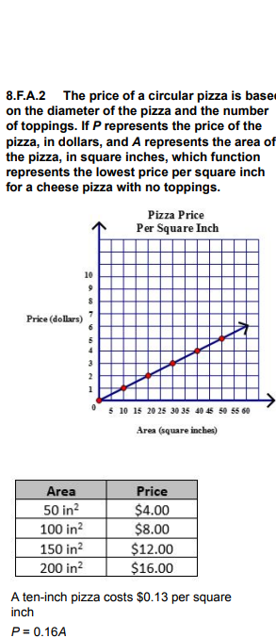

The Table is the lowest price

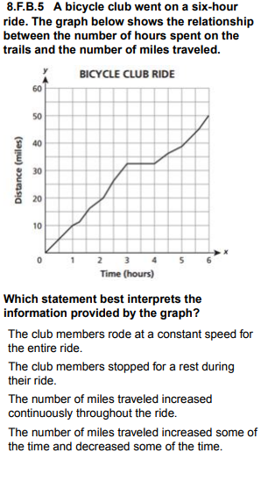
The club members stopped for a rest during
their ride.

8.F.B.5 Mr. League's science class went on a
field trip to explore how the depth of a nearby
lake changes as you get further from the
shore. Using sonar and boat instrumentation,
they were able to record the depth of the lake
in feet and their distance from the shore in
miles.
In one of the student's journals, they noted
that:
The depth increased at a non-constant rate
until a certain point, then the depth remained
the same for a while. Then the depth of the
lake decreased until the end of our trip.
Which graph matches the description in the
student's journal?

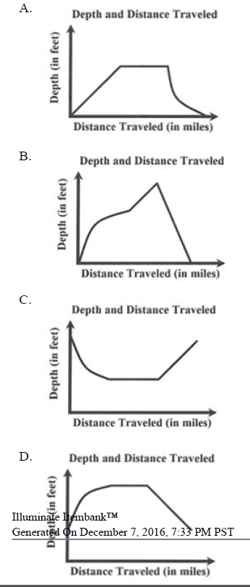
D is the right answer

