**ID: A**

**Name: ______________________ Date: ____________ C # _____**

**On Linear Function Essentials [SLOPE]**

1. Calculate the slope of the line passing through the points, (4, 5) and (2, 3). Then, graph the line.

*Solve for the Slope FIRST!!!*

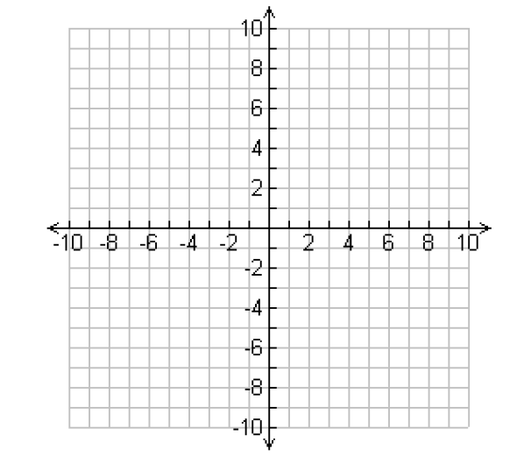

1. Calculate the slope of the line passing through the points, (-6, -1) and (-6, 4). Then, graph the line.

*Solve for the Slope FIRST!!!*



1. A line with a slope of -4 passes through the points (-7, m) and (-6, 6). What is the value of m?
2. Calculate the Rate of Change between any two coordinates to find the slope of each line.

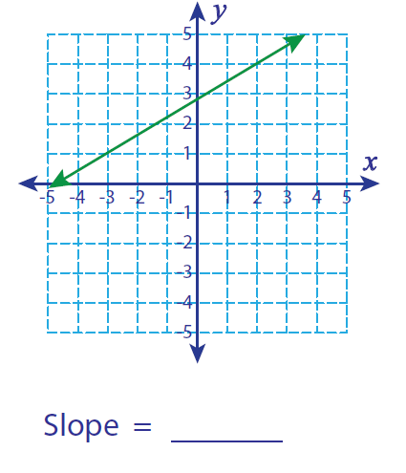

1. Put the following equations in Slope-Intercept Form and then graph them on the coordinate plane.

**6x + 2y = -8**



Calculate the slope of the line passing through the points, (1, 5) and (5, 2). Then, graph the line.

*Solve for the Slope FIRST!!!*



1. Calculate the slope of the line passing through the points, (4, 1) and (6, 1). Then, graph the line.

*Solve for the Slope FIRST!!!*



1. A line with a slope of 9 passes through the points (-10, -5) and (-9, m). What is the value of m?
2. Calculate the Rate of Change between any two coordinates to find the slope of each line.

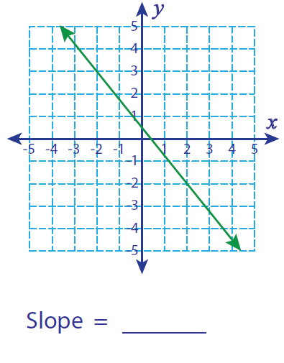

1. Put the following equations in Slope-Intercept Form and then graph them on the coordinate plane.

**2x – 3y = 9**

