**Scatter Plot Class work – Active hours Name________________________**

The data below compares the amount of activity people do each week with their measured Body Mass Index (BMI). Use the data to do the following problems. **Round to the nearest thousandths when necessary.**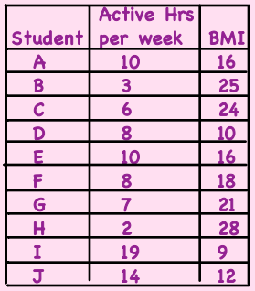

1. Make a scatter plot of the data on your calculator.

2. Find the correlation coefficient (r). _______________

3. Graph the correlation coefficient on the number line.

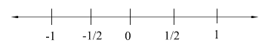

4. Describe the meaning of the correlation coefficient for this situation.

5. What do x and y represent for this situation?

x = ______________________ y = _________________________

6. Find the regression equation (best fit line) using the graphing calculator. y = ax + b

7. What do a and b represent for this situation?

a = ______________________ b = _________________________

8. **Use your graph to answer the following with a complete sentence.**

a). How many hours of activity would you expect a person with a BMI of 20 to

participate in weekly?

b) If a student participates in 16 hours of activity each week, what would you expect

their BMI to be?

9. Describe how you would verify a) and b) above using your equation.