1) Ali and Mojeeb go running, Ali’s distance around the track is given by the equation d = 15s, where d is distance in yards and s is time in seconds. After running, Mojeeb decides to create a table below charting the distance and time by using his smart watch. Who has the faster average time?

|  |  |
| --- | --- |
| time | Distance |
| 0 | 0 |
| 1 | 12 |
| 2 | 24 |

2) Chet has a choice to work at two companies either Apple or Microsoft. Apple pays an hourly rate of $12.00.

Below is the hourly rate at Microsoft:

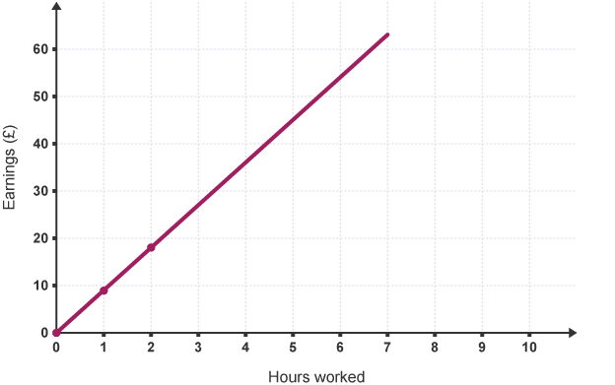

Which job pays him more money per hour?

1) Ali and Mojeeb go running, Ali’s distance around the track is given by the equation d = 15s, where d is distance in yards and s is time in seconds. After running, Mojeeb decides to create a table below charting the distance and time by using his smart watch. Who has the faster average time?

|  |  |
| --- | --- |
| time | Distance |
| 0 | 0 |
| 1 | 12 |
| 2 | 24 |

2) Chet has a choice to work at two companies either Apple or Microsoft. Apple pays an hourly rate of $12.00.

Below is the hourly rate at Microsoft:



Which job pays him more money per hour?