**8.F.A.1** NAME: __________________________________

**FUNCTION OR NOT A FUNCTION #1**

1.) { ( - 3, 6 ), ( 3, 6 ), ( 1, 4 ), ( -2, 5 ) }

Does this relation represent a function?

Why or why not?

__________________________________

__________________________________

__________________________________

2.) { ( - 6, 2 ), ( - 8, 0 ), ( - 7, 1 ), ( - 6, - 2 ) }

Does this relation represent a function?

Why or why not?

__________________________________

__________________________________

__________________________________

3.) { ( - 5, - 3 ), ( - 3, - 5 ), ( - 5, - 7 ), ( -7, -5 ) }

Does this relation represent a function?

Why or why not?

__________________________________

__________________________________

__________________________________



4.) { ( 0, - 3 ), ( 2, 5 ), ( 1, - 2 ), ( - 1, - 4 ) }

Does this relation represent a function?

Why or why not?

__________________________________

__________________________________

__________________________________

5.) Make a table of values and graph the function y = 3x + 6

|  |  |
| --- | --- |
| **x** | **y** |
|  |  |
|  |  |
|  |  |
|  |  |
|  |  |
|  |  |
|  |  |

6.) Make a table of values and graph the function y = -x + 5

|  |  |
| --- | --- |
| **x** | **y** |
|  |  |
|  |  |
|  |  |
|  |  |
|  |  |
|  |  |

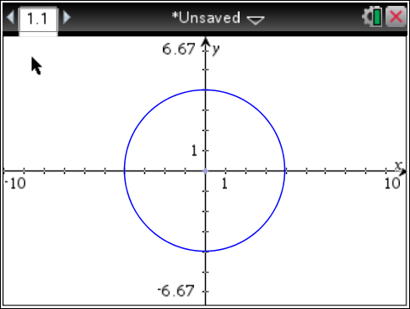7.) Function or Not a Function

Why or Why Not?

_________________________________

_________________________________

_________________________________

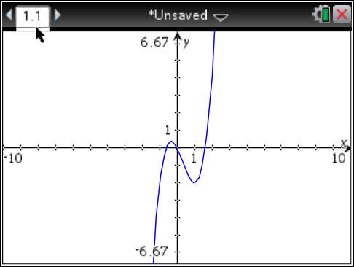8.) Function or Not a Function

Why or Why Not?

_________________________________

_________________________________

_________________________________

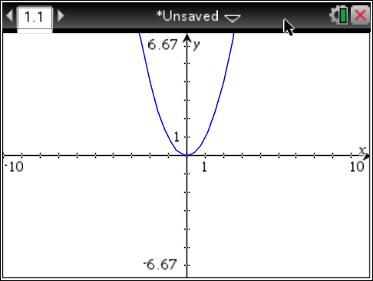9.) Function or Not a Function

Why or Why Not?

_________________________________

_________________________________

_________________________________

10.) Does the relation represent a function?

Why or why not? _____________________________________________________________

___________________________________________________________________________

 11.) Does the relation represent a function?

Why or why not? _____________________________________________________________

___________________________________________________________________________

 12.) Does the relation represent a function?

Why or why not? _____________________________________________________________

___________________________________________________________________________