**Unit 2: Three Worlds Meet (Study Guide)**

1. Within the Iroquois family structure the ______________ _____________ was responsible for leading the family.
2. Define clan: _______________________________________________________________
3. An ___________________ was used by sailors to find their latitude on the sea.
4. Europeans wanted to travel by sea to Asia because it was ___________________, ______________________, and _____________ than traveling by land.

1. During the Age of Exploration the economy (market for trading goods/ services) changed and there was an increased demand (want) for _____________________________________ goods.
2. In Northern and Western Africa, ___________________ and _________________were traded during the 16th century.
3. The major cause of conflict between the Native Americans and the settlers (explorers) was that the two cultures had different _________________ and __________________.
4. The major causes of death for Native Americans in the 1500’s and 1600’s was _________________ and _________________ brought by Europeans.
5. European exploration affected the relationships between Spain, England, and France because all of these countries were _______________ for resources and this caused __________________ to raise.
6. A Native American chief once said, “How can you buy or sell the sky-the warmth of the land?” What does this quote tell you about how the natives viewed owning land?

______________________________________________________________________________________________________________________________

1. The voyages of Columbus changed life in Europe by introducing new ____________ and ____________________ to countries like Spain.
2. Color the Native American regions on the map below and write the name of each region. 

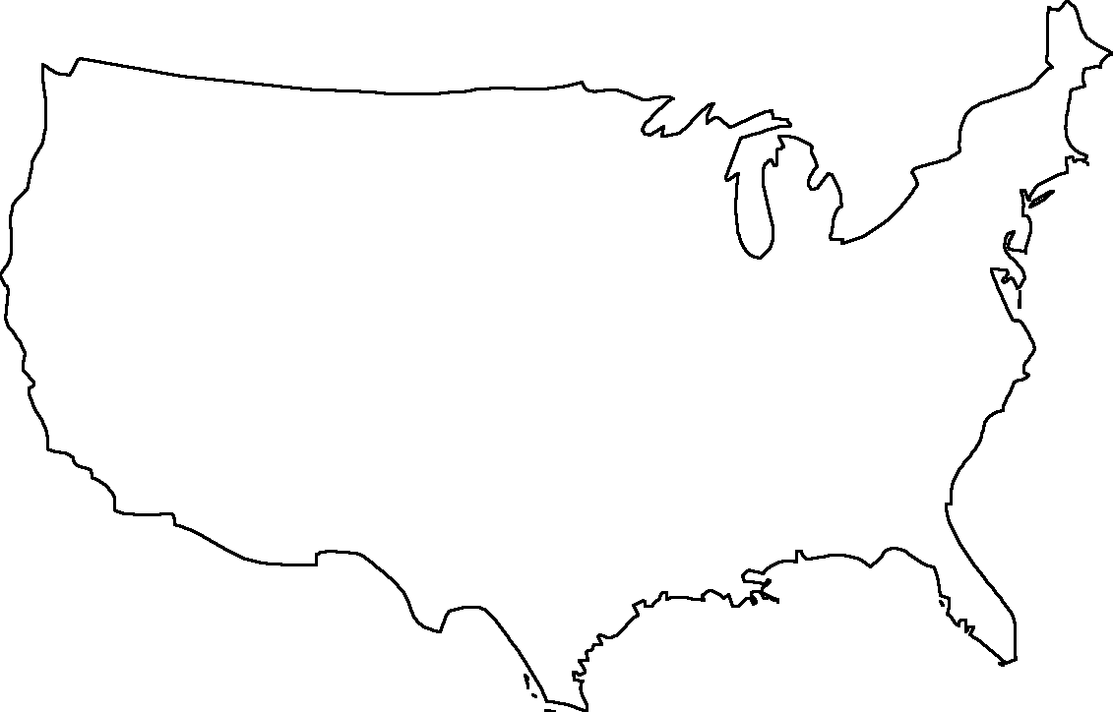

1. The Columbian Exchange was the trading of goods and ideas between the old world (Europe) and the new world (America), but this exchange did not impact the ____________________ trade in Northern Africa.
2. Show on the map of Africa which region slaves came from.

