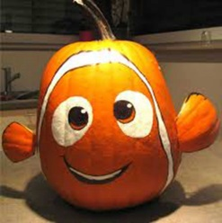 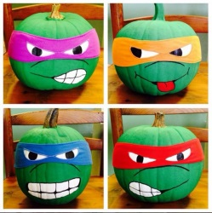 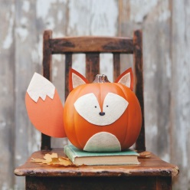 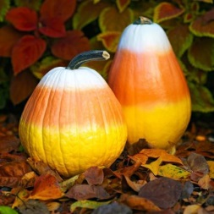 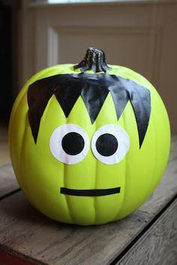

**Pumpkin Raffle Wednesday and Thursday**

Howard teachers and staff will be decorating pumpkins to raffle off for Halloween. Tickets will be sold on Wednesday and Thursday during lunch. Each ticket is $1.00. Please send money in an envelope or baggie. Proceeds will be used to purchase fleece to make blankets for the animals at the animal shelter. If your child wins a decorated pumpkin, it will need to be picked up on Thursday after school or Friday.