Adapted PE Field Day
May 26th 9am-12:30pm @ Edsel Ford High School Football Field

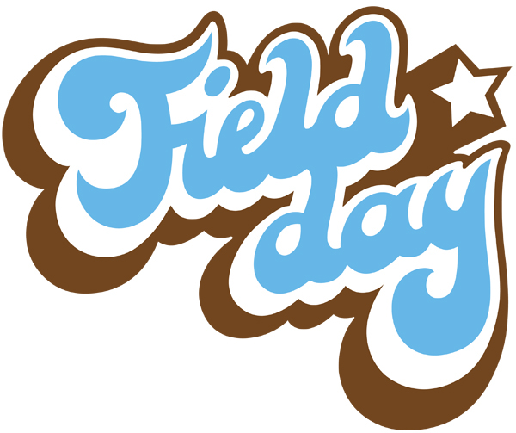
Fun, Fitness, & Games!
(20 + Stations)

Dearborn Public Schools
Special Needs Students
in Peer to Peer Collaboration
with Edsel Ford High School Students


Lunch Donated by Ali Sayed -- Founder and CEO of
HYPE Athletics

