Era 5 Test

“In the meantime we have tried every effort at reconciliation. The cup of forbearance had been exhausted even before the recent information from the frontier of the Del Norte. But now, after reiterated menaces, Mexico has passed the boundary of the United States, has invaded our territory and shed American blood upon the American soil. She has proclaimed that hostilities have commenced, and that the two nations are now at war.

As war exists, and, notwithstanding all our efforts to avoid it, exists by the act of Mexico herself, we are called upon by every consideration of duty and patriotism to vindicate with decision the honor, the rights, and the interests of our country.”- President James K. Polk, War Message to Congress, May 11, 1846

1. Expansionist sentiments like those expressed by President Polk were motivated by all the following factors EXCEPT:
   1. Claims of white superiority
   2. Sense of American cultural superiority
   3. Assertion of US power in the Western Hemisphere
   4. Respect of Mexican sovereignty

“All territory of the Union is the common property of all the states-every member, new and old, of the Union, admitted to partnership under the Constitution, has a perfect right to enjoy the territory, which is the common property of all…Any law or regulation which interrupts, limits, delays, or postpones the rights of the owner to the immediate command of his service or labor, operates a discharge of the slave from service, and is a violation of the Constitution…To set up therefore a pretence that if they adhere to the property they possess, they shall be deprived of their rights in the states to be formed in any acquired territory, is an unprincipled violation of a solemn treaty, an attack upon the Constitution, and a gross injustice to the rights of neighboring states.”-Editorial in The United States Magazine and Democratic Review (October 1847)

“It can no longer be doubted that this is a war of conquest…A war of conquest is bad; but the present war has darker shadows. It is a war for the extension of slavery over a territory which has already been purged, by Mexican authority, from this stain and curse. Fresh markets of human beings are to be established; further opportunities for this hateful traffic are to be opened; the lash of the overseer is to be quickened in new regions; and the wretched slave is to be hurried to unaccustomed fields of toil. It can hardly be believed that now, more than eighteen hundred years since the dawn of the Christian era, a government, professing the law of charity and justice, should be employed in war to extend an institution which exists in defiance of these sacred principles.”- Charles Sumner, US Senator from Massachusetts, “Report on the War with Mexico.

1. A person who agreed with the views expressed in the editorial in *The United States Magazine and Democratic Review* would most likely have advocated laws that promoted the:
   1. Non-extension of slavery to any new territories
   2. Application of the principle of popular sovereignty
   3. Abolition of the international slave trade
   4. Unequivocal expansion of slavery

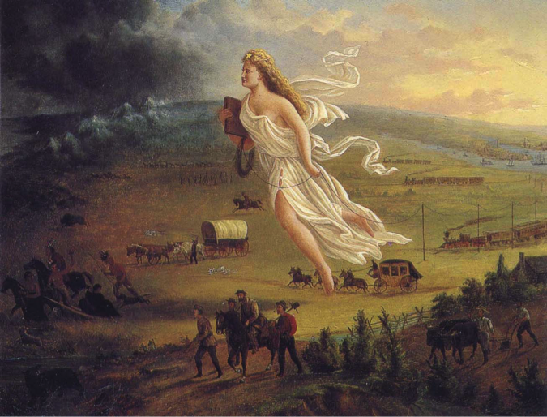

1. Advocates for individuals such as the Native Americans shown in the painting would most likely have expressed which of the following conclusions about expansion?
   1. Expansion occurred as a result of individual initiative and little support from the national government
   2. American Indians successfully resisted white encroachment on western lands
   3. White settlement out West was often associated with land forcibly taken from Native Americans
   4. White settlement largely occurred in areas not previously occupied by American Indians

“These ports belong to some of the richest, most productive, and most populous provinces of the Empire, and are likely to become very important marts of commerce. A leading object of the mission in which you are now to be engaged is, to secure the entry of American ships and cargoes into these ports on terms as favorable as those which are enjoyed by English merchants. It is not necessary to dwell here on the great and well known amount of imports of the productions of China into the United States….Latterly, a considerable trade has sprung up in the export of certain American manufactures to China. To augment these exports, by obtaining the most favorable commercial facilities, and cultivating, to the greatest extent practicable, friendly commercial intercourse with China, in all its accessible ports, is matter of moment to the commercial and manufacturing as well as the agricultural and mining interest of the United States.”-Instructions of Secretary Daniel Webster to Diplomat Caleb Cushing, Washington, May 8, 1843

1. Webster’s instructions reflect what broader pattern in US foreign policy in the first half of the nineteenth century?
   1. Expanding trade initiatives throughout the Western Hemisphere
   2. Limiting trade initiatives exclusively to the European markets
   3. US shift to expand trade and economic, diplomatic, and cultural initiatives to Asia
   4. Implementation of extensive efforts to promote economic globalization

|  |  |  |
| --- | --- | --- |
| 1. I'm a decent boy just landed From the town of Ballyfad I want a situation, yes And want it very bad I have seen employment advertised "It's just the thing" says I "But the dirty spalpeen ended with 'No Irish Need Apply'  2. "Whoa," says I, "that's an insult But to get the place I'll try" So I went to see the blackguard With his "No Irish Need Apply" Some do count it a misfortune To be christened Pat or Dan But to me it is an honor To be born an Irishman.  3. I started out to find the house, I got it mighty soon There I found the old chap seated He was reading the Tribune I told him what I came for When he in a rage did fly "No!" he says, "You are a Paddy And no Irish need apply" |  | 4. Then I gets my dander rising And I'd like to black his eye To tell an Irish gentleman "No Irish Need Apply" Some do count it a misfortune To be christened Pat or Dan But to me it is an honor To be born an Irishman.  5. I couldn't stand it longer So a hold of him I took And gave him such a welting As he'd get at Donnybrook He hollered, "Milia murther" And to get away did try And swore he'd never write again "No Irish Need Apply"  6. Well he made a big apology I told him then goodbye Saying, "When next you want a beating Write 'No Irish Need Apply' Some do count it a misfortune To be christened Pat or Dan But to me it is an honor To be born an Irishman. |

-NO IRISH NEED APPLY, John F. Poole, 1862, sung by Brendan Nolan

1. The patterns described in the song led to which of the following trends among immigrants?
   1. Formation of interethnic communities across immigrant groups
   2. Extensive entry into higher-level and skilled jobs
   3. Maintenance of cultural heritage through religion, language, and customs
   4. 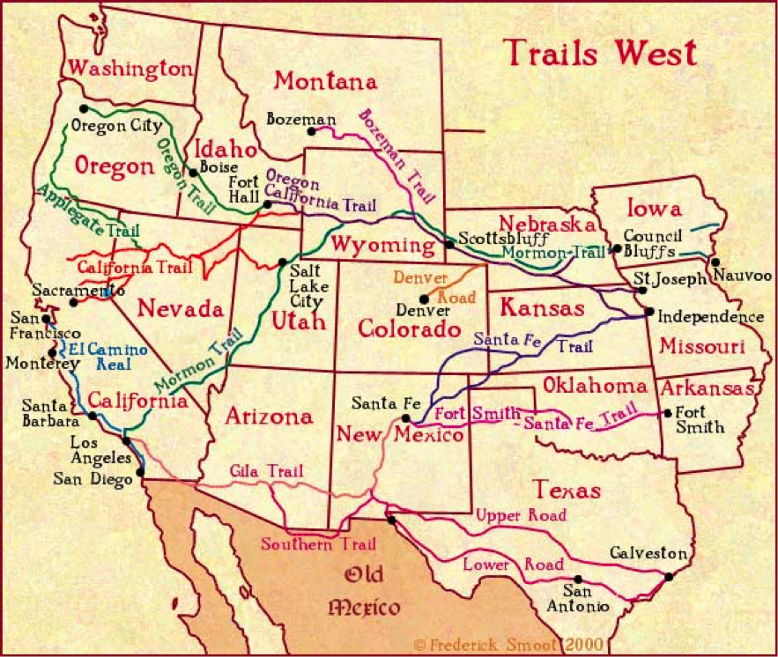The rapid assimilation into American culture in order to achieve positions of power
2. The map illustrates all of the following trends during the 19th century except?
   1. The pursuit of economic opportunities in the West by whites and minorities
   2. The vision of the West as a refuge for religious minorities
   3. The continued resonance of the frontier image as a land of opportunity
   4. Extensive development of infrastructure to promote interstate travel

“The ramifications of the massacre, however, extended far beyond the politics and borders of Colorado Territory. At Sand Creek the era of the Indian trader in Colorado came to a conclusive end, and the dominance of the Cheyennes and Arapahoes to the land east of the mountains was broken. But of greater importance, the Sand Creek Massacre, probably more than any other Indian conflict, set the stage for the years of bloody battle with the Plains tribes after the Civil War. In the years to follow, it would remain with the Indian as the most potent symbol of white-man treachery.”-Stan Hoig, The Sand Creek Massacre, Norman: U of Oklahoma, 1961. Print

7. The trends described by the author most directly illustrate which of the following major historical developments in the West during the 19th century?

1. Conflicts between Native Americans and the US government increasingly altered the cultures and customs of Native Americans and raised questions about their status and legal rights
2. interactions between Native Americans and the US government, while at times violent, were largely characterized by cooperative and diplomatic solutions to disputed land claims
3. despite efforts by the US government to generously compensate Native Americans became increasingly resistant to co-existing with white migrants
4. conflicts with Native Americans like the Sand Creek Massacre increasingly discouraged settlement in western territories

“Of course, concern over "slavery" was very much in the air in Jacksonian Amer­ica, whose citizens worried variously that Catholics, Mormons, Masons, monopolists, fashion, alcohol and the national bank were about to enslave the republic. Nonethe­less, the use of the white slave metaphor for wage workers ought not be dismissed as merely another example of the "paranoid" style of antebellum politics. It might instead be profitable to view the paranoid style itself as a republican tradition much enlivened by the horrific example of chattel slavery and fears engendered by the grow­ing failure of the American republic to produce a society of independent farmers and mechanics among whites.”- David Roediger. “White Slaves, Wage Slaves, and Free White Labor in the North.” 2012.

8. All of the following contributed to the historical development described except?

1. the sense of marginal status among wage workers
2. a decline in nativist sentiments
3. a perception of disproportionate support for commercial farmers and larger industries
4. a recognition of the dehumanizing conditions of slavery

“But such is not the state of the case. I say it with a sad sense of disparity between us. I am not included within the pale of this glorious anniversary! Your high independence only reveals the immeasurable distance between us. The blessings in which you this day rejoice are not enjoyed in common. The rich inheritance of justice, liberty, prosperity, and independence bequeathed by your fathers is shared by you, not by me. The sunlight that brought life and healing to you has brought stripes and death to me. This Fourth of July is yours, not mine. You may rejoice, I must mourn. To drag a man in fetters into the grand illuminated temple of liberty, and call upon him to join you in joyous anthems, were inhuman mockery and sacrilegious irony. Do you mean, citizens, to mock me, by asking me to speak today?”-Frederick Douglass, “What to the Slave is the Fourth of July?” Rochester, New York, July 5, 1852

9. The types of views expressed by Douglass emerged most directly from which of the following trends?

1. Abolitionists organized an increasingly visible movement against slavery in the form of arguments and support of escaped slaves
2. White speakers remained the exclusive leaders within the abolitionist movement
3. Black and white opponents of slavery shared similar worldviews and strategies for the end of slavery
4. Abolitionist arguments against slavery were couched in patriotic language and imagery

“I turn to the political; and here I fearlessly assert that the existing relation between the two races in the South, against which these blind fanatics are waging war, forms the most solid and durable foundation on which to rear free and stable political institutions. It is useless to disguise the fact. There is and always has been in an advanced stage of wealth and civilization, a conflict between labor and capital. The condition of society in the South exempts us from the disorders and dangers resulting from this conflict; and which explains why it is that the political condition of the slaveholding States has been so much more stable and quiet than that of the North…”-Statement by John C. Calhoun, February 6, 1837

10. The excerpt above would be most useful to historians as a source of information about which of the following?

1. Defenses of segregation in public facilities as a means to promote order
2. Harry Truman’s decision to desegregate the armed forces
3. Race riots that followed the assassination of Martin Luther King Jr.
4. 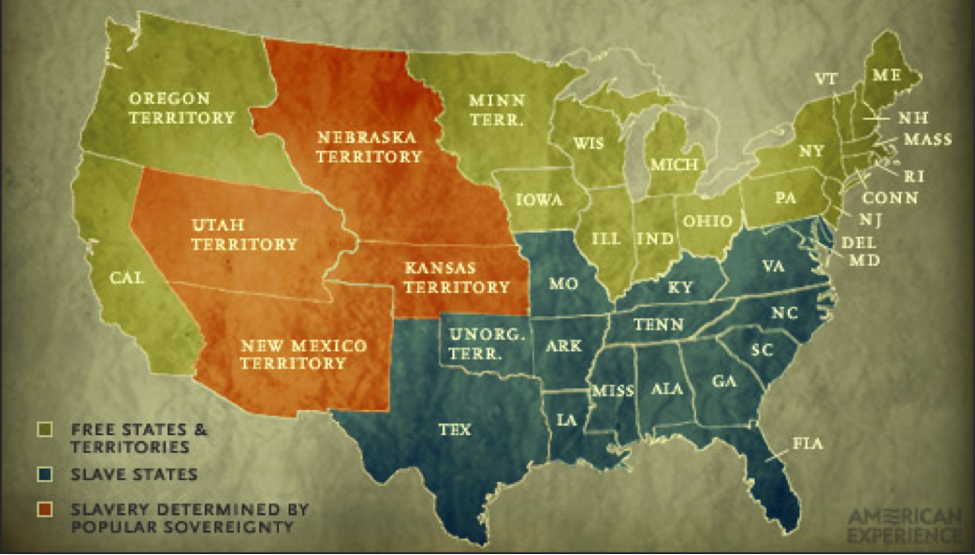The existence of racially homogenous communities in Northern cities like Chicago

11. The pattern depicted in the map is the direct political result of:

1. Dred Scott decision
2. Kansas-Nebraska Act
3. Compromise of 1850
4. Missouri Compromise

“…A geographical line has been drawn across the Union, and all the States north of that line have united in the election of a man to the high office of President of the United States, whose opinions and purposes are hostile to slavery. He is to be entrusted with the administration of the common Government, because he has declared that that "Government cannot endure permanently half slave, half free," and that the public mind must rest in the belief that slavery is in the course of ultimate extinction.

We, therefore, the People of South Carolina, by our delegates in Convention assembled, appealing to the Supreme Judge of the world for the rectitude of our intentions, have solemnly declared that the Union heretofore existing between this State and the other States of North America, is dissolved, and that the State of South Carolina has resumed her position among the nations of the world, as a separate and independent State; with full power to levy war, conclude peace, contract alliances, establish commerce, and to do all other acts and things which independent States may of right do.”-South Carolina Declaration of Causes of Secession, Convention of South Carolina. December 20, 1860

12. Northern opponents of the ideas expressed in the excerpt would most likely argued that

1. States can nullify federal laws as they deem necessary to avoid conflict
2. Slavery has the right to extend into newly-acquired territories
3. Slaves should be immediately emancipated
4. States do not have the constitutional authority to secede from the Union

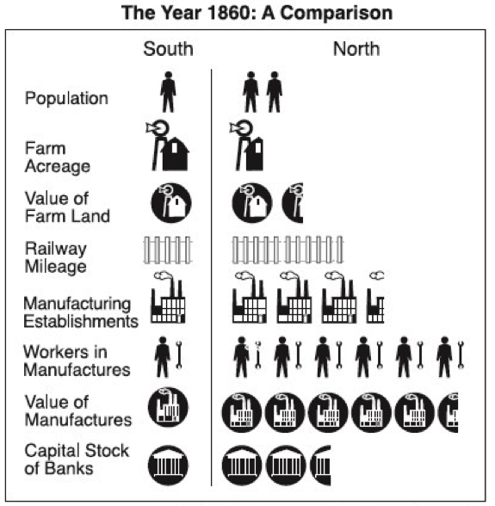

13. Which of the following was a significant cause of the trend illustrated in the chart?

1. Generations of industrial development in the North
2. Failure to develop agriculture in the North
3. Growing urban centers in the South
4. A more diversified economic structure in the South

14. Which of the following was a direct effect of the trend shown in the chart?

1. The South had significant financial advantage relative to the North
2. The North benefited form an industrial economy that could produce needed manufactured goods for the war effort
3. The South was able to effectively leverage its reliance on cotton as a cash cropA

15. The patterns depicted what long-term impact of the Civil War?

1. Widespread destruction of the South’s environment and infrastructure
2. The critical role military leadership played in early Union victories
3. The extensive destruction of Northern territories over the course of the war
4. Critical victories from more innovative military strategies of Confederate leadership

“And by virtue of the power, and for the purpose aforesaid, I do order and declare that all persons held as slaves within said designated States, and parts of States, are, and henceforward shall be free; and that the Executive government of the United States, including the military and naval authorities thereof, will recognize and maintain the freedom of said persons.” Abraham Lincoln, January 1, 1863

16. The statement above comes from the

1. Kansas-Nebraska Act
2. Missouri Compromise
3. 13th amendment
4. Emancipation Proclamation

17. Which of the following statements most accurately describes the significance of the US Civil War?

1. The Union victory in the Civil War failed to resolve significant debates regarding the institution of slavery and a state’s right to secede
2. The Civil War resolved all debates regarding the power of the federal government
3. The Union victory and the subsequent struggle to reconstruct the South ultimately settled the issue of slavery and secession
4. The Civil War firmly established equal social and political standing for African Americans

"The Civil War settled definitively the question of the South's continued existence as a part of the United States, but in 1865 there was no strategy for cleansing the South of the economic and intellectual addiction to slavery…

In the first decades of that span, the intensity of southern whites' need to reestablish hegemony over blacks rivaled the most visceral patriotism of the wartime Confederacy. White southerners initiated an extraordinary campaign of defiance and subversion against the new biracial social order imposed on the South…”-Douglas Blackmon, Slavery by Another Name, Pgs. 41-42

18. The patterns described in the excerpt most directly foreshadowed which of the following developments?

1. The success of radical Republicans in permanently influencing black political rights
2. The inability for blacks to exercise political rights at any point after the Civil War
3. The sustained implementation of the 14th Amendment
4. Efforts to reverse gains for African-Americans that came as a result of the Civil War

“The morality is always false which excuses a wrong because it proposes to accomplish a desirable end. We are not permitted to do evil that good may come… The subjugation of the States to Negro domination would be worse than the military despotism under which they are now suffering…. Negro suffrage was established by act of Congress, and the military officers were commanded to superintend the process of clothing the Negro race with the political privileges torn from white men.”-President Andrew Johnson, “Third Annual Message.” December 3, 1857

“Having these States, as we all agree, entirely within the power of Congress, it is our duty to take care that no injustice shall remain in their organic laws… Impartial suffrage, both in electing the delegates and ratifying their proceedings, is now the fixed rule… every man, no matter what his race or color; every earthly being who has an immortal soul, has an equal right to justice, honesty, and fair play with every other man; and the law should secure him those rights.”- Congressman Thaddeus Stevens, speech in the House, January 3, 1867

19. The excerpts were written in direct response to:

1. The overwhelming power of the presidency during Reconstruction
2. The impeachment of President Andrew Johnson
3. Widespread and violent uprisings of African-Americans in the post-war South
4. The question of promoting political rights for African-Americans after the Civil War

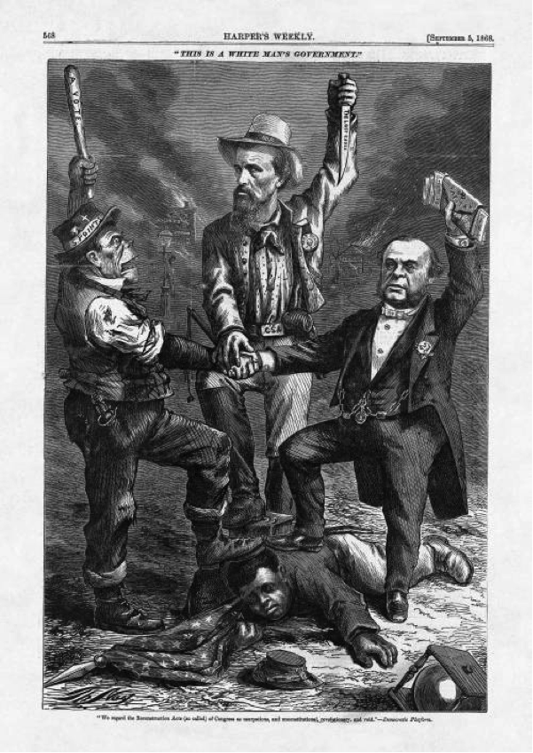

-“We regard the Reconstruction Acts (so called) of Congress as usurpations, and unconstitutional, revolutionary, and void.” (Democratic Platform, Cartoonist: Thomas Nast, Harper’s Weekly, September 5, 1868

20. Advocates for individuals such as the man shown under the feet of the three men would have most likely agreed with which of the following perspectives”

1. Former Confederates played a growing influence in Northern politics
2. While freedom was guaranteed with the passage of the 13th Amendment, citizenship, and equality were still being fiercely enforced
3. The Republican party provided a weak alternative to the Democratic Party as a protector of black rights
4. Southern states played an exclusive role in supporting discrimination toward African-Americans

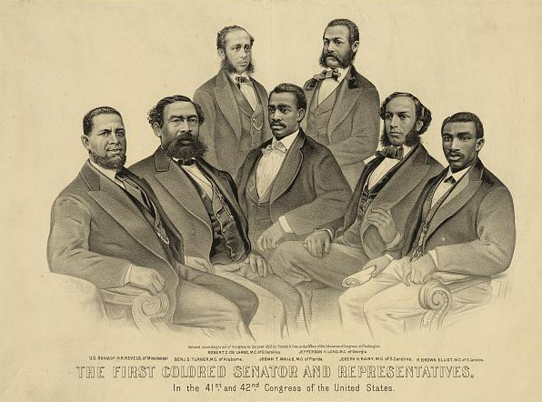US

The first African-American senator and representatives- in the 41st and 42nd Congress of the US

21. All of the following political developments were influential in dismantling the historical pattern depicted in the image except:

1. Segregation
2. Violence and local political tactics
3. Supreme Court decisions
4. Radical Reconstruction

“The only question left to be settled now is: Are women persons? And I hardly believe any of our opponents will have the hardihood to say they are not. Being persons, then, women are citizens; and no state has a right to make any law, or to enforce any old law, that shall abridge their privileges or immunities. Hence, every discrimination against women in the constitutions and laws of the several states is today null and void, precisely as is every one against Negroes.”- Susan B. Anthony, “On Women’s Right to Vote.” 1873

22. The views expressed by Susan B. Anthony most directly supported which of the following?

1. The logical need for the extension of rights to all women on the same basis in which it was extended to African-American men
2. The need to extend the right to vote to white women given the legal recognition given to white men
3. The need to extend the right to vote to all people, regardless of citizenship status
4. The need to extend the right to vote to all white women before it is extended to racial minorities

“All persons born or naturalized in the United States, and subject to the jurisdiction thereof, are citizens of the United States and of the state wherein they reside. No state shall make or enforce any law which shall abridge the privileges or immunities of citizens of the United States; nor shall any state deprive any person of life, liberty, or property, without due process of law; nor deny to any person within its jurisdiction the equal protection of the laws.”- 14th Amendment of the Constitution of the US

23. Which of the following statements best characterizes the long-term impact of the 14th Amendment

1. It has been interpreted exclusively for racial minorities
2. It has been consistently interpreted to protect minority rights
3. It was immediately applied to all marginal social groups in the US
4. It has been used to uphold legal discrimination as well as to reject it

Answers:

1: D

2: D

3: C

4: C

5: C

6: D

7: A

8: B

9: A

10: A

11: B

12: D

13: A

14: B

15: A

16: D

17: C

18: D

19: D

20: B

21: D

22: A

23: D