Industrial Cities Culminating Project
If you look at any list of dangerous cities in the United States, one common thing you will see is that many of them used to be very industrial cities during the time our unit takes place. Your job is to select a former industrial city and figure out its history using this past unit as a guide.
Your goal is to take one of these industrial cities:
Detroit, MI | Flint, MI | Saginaw, MI | Benton Harbor, MI
Pontiac, MI | Gary, IN | St. Louis, MO and/or East St. Louis, IL | Camden, NJ
Trenton, NJ | Newark, NJ | Buffalo, NY | Pittsburgh, PA
Memphis, TN | Cleveland, OH | Baltimore, MD | Chester, PA

Part 1: During the Industrial Age
- Once you pick a city, you may work with ONE (1) partner and research the following for your selected city (keep in mind that the time era you should be looking at is around the mid 1800s-1940s with section
- What resources were available in the area around your city to make them an industrial power?
- What were the main industries in your city?
- Find any major government corruption in your city during this time.
- Were there any prominent labor unions? What were they and what did they stand for?
- Where did people come from to work in this city? (Look for migrations from other parts of the United States AND other countries).
- How did these industries affect the state and the United States?
Part 2: Post-Industrialization
- Now for after the 1950s-present, research what happened to your city
- Did the population drop? (include a peak population with year and what it is presently)
- Did industries or factories close? Explain the main factories that closed.
- Why did factories close? Explain the reasons some of the main factories closed.
- Was there government corruption that helped lead to the demise of your city? Explain.
- Is crime a big problem in your city? Explain why. Give current crime stats and the period when crime became a major problem.
- What are some things your city is investing in now?
Part 3: The Present to the Future
- Finally, what do you think needs to be done to “fix” your city, or cities in general that went through de-industrialization? Based on what you have read, learned, and researched, do we need another Progressive Era to fix these cities?
- Must explain at least 3 well-thought out ways to help fix your city.

(There’s a little bit more on the back!!! )

How to present your project:

You can use one of these websites/resources to present your findings
- http://prezi.com/ (an interactive presentation website) Here’s a site to show you around http://www.wikihow.com/Use-Prezi
- http://www.wiki.com/ (create a Wikipedia-style page) Go to this site to set it up http://www.wikihow.com/Start-a-Wiki
- http://www.weebly.com/ (create a website with your findings) Here’s a video to show you around http://www.youtube.com/watch?v=UMBknOSR0CA, http://divtagtemplates.com/tutorials/how-to-create-an-amazing-website-using-weebly/
- http://www.powtoon.com/ (good animated presentation site) Here’s a source that shows you how to use it http://www.powtoon.com/tutorials/
- PowerPoint (very BORING RESOURCE!!. I will only allow 2 groups per class to pick this method because it is very boring. I only use PowerPoints for pretty pictures and very quick lectures)
- If you use something else, you must get it approved by myself first.
General Guidelines:
- Must use proper spelling/grammar
- Make the presentation look nice! Include pictures when appropriate. This will add to the presentation
- MUST have an MLA citation page. NO EXCEPTIONS! If you do not have one you will receive a zero (0) for the ENTIRE ASSIGNMENT! Here are some sites to help you cite your sources.
  - https://owl.english.purdue.edu/owl/resource/747/01/
  - http://www.easybib.com/
  - http://www.citationmachine.net/mla/cite-a-book
- Please do not use the following websites
  - Wikipedia
  - Yahoo Answers, Answers.com, or anything where people comment to give answers.
- The presentation should take no longer than 5-7 minutes.

This is a topic very dear to my heart as a social studies teacher and a good way to connect the past to the present. Take it seriously, get enlightened, and have fun!
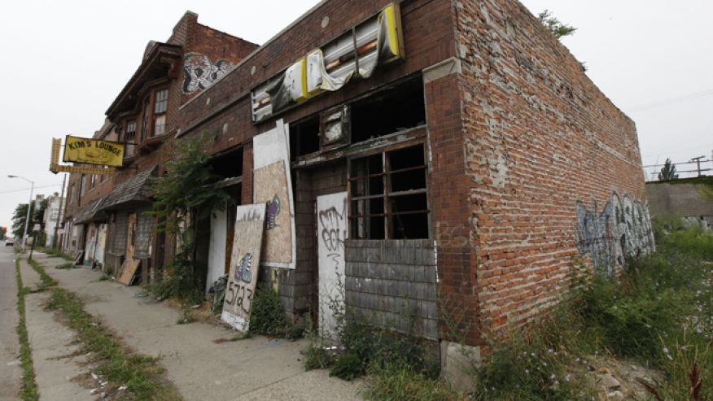
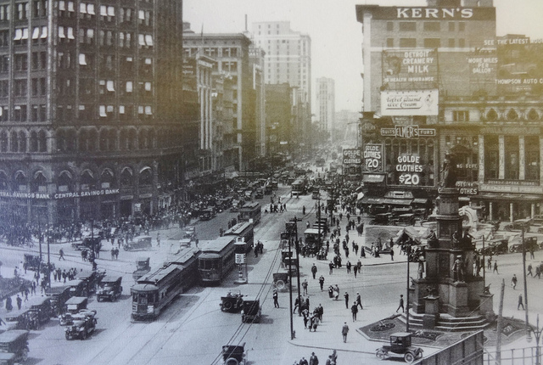

Scoring Rubric
PRESENCE 3 2 1 0
-body language & eye contact
-contact with the public
-poise
-physical organization
LANGUAGE SKILLS 3 2 1 0
-correct usage
-appropriate vocabulary and grammar
-understandable (rhythm, intonation, accent)
-spoken loud enough to hear easily
ORGANIZATION 3 2 1 0
-clear objectives
-logical structure
-signposting
MASTERY OF THE SUBJECT 3 2 1 0
-pertinence
-depth of commentary
-spoken, not read
-able to answer questions
VISUAL AIDS 3 2 1 0
-transparencies, slides
-handouts
-audio, video, etc.
OVERALL IMPRESSION 3 2 1 0
-very interesting / very boring
-pleasant / unpleasant to listen to
-very good / poor communication TOTAL SCORE _______ / 18

