Name: __________________________________
Date: ____________________ Period: ____

World War I
Document Based Question

Historical Context: World War I started in Europe in August 1914. For three years Americans debated whether the United States should enter the conflict. Eventually in 1917, America joined the Allies. Some Americans protested this decision. In response, the U.S. government launched a major campaign to win support for the war.

Task: Using information from the documents and your knowledge of U.S. history, think about the questions that follow each document. You will then create a brief outline categorizing the documents and then write a thesis statement expressing your opinion and conclusions.

Document Based Question: Should America abandon neutrality and enter WWI in 1917?

Document Directions:
Read and examine the following documents. Underline key words and make notes in the margin if you wish. Then categorize the documents using the chart on the next page and write a thesis statement expressing your opinion about the American entry into the war.

*****Before you begin*****
Start thinking about what situations you would support America going to war. This can help inform your thesis and conclusions after analyzing the documents related to World War I.

Directions: For each of the following situations, consider whether you agree or disagree that it is a valid reason to go to war. Be prepared to defend your answer to the class.
A = Agree D = Disagree

- Our country is attacked by another country’s army. A D

- One of our allies is attacked by another country. A D

- A terrorist from another country assassinates our President. A D

- One of our navy ships is intentionally sunk while in a foreign country’s harbor. A D

- A territory under our control rebels against our rule. A D

Document A:
President Wilson’s declaration of neutrality at the start of the war
The effect of this war upon the United States will depend upon what American citizens say and do. Every man who really loves America will act and speak in the true spirit of neutrality…The spirit of the Nation in this critical matter will be determined largely by what individuals….do and say, upon what newspapers and magazines contain, upon what ministers utter in their pulpits…

The United States must be neutral in fact as well as in name during these days that are to try men’s souls. We must be impartial in thought as well as in action…

- President Woodrow Wilson
from a speech to the U.S. Senate, 1914

What policy is Wilson promoting about the war in Europe?

According to Wilson who is responsible for the success of that policy?

Document B:
President Wilson’s Declaration of war speech
Neutrality is no longer feasible or desirable where the peace of the world is involved and the freedom of its peoples…

We have no quarrel with the German people. We have no feelings towards them but one of sympathy and friendship. It was not upon their impulse that their government acted in entering this war…. We are accepting this challenge…. to fight thus for the ultimate peace of the world and for the liberation of its peoples, the German peoples included….The world must be made safe for democracy….We are but one of the champions of the rights of mankind.

- President Woodrow Wilson
from a speech to Congress, April 2, 1917

What does Wilson believe about the people of Germany?

What reasons does Wilson give for going to war?

Document C
Cartoon in response to German U-Boat Attacks on American Ships at Sea (1917)

What is President Wilson doing in the cartoon?

What is the reason for his actions in the cartoon?

Document D:
U.S. Exports to Europe 1910-1915 (exports = selling goods to another country)
Think: What is the trend related to exports to Britain? (U.K.)

What is the trend related to Germany?

What does this chart tell you about American neutrality?

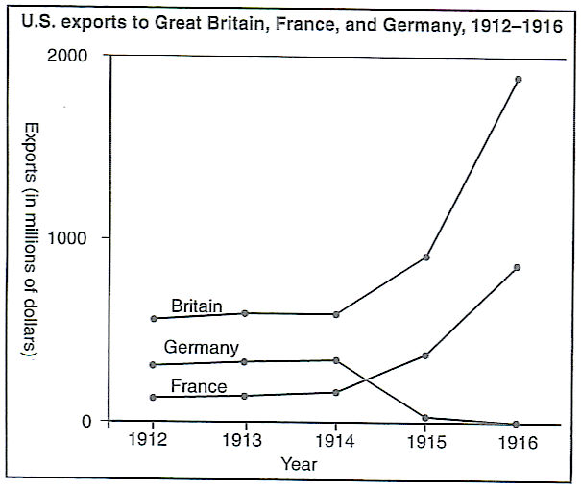

Document E:
The Zimmerman Note
“On the first of February we intend to begin submarine warfare unrestricted. In spite of this it is our intention to keep neutral the United States of America. If this attempt is not successful we propose an alliance on the following basis with Mexico: That we shall make war together and together make peace. We shall give generous financial support, and it is understood that Mexico is to reconquer the lost territory in New Mexico, Texas, and Arizona. The details are left for your settlement. Please call to the attention of the President of Mexico that the employment of ruthless submarine warfare now promises to compel England to make peace in a few months.”

- Note from the German Foreign Secretary Arthur Zimmerman to German Ambassador to Mexico (written January 19, 1917). Intercepted and released by British naval intelligence

What would Mexico get out of allying with Germany and fighting the United States?

What does Germany say about war with England?

Document F:
Risk of Going to War – The Numbers

The following charts shows how many soldiers were in the U.S. Army in 1916. Also it shows the number of soldiers killed (not including the wounded) in one battle in 1916 (The Battle of the Somme)

U.S. Army in 1916: 200,000 troops
Would this information make you more or less likely to support American entry into WWI? Explain.

Country | Men Killed During the Battle of the Somme
Britain | 95,000
France | 50,000
Germany | 160,000
Total | 250,000

Document G:
The Sinking of the Lusitania
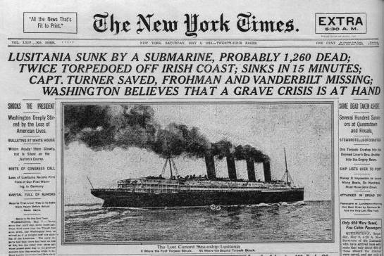
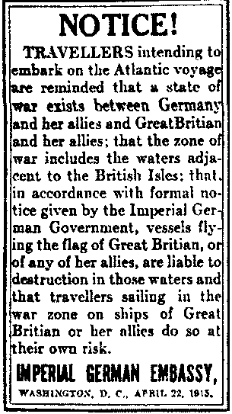

What was the purpose of the notice from the Imperial German Embassy?

What effect do you think that the incident described in the NY Times might have had on American public opinion about involvement in the war?

Document H:
A Jersey City, NJ Munitions Factory lay in ruins after it was blown up by German Spies in July, 1916
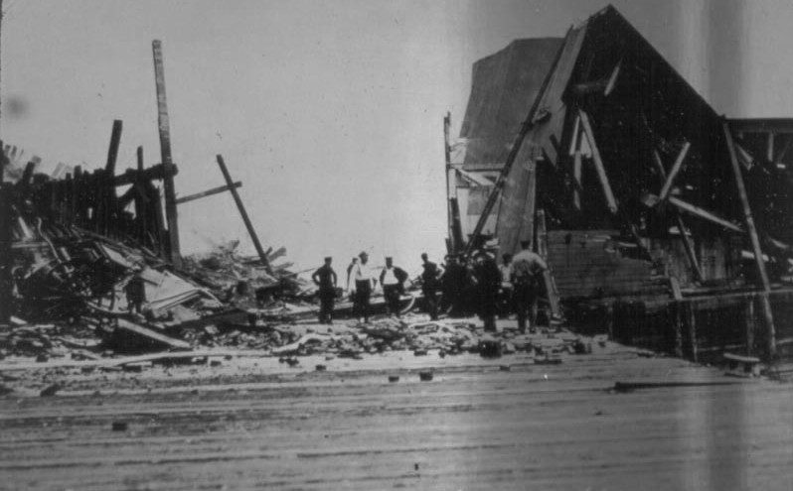
What is significant about the date of this disaster?

How might the events at the munitions factory swayed American public opinion about the war?

Document I:
Singing Against the war – Alfred Bryan - 1915
*We will listen to the audio together*

“I Didn’t Raise My Boy to Be a Soldier”

Ten million soldiers to the war have gone,
Who may never return again.
Ten million mothers’ hearts must beak,
For the ones who died in vain.
Head bowed down in sorrow in her lonely years,
I heard a mother a murmur thro’ her tears:

Chorus:
I didn’t raise my boy to be a soldier,
I brought him up to be my pride and joy,
Who dares to put a musket on his shoulder,
To shoot some other mother’s darling boy?
Let nations arbitrate their future troubles,
It’s time to lay the sword and gun away,
There’d be no war today,
If mothers all would say,
I didn’t raise my boy to be a soldier.

(Chorus)

What victory can cheer a mother’s heart,
When she looks at her blighted home?
What victory can bring her back,
All she cared to call her own?
Let each mother answer in the year to be,
Remember that my boy belongs to me!

(Chorus)

Categorizing Chart
Directions: Now that you have discussed and analyzed the documents, use the chart below to organize your documents. When your chart is complete, construct your thesis statement at the bottom.

DBQ: Document Based Question: Should America abandon neutrality and enter WWI in 1917?

YES YES YES | Reason 1 | Reason 2 | Reason 3
List reason (clause)
Explain each reason

What document(s) support that reason?

NO NO NO | Reason 1 | Reason 2 | Reason 3
List reason (clause)
Explain each reason

What document(s) support that reason?

Thesis Statement: (Choose which one you agree with)

