.. 2015 U.S. Hist.

Part I: Directions: Fill in the letter on your SCANTRON that best describe the contributor’s role during WWII. Each person will be used only once. ¾ of this should be mostly review from last semester.

A. Adolf Hitler AB. Erwin Rommell
B. Benito Mussolini AC. Douglas MacArthur
C. Hideki Tojo AD. Harry Truman
D. Franklin Roosevelt AE. Dwight Eisenhower
E. Winston Churchill BC. Joseph Stalin

____ 1. President of the United States from 1933-1945

____ 2. German fascist dictator

____ 3. Leader of the United Kingdom (Britain)

____ 4. Leader of island hopping campaign and oversaw the occupation of Japan

____ 5. Communist dictator of the Soviet Union (Russia)

____6. German general in North Africa, known as the “Desert Fox”

____ 7. Japanese Prime Minister

____ 8. Italian fascist dictator

____ 9. The president after Franklin Roosevelt died, ordered the atomic bombs to be dropped on Japan

____ 10. An American general who led the Allied forces. His last name starts with “E”.

Part II: Directions: Fill in the letter on your SCANTRON that best describe the event’s role in WWII. Each letter will be used only once.

a. Battle of the Atlantic ab. Doolittle’s Raid
b. Stalingrad ac. Battle of the Midway
c. North African Campaign ad. D-Day
d. Italian Campaign ae. Battle of the Bulge
e. Bataan Death March bc. Okinawa

11.________This was one of the deadliest battles of all time. Took place in Russia and was a huge turning point for the Allies against the Nazis.

12. ________The largest land and sea battle in history. Allowed the Allies to regain France and became one of the final blows against Germany.

13. ________Winning this battle allowed the United States to get within fueling range of Japan.

14. ________This gave the United States a moral boost after the attack on Pearl Harbor.

15. _______Winning in this country took out one of Germany’s allies, where the people eventually killed their dictator.

16. _______This was a major blow to the United States as the Japanese took thousands of Americans and Filipinos hostage and made them walk over 65 miles while enduring horrible treatment.

17. _______This battle was over supply lines and was victorious for the Allies even though they lost over 3,000 ships.

18. ________This back and forth part of WWII resulted in the Allies stopping the Axis Powers from gaining access to oil fields.

19. ________Hitler’s last major effort to stop the Allies. Ultimately led the Germans to retreat.

20. _______The first major island taken from Japan using the “island hopping” technique.

Part III: Please fill in the corresponding answer on your Scantron.

21. This is a fixed allowance of provisions or food
a. ration
b. internment
c. communism
d. war bonds

22. the imprisonment or confinement of people, commonly in large groups
a. containment c. imprisonment
b. concentration d. internment

23. This is why the Japanese in America were relocated into camps
a. Their loyalty was questioned c. To make America safe
b. Their army was questioned d. The Japanese are evil

24. This African American unit was one of the most successful in WWII
a. 54th Massachusetts c. Black Panthers
b. Tuskegee Airman d. Harlem Hellfighters

25. 1 in 3 of these minorities fought in WWII. Many were “code-talkers”.
a. Mexicans c. Native Americans
b. Women d. African Americans

26. Who is the most interesting, funny, and awesomest teacher at Dearborn High?
a. Mr. Maynard
b. You better choose letter A

27. Many cities like Detroit and Flint started producing
a. War materials
b. Cars
c. Steel
d. Railroads

28. Unemployment fell to during WWII
a. 12%
b. 22%
c. 45%
d. 1.2%

29. Farming income during WWII
a. dropped drastically
b. increased
c. tripled

30. To help ease soldiers back into American life, this was instituted
a. G.I. Bill c. G.P. Bill
b. U.S. Bill d. F.U. Bill

31. This research project produced the first atomic bombs
a. Brooklyn Project c. Harlem Project
b. Queens Project d. Manhattan Project

32. America dropped atomic bombs on these two cities
a. Tokyo and Hiroshima
b. Nagasaki and Hiroshima
c. Kyoto and Hiroshima
d. Berlin and Hiroshima

33. A consequence of dropping the atomic bombs is that
a. WWII did not end
b. It lead to the Cold War with the Soviet Union
c. Japan would not quit

34. This helped create the United Nations and split Germany into 4 zones:
a. Yalta Conference
b. Nuremberg Trials
c. Occupation of Japan
d. Manhattan Project

35. This is how the main Nazis were punished after WWII.
a. Yalta Conference
b. Nuremberg Trials
c. Occupation of Japan
d. Manhattan Project

36. Which of the following did not happen during the occupation of Japan after WWII?
a. Douglas MacArthur led the occupation
b. Japan had to give the land back it took
c. MacArthur helped create a constitution
d. Tojo committed suicide

37. This riot was against Mexicans in 1943
a. Detroit Riots
b. Los Angeles Riots
c. Tuxedo Riots
d. Zoot Suit Riots

38. Franklin Roosevelt had to bring in troops to suppress a riot in this city in 1943
a. Chicago
b. Los Angeles
c. Detroit
d. Philadelphia

39. The Soviet Union’s goal after WWII was to
a. Keep Germany weak and spread communism to Eastern Europe
b. Keep Germany strong and spread communism to Western Europe
c. Keep Germany strong and spread democracy
d. Keep Germany weak and spread democracy

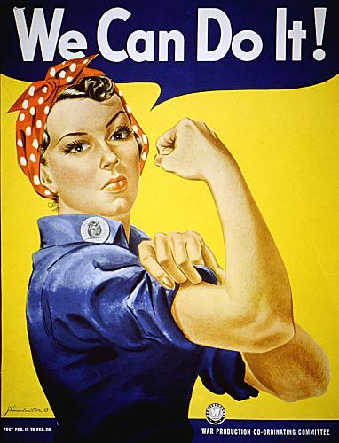

40. This is trying to tell American women :
a. Working will help the soldiers overseas
b. Women are strong
c. Women needed to work at jobs normally for men
d. All of the above
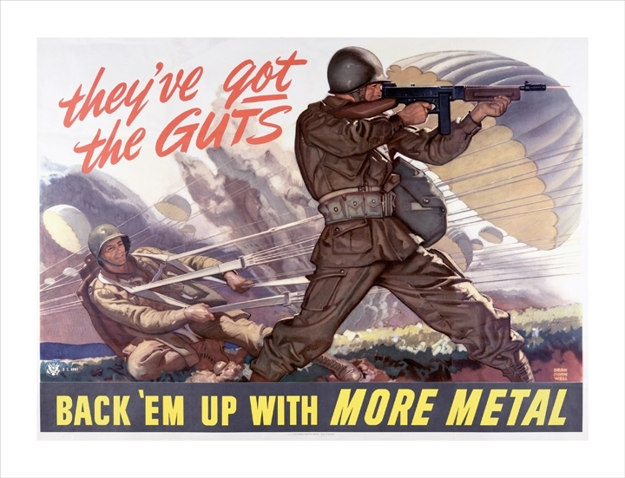

41. This is trying to tell people to
a. ration things like sugar
b. ration things like cereals
c. ration things like cats
d. ration things like wire or cans

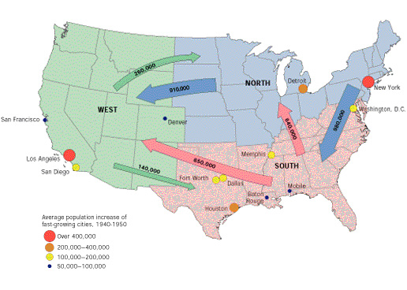

42. Millions of people moved from the south to where?
a. The north and west
b. The north and south
c. The west and east
d. Canada and Mexico

43. According to the map, which of these places in the north got the most people from this migration?
a. Boston and Detroit
b. Detroit and New York
c. New York and Chicago
d. Washington and Detroit

44. According to the map, which of the following cities gained the most people in the west during this migration?
a. Dallas and Houston
b. Detroit and New York
c. Los Angeles and San Diego
d. San Francisco and Denver

45. After the war, what happened to Berlin (the capital of Germany)?
a. It was destroyed
b. It was split into a democratic and a communist side
c. America took over the city
d. The Soviet Union took over the city

46. Which of the following is not a reason for dropping the atomic bomb on Japan?
a. To force Japan to surrender
b. Fighting the war longer could cause more casualties than the bomb
c. To kill civilians
d. To show Russia who is strong

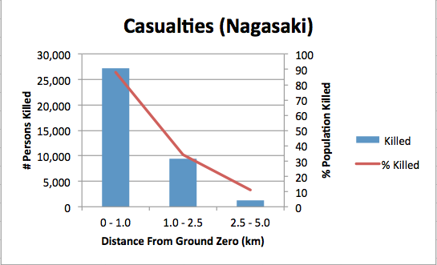

47. About what percentage of Nagasaki’s population was killed within 1km of the atomic bomb explosion?
a. 70% c. 27,000
b. 90% d. 25,000

48. About how many people were killed within 1km of the explosion in Nagasaki?
a. 70% c. 27,000
b. 90% d. 25,000

49. This was the term for Japanese suicide pilots
a. internment c. island hopping
b. kamikaze d. hiroshima

50. Which side won the war?
a. Allied Powers
b. Axis Powers

