**The Korean War**

***Introduction***

After the defeat of Japan, its former colony Korea was divided at the 38th parallel by the victors. Soviet armies occupied Korean territory north of the line, while U.S. forces occupied territory to the south. By 1949 both armies were withdrawn, leaving the North in the hands of the Communist leader Kim Il Sung and the South under the conservative nationalist Syngman Rhee.

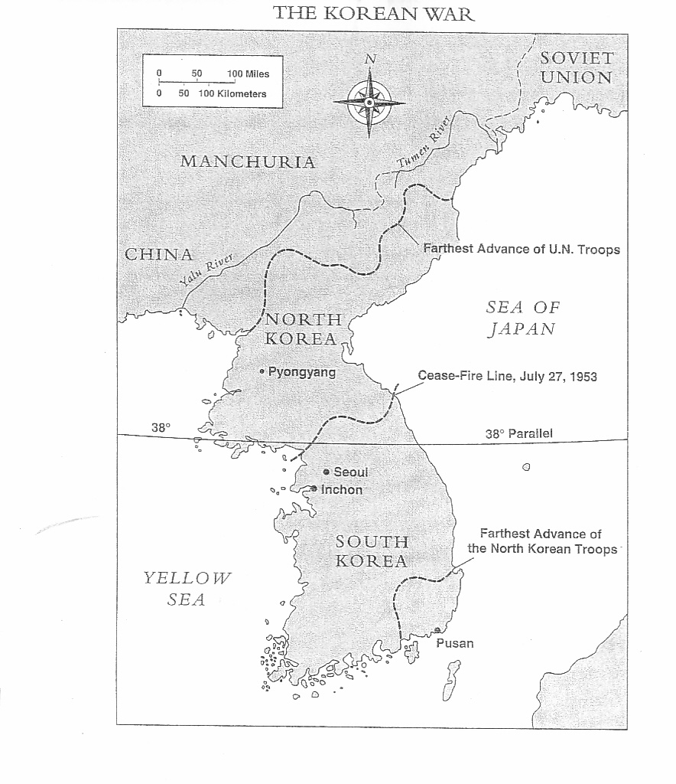

***Invasion***

On June 25, 1950, the North Korean army surprised the world, even possibly Moscow, by invading South Korea. Truman took immediate action, applying his containment policy to this latest crisis in Asia. He called for a special session of the U.N. Security Council. Taking advantage of a temporary boycott by the Soviet delegation, the Security Council under U.S. leadership authorized a U.N. force to defend South Korea against the invaders. Although other nations participated in this force, U.S. troops made up most of the U.N. forces sent to help the South Korean army. Commanding the expedition was General Douglas MacArthur. Congress supported the use of U.S. troops in the Korean crisis but failed to declare war, accepting Truman's characterization of U.S. intervention as merely a "police action."

***Counterattack***

At first the war in Korea went badly, as the North Koreans pushed the combined South Korean and American forces to the tip of the peninsula. However, General MacArthur reversed the war by a brilliant amphibious assault at Inchon behind the North Korean lines. U.N. forces then proceeded to destroy much of the North Korean army, advancing northward almost as far the Chinese border. MacArthur failed to heed China's warnings that it would resist threats to its security. In November 1950, masses of Chinese troops crossed the border into Korea, overwhelmed U.N. forces in one of the worst defeats in U.S. military history, and drove them out of North Korea.

***Truman versus MacArthur***

MacArthur managed to stabilize the fighting near the 38th parallel. At the same time, he called for an expanded war, including the bombing and invasion of mainland China. As commander in chief, Truman cautioned MacArthur about making public statements that suggested criticism of official U.S. policy. The general spoke out anyway. In April 1951, Truman with the support of the Joint Chiefs of Staff recalled MacArthur for insubordination. MacArthur returned home to a hero's welcome. Most Americans understood his statement, "There is no substitute for victory," better than the president’s containment policy and concept of "limited war." Truman and the Democrats were viewed by many as appeasers for not trying to destroy communism in Asia.

***Armistice***

In Korea, the war was stalemated along a front just north of the 38th parallel. At Panmunjom, peace talks began in July 1951. The police action dragged on for another two years, however, until an armistice was finally signed in 1953 during the first year of Eisenhower's presidency. Before the fighting ended, more than 54,000 Americans had died in Korea.

***Political consequences***

From the perspective of the grand strategy of the Cold War, Truman's containment policy in Korea worked. It stopped Communist aggression without allowing the conflict to develop into a world war. The Truman administration used the Korean War as justification for dramatically expanding the military, funding a new jet bomber (the B-52), and stationing more U.S. troops in overseas bases. The Republicans, however, were far from satisfied. In fact, the stalemate in Korea and the loss of China provided Republican politicians with plenty of material to characterize Truman and the Democrats as "soft on communism." They attacked leading Democrats as members of "Dean Acheson's Cowardly College of Communist Containment." (In 1949 Acheson had replaced George Marshall as secretary of state)

1. How did the Korean War begin?
2. What circumstances led up to the deployment of US troops in the Korean War?
3. What were the circumstances leading up to the firing of General MacArthur by President Truman during the Korean War?
4. How did the Korean War end?
5. What were the repercussions of the Korean War in the United States?