Island Hopping Campaign

Topic Overview:

After losing the Philippine Islands to the Japanese, General Douglas MacArthur, commander of American forces in the Pacific during WW II, promised to reclaim them. MacArthur knew that attempting to take every occupied island from the Japanese would be bloody and time consuming. MacArthur decided to only attack the most strategically important islands. This “island hopping” tactic helped the Americans capture Japanese-controlled islands such as Iwo Jima and Okinawa, and it left less-important islands to "wither on the vine.”

Activity Overview:

In this simulation game, chairs will be arranged to resemble the chain of Pacific Islands controlled by the Japanese. The students will be divided into 2 teams: the US and Japan. The battles are fought by playing “Rock-Paper-Scissors.” As the Japanese forces stand on the chairs, the US must attack certain islands to eventually reach Japan. The US can attack every island or hop to selected ones.
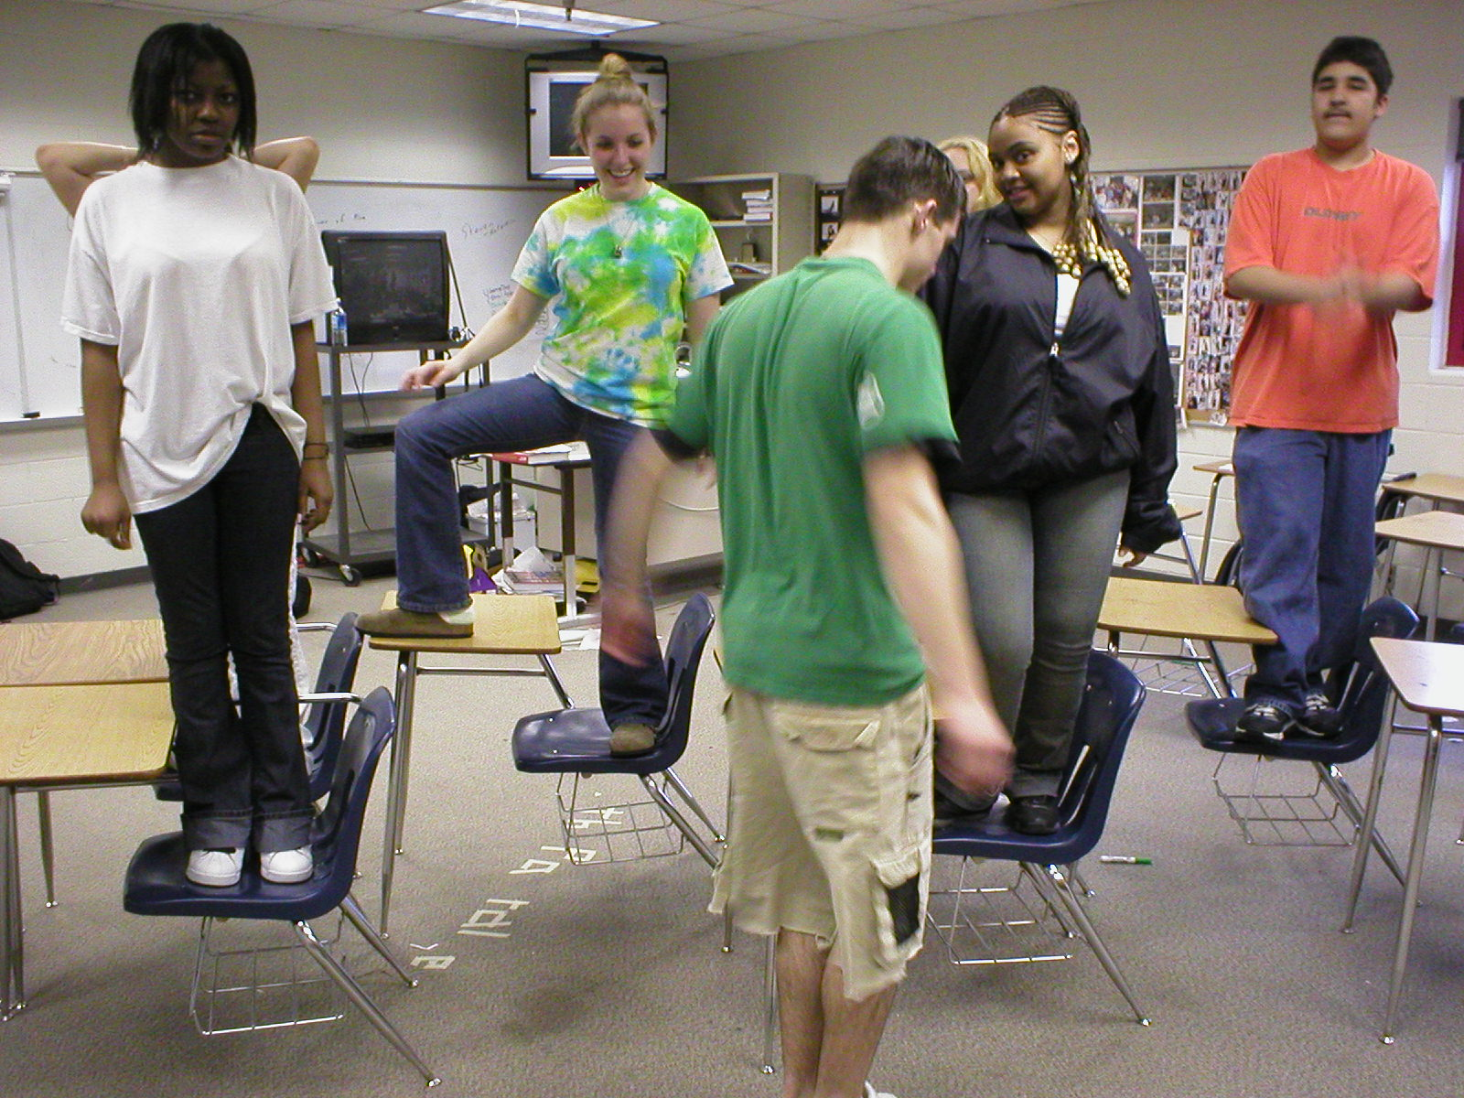

Objectives:
- Students will define and explain the strategy known as Island Hopping.
- Students will explain the benefits and dangers of the Island Hopping strategy.
- Students will be able to evaluate the effectiveness of the Island Hopping strategy.

Setup:
  - Arrange 10 chairs into a curved line about 1’ apart.
  - Place 5 other desks on the inside of the curve, close to the curved line, about 3’ from each other.
  - Tape the Island Signs to the desks in geographic order.
  - Make an overhead transparency of the Island Hopping Campaign Worksheet Key.

Materials:
- Roll of masking tape
- Island Hopping Campaign Notes and Key (p. 5)
- Island Signs (p.7-9)

Activity in Detail:
- Divide the class into 2 teams: the US and Japan.
- Designate an American to play the role of General MacArthur.
- Have the Japanese stand on the chairs in the following order from the start: Guadalcanal, Tarawa, Saipan, the Philippines, Okinawa, Iwo Jima, and Japan.
- If there are less than 15 students per team, fill the inside desks first and then fill the main curve near the start.
- Have the US form a line off to the side, starting at Gaudalcanal.
- Explain the rules to both teams.
        - “The goal for the US is to defeat Japan by getting all the way to the home islands. Each chair represents a Japanese-occupied island.”
        - “Combat is simulated by playing ‘Rock-Paper-Scissors.’ A 2 out of 3 victory decides the battle for each island. If the US wins, they take the island. If the Japanese win, the American is dead and cannot compete anymore. Japanese students that die in battle move on to fill in empty chairs.”
        - “Americans can attack in 1 of 2 ways: inside islands or outside islands.”
          - “For an Outside Island Attack: Walk to each island on the outside curve and play ‘Rock-Paper-Scissors.’ If the American defeats the Japanese, he/she can continue walking around and fighting or they can hop to an inside island within reach.”
          - “For an Inside Island Attack: Hop to each island on the inside curve and fight. You must get both feet past the near leg of the chair. If you fail to make the jump, you ‘die.’”
          - “You can hop from the outside to the inside. In other words, you can mix the 2 strategies. If you choose to hop, you must land successfully at every island that lies between you and the goal, even if those islands have been taken already.”
- Prior to starting, ask General MacArthur to decide which way he/she wants to attack Japan. Have the 1st student begin the campaign in that manner. When students “die,” have them watch the activity proceed.
- Make sure that the hoppers get both feet across the line of each chair.
- Allow students to play both roles by switching sides after a while.

Debriefing:
- Ask students:
  - “Who led the Island Hopping Campaign in the Pacific?” General Douglas MacArthur
  - “How did getting both feet to land past the line at each island show the dangers of the Island Hopping strategy? Island Hopping was a logistically difficult technique. Many military personnel lost their lives. The Japanese were “dug in” deeply and knew the limited terrain well.”
  - “What strategy in the game was more successful? Why? Island Hopping was more successful. The Americans did not try to conquer every island because of the high cost in lives, time, and resources.”
- Have students complete the Island Hopping Campaign Notes.

Assessment:
- Island Hopping Campaign Notes
- Essay Question: How was America able to win the war in the Pacific, and what were the costs?
Island Hopping Campaign Notes Key
Battle | Date | Casualties | Important Facts
Guadalcanal | 1942 | US Marines: 1,600 killed  Japanese: 14,000 killed | First offensive by US land forces in the Pacific theater.
Tarawa | 1943 | US Marines: 1,000 killed  Japanese: 4,836 killed | US Marines take the island despite “kamikaze” attacks.
Saipan | 1944 | US Marines: 3,426 killed  Japanese: 24,000 killed | Japanese civilians hide in caves and jump off cliffs after hearing rumors of American atrocities.
Philippines | 1944 | Japanese: 300,000 killed or wounded  Americans: 47,000 killed or wounded | US Army takes Manila;  MacArthur returns
Iwo Jima | 1945 | Japanese: 21,800 killed 200 POW’s  Americans: 7,000 dead, 19,000 wounded | US Marines raise the US flag over Mt. Suribachi.  Over 25% of the Medals of Honor awarded to US Marines in WW II were given for conduct on Iwo Jima.  Admiral Chester W. Nimitz says of the Marines: “uncommon valor was a common virtue"  The US was now in fuel range to successfully bomb the mainland of Japan.
Okinawa | 1945 | Japanese: 109,000 killed  Americans: 49,000 killed or wounded | 500 Japanese surrender (matched the total for the whole war).  “Kamikazes” sink 36 US ships and damage 200 more.  Island was to a staging area for a possible invasion of Japan.

Island Hopping Campaign Notes
Battle | Date | Casualties | Important Facts
Guadalcanal

Tarawa
Saipan

Philippines

Iwo Jima

Okinawa

Island Signs
Guadalcanal

Tarawa

Saipan
Island Signs
Philippines

Okinawa

Iwo Jima
Island Signs
Japan

