**Circle Graphs**

A circle graph, often called a pie chart, use percentages to show parts of a whole.

What else in mathematics compares a part to its whole?

Directions: Read the circle graph and answer the questions.

**You MUST show what you typed into the calculator.**

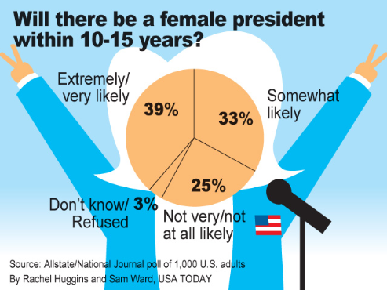

2. How many people were interviewed?

3. How many people refused to answer the survey?

4. How many people think it is very likely we will have a female president within 10-15 years?

5. How many people think it is not very likely we will have a female president within 10-15 years?

6. What can you conclude based on the data?

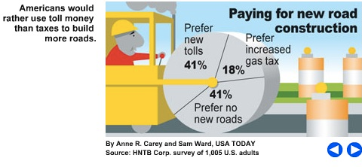

7. How many people were interviewed?

8. How many people prefer no new roads?

9. How many people prefer to increase the gas tax?

10. How many people prefer new tolls on toll roads?

11. What can you conclude based on the data in this graph?

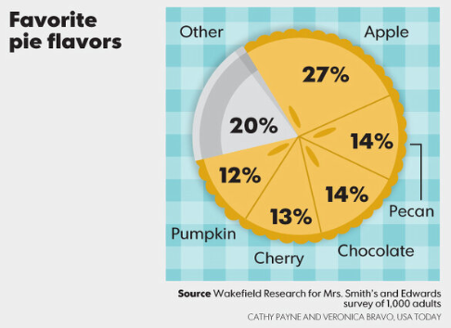

12. How many people were interviewed?

13. How many people prefer pumpkin pie?

14. How many people prefer cherry pie?

15. How many people prefer a pie that is not listed on the survey?

16. What can you conclude based on the data in this graph?



13. What do most consumers want when they dine out at a restaurant? How can you tell.