Quiz 9

Use the following graph of f’ to answer all the questions. Show complete work.

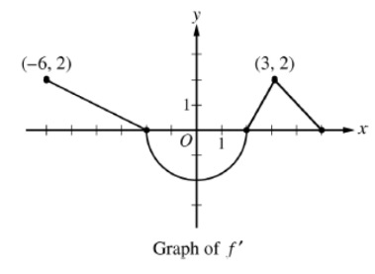





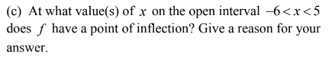

(d) If h(x) = $\int_{0}^{x}{f^{'}\left(t\right)dt}$, find h(2.5) and h’(2.5).