Quiz 8 – Mixed Unit 5-7

1. 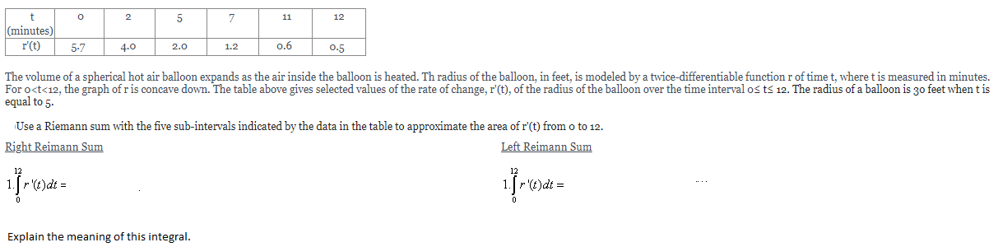
2. 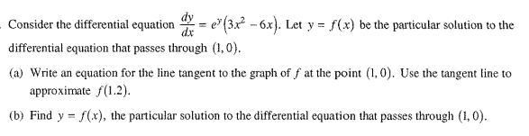
3. 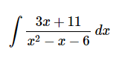Calculate the following integral