Quiz 7

1. For the following differential equation find the particular solution that satisfies the initial condition and graph it on the given slope field

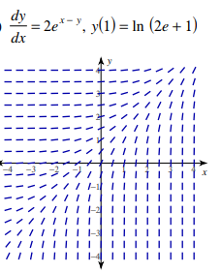

1. Calculate the following integrals
2. 
3. 