Quiz 6 – Integration

1. 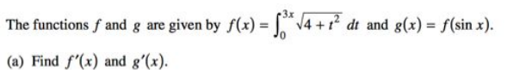
2. Calculate the following integrals. Show complete work
3. 
4. 
5. 