**Matching Integrands to Outcomes**

Match each expression in column A to its corresponding outcome in column B. Writer the letter

from column B on the blank line next to the expression in column A.

Column A

If you integrate:

Column B

You will find:

__1. The rate snow is falling on a driveway A. The amount of oil removed

__2. The rate that water is flowing into a tank B. The amount of weight gained

__3. The rate oil is being removed from an oil C. The amount of a product that has been sold spill

__4. The rate a pizza is cooling D. The amount of water added to the tank

__5. The rate a product is selling E. The amount of new vocabulary acquired

__6. The rate a drug is entering a patient’s F. The amount of a drug that has entered

bloodstream the bloodstream

__7. The rate at which a puppy is gaining G. The amount of snow that has fallen on

weight the driveway

__8. The rate at which a student acquires H. The amount by which the temperature of

new vocabulary the pizza has changed

**Check your understanding**

Complete each of the following sentences.

If you integrate the rate that a house is being painted, you will find:

______________________________________________________________________.

If you integrate the rate that grass clippings are decomposing in a bin, you will find:

______________________________________________________________________.

If you integrate the rate that sand is eroding off of a beach, you will find:

______________________________________________________________________.

**Using the NUT Strategy to Identify Errors in Interpretation**

A correct interpretation for a definite integral includes an appropriate noun (N), the correct units

(U), and a time element (T) – or, the “NUT” strategy. For each of the following situations, a

student has attempted to interpret a definite integral using the NUT strategy, but has made a

mistake in one of the three parts. First identify the student’s error (was it the noun, the units, or the

time?), then provide a correction to the statement. The first one has been done as an example.

Example:

A tank initially contains 50 gallons of honey. Honey is added to the tank at a rate of H t( ) gallons

per hour and removed from the tank at a rate of R t( ) gallons per hour.

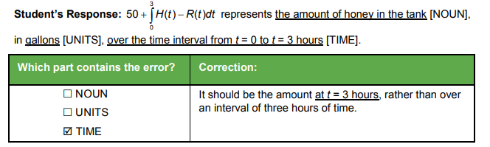**Situation One**

The number of mosquitoes on a tropical island is given by M t( ) , where M is the number of

mosquitoes in thousands, and t is the number of days since the beginning of the year.

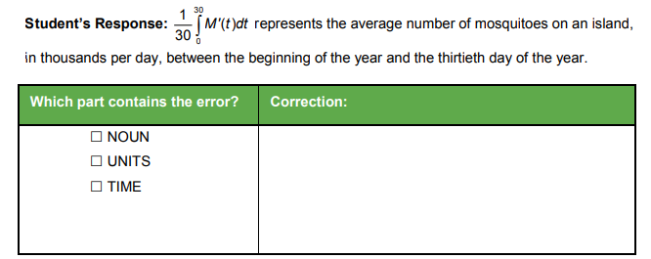

**Situation Two**

The temperature in a house is modeled by a function H t( ) , where H is measured in degrees

Fahrenheit, and t is measured in hours since midnight.

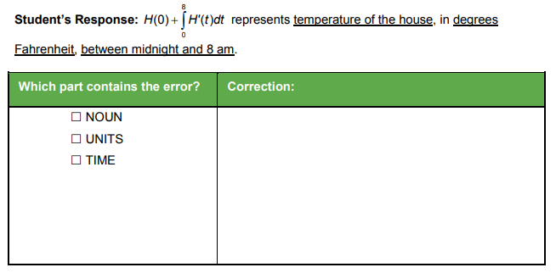**Situation Three**

A cup of tea is cooling on a counter. The temperature is a differentiable function T t( ) , where T is

measured in degrees Celsius, and t is measured in minutes.

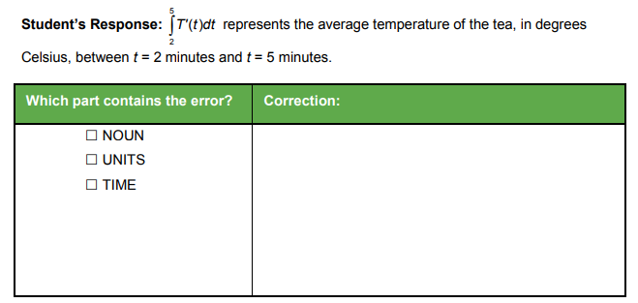

**Situation Four**

The rate that sand is removed by the tide is modeled by the differentiable function S t( ) , where S

is measured in cubic yards per hour, and t is measured in hours since midnight. While sand is

removed by the tide, a pumping station nearby returns sand to the beach at a rate of R t( ) ,

where R is measured in cubic yards per hour.

