**Extra Credit Ecosystem Project** 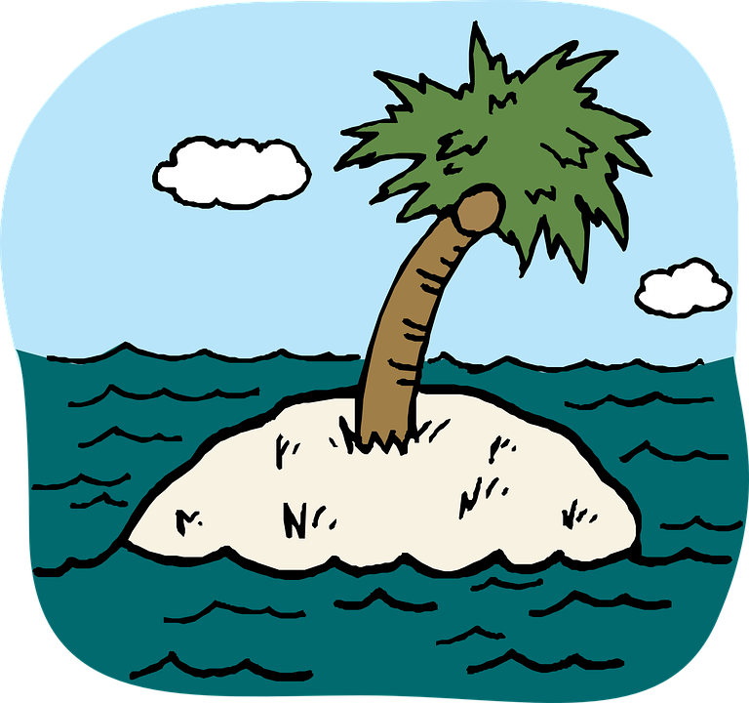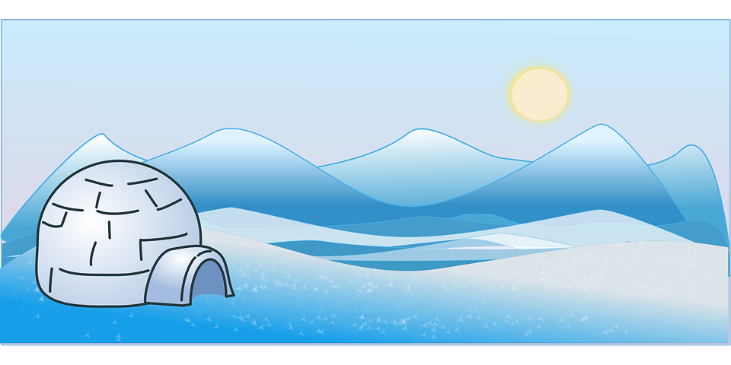

(Use the animal you chose for your PBL project.)

An **ecosystem** includes all of the living things (plants, animals and organisms) in a given area interacting with each other, and also with their non-living environments (weather, earth, sun, soil, climate, and atmosphere).

Examples of ecosystems include: Rainforest, desert, ocean, freshwater (pond, river, or lake), tundra, deciduous forest, savanna, wetlands

Your job is to create your own ecosystem diorama (in a box- shoeboxes work perfectly) for the environment in which your animal lives.

The diorama should contain:

* + At least 3 animal species that live in your ecosystem, including your animal
  + At least 3 plants that live in your ecosystem
  + The ecosystem should be realistically represented with geographical features such as mountains, streams, rivers, etc.
  + You may use clay, paint, papier-mâché, small plastic trees or animals, or anything else that you can think of to portray your ecosystem correctly. BE CREATIVE!!
  + A background on the back and sides of the box
    - The background may be painted, drawn and colored, or made of a neat collage of pictures cut from magazines

Please do not just print out pictures or draw pictures to include in your diorama. While that might be necessary to represent some parts, get creative!! Use 3D objects whenever possible!

Your diorama should include a title telling us what type of ecosystem you created. Be able to orally explain the different plants and animals that make up the food chain/web and features within your ecosystem. Make sure the basic needs of your plants and animals are included, along with a food source for each animal.

There are lots of wonderful ideas on Pinterest, or other websites. Below are just a few ideas for you:

