Lowrey-6th Grade Math Supplies Checklist
Due: Thursday, August 29th, 2019
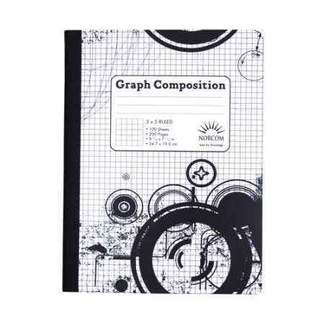⬜Item: ONE GRAPH PAPER COMPOSITION NOTEBOOK, side bound only, NO SPIRALS NO PADS OF PAPER  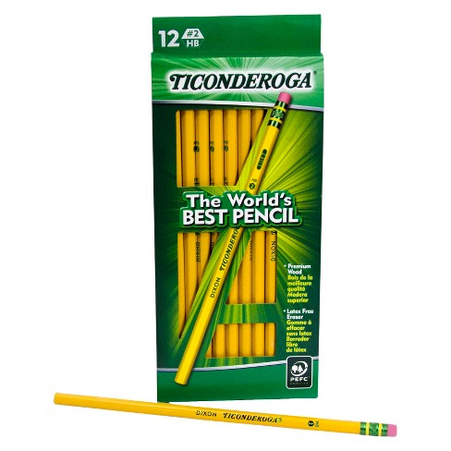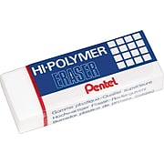  ⬜Item: FIVE Regular Pencils with Erasers  Recommended Brand: Ticonderoga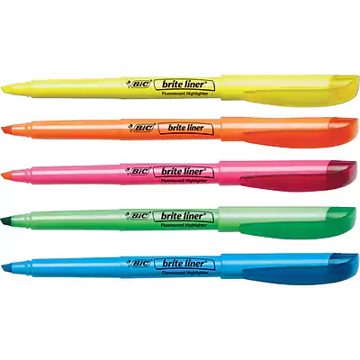  ⬜Item: THREE DIFFERENT COLORS of Highlighters  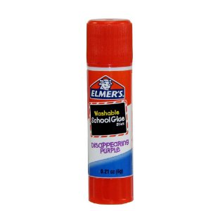  ⬜Item: ONE Glue Stick | 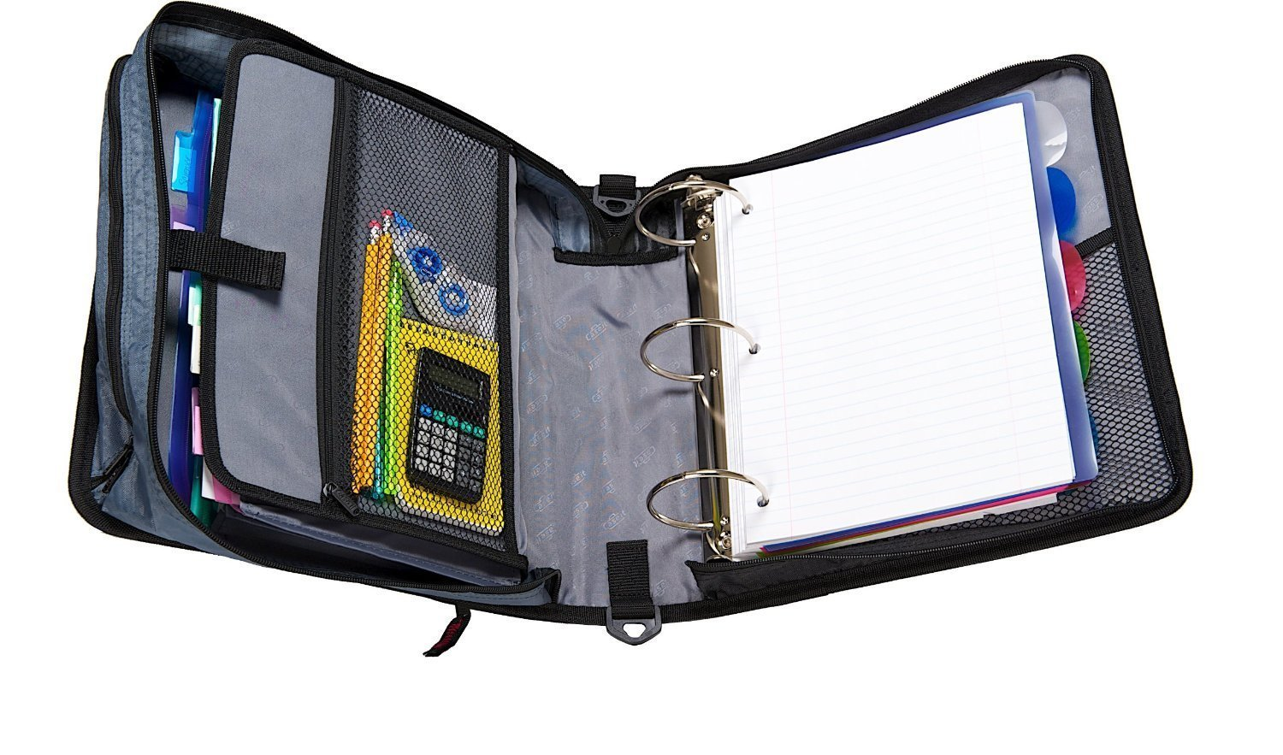  ⬜Item:ONE Trapper Keeper, 3-rings with full exterior zipper  Optional: Dividers  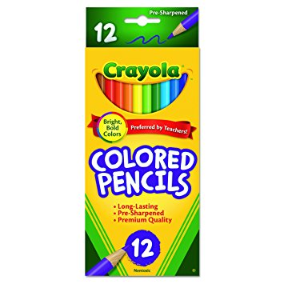  ⬜Item: ONE PACK of Colored Pencils  Recommended Brand: Crayola  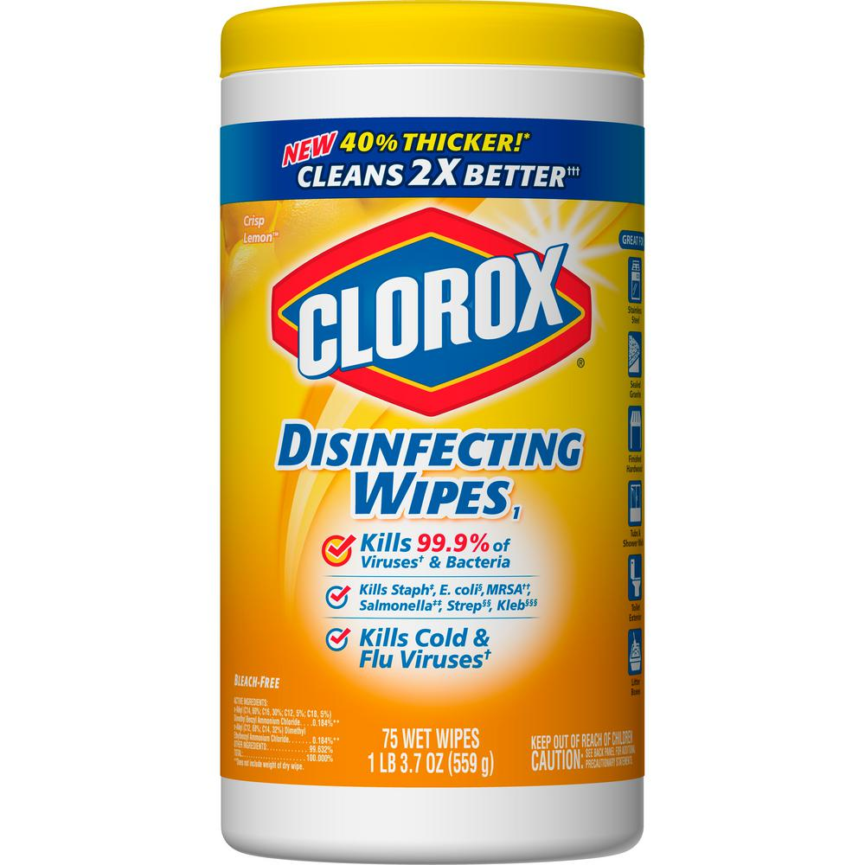  ⬜Item: ONE OR MORE CONTAINERS of Clorox Wipes for class  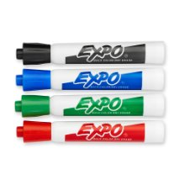  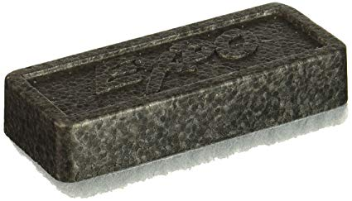  ⬜Item: FOUR Dry Erase Markers and Eraser  Recommended Brand: EXPO | 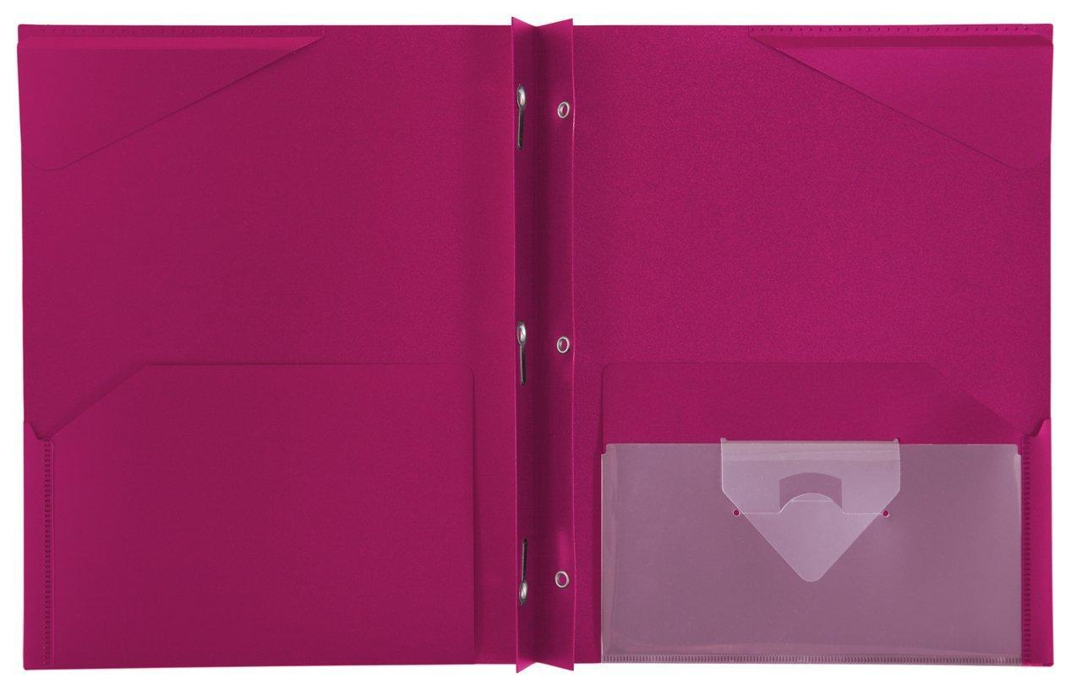⬜Item: TWO Red folders with 2 pockets and 3 binder holes  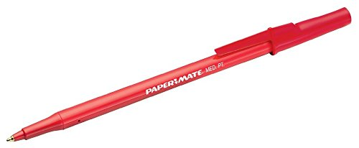  ⬜Item: TWO Red pens for checking  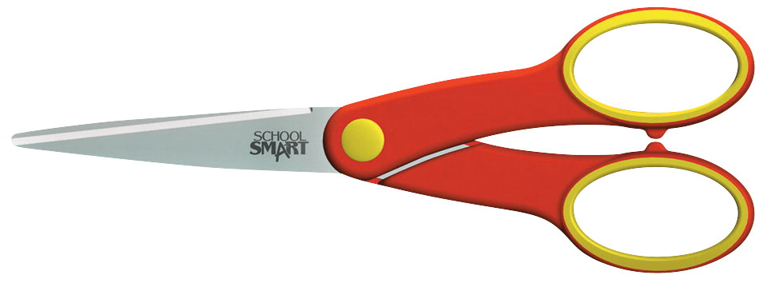  ⬜Item: ONE PAIR of School Scissors  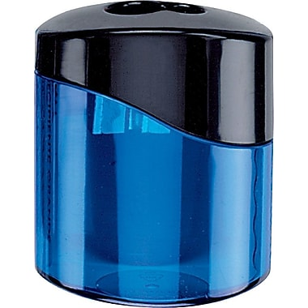  ⬜Item: ONE Pencil Sharpener WITH COVER  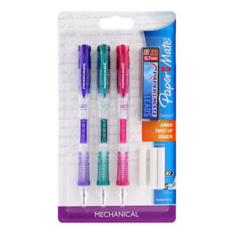  ⬜Optional: Additional Mechanical Pencils TEACHERS DO NOT HAVE LEAD TO GIVE  Recommended Brand:  PaperMate ClearPoint  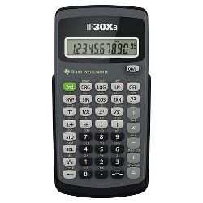  ⬜Item: ONE Calculator (Optional) | 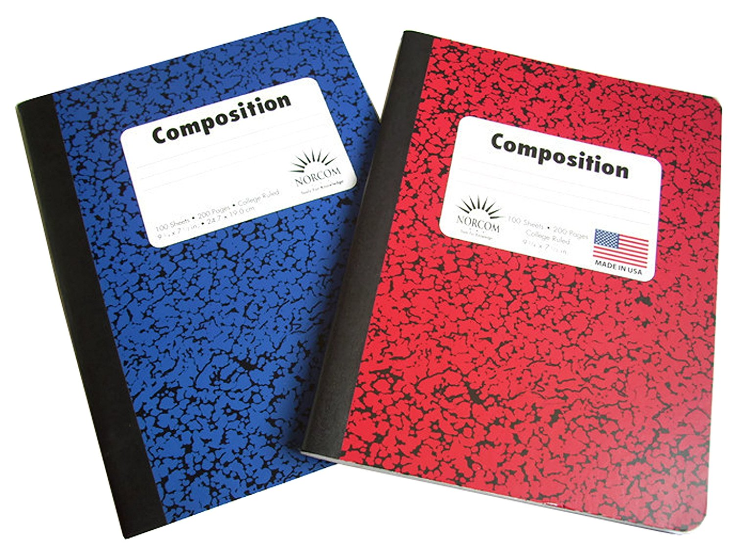  ⬜Item: TWO College Ruled Composition Notebooks  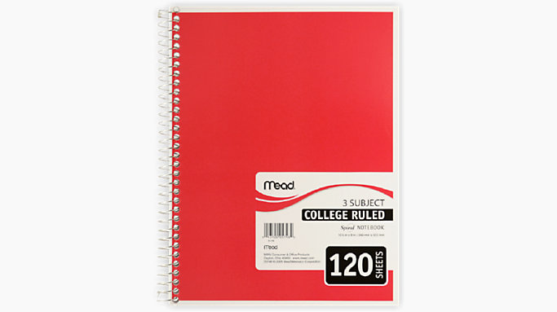  ⬜Item:ONE College Ruled Spiral Notebook  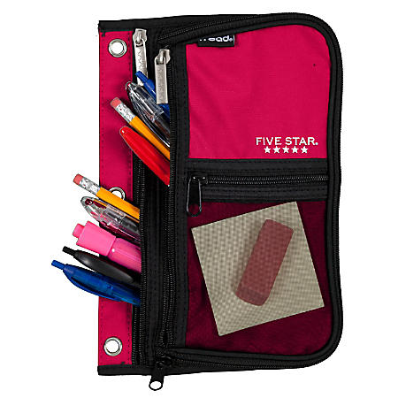  ⬜Item:ONE LARGE Pencil Pouch with Zipper, NO BOXES ALLOWED  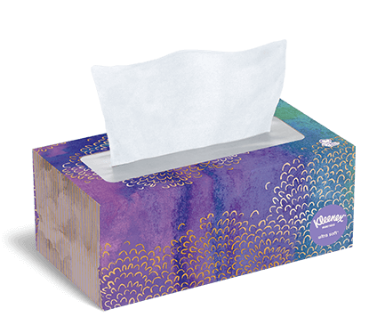  ⬜Item: TWO OR MORE Kleenex Boxes for class  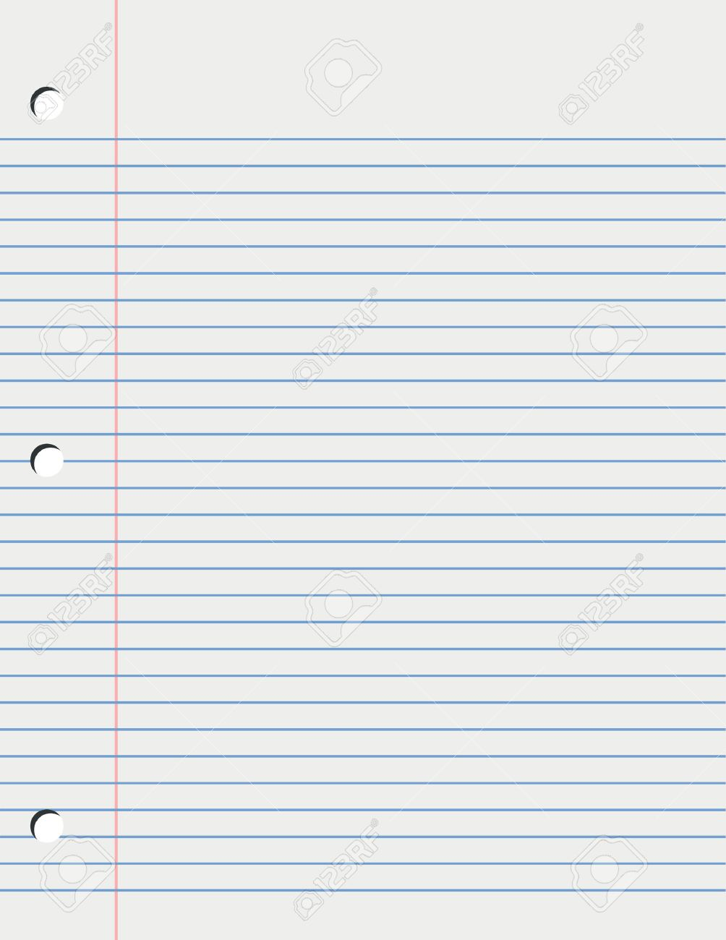  ⬜Item: ONE Pack of loose-leaf, lined paper, college ruled

