Chapter 5 Ancient Sumer

Why do historians classify ancient Sumer as a civilization?

5.1 Introduction

The rise of Sumerian city-states began around 3500 B.C.E. In this chapter, you'll take a closer look at life in Sumer. Like an archaeologist, you'll consider evidence to try to answer this question about the distant past: Why do historians classify ancient Sumer as a civilization? A civilization is a society that has developed arts and sciences and organization.

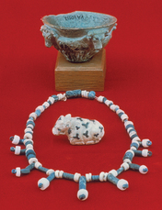
Until about 150 years ago, archaeologists had no idea that the Sumerian people had lived at all. Then, in the mid-19th century, archaeologists began finding artifacts in the area of the Fertile Crescent that we call Mesopotamia.They uncovered tablets, pottery, and the ruins of cities. They were surprised to find writing in a language they had never seen before.
By studying artifacts, archaeologists have been able to learn a lot about Sumer. One artifact is the Standard of Ur(uhr). It was found where the ancient city of Ur once stood. It is made of wood and decorated with pieces of shell and lapis lazuli, a semiprecious blue stone. The standard shows the Sumerians in times of peace and war. Artifacts like this one can tell us a great deal about daily life in ancient Sumer.
We now know that the Sumerians had a complex society. Some of the things they invented, like the plow and writing, are still in use today. But which characteristics of Sumer society cause historians to classify it as a civilization? Let's take a closer look at ancient Sumer.

5.2 Characteristics of Civilization
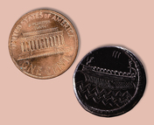
Sumer was a challenging place to live. It had hot summers, little rain, and rivers that flooded the plains in the spring. Yet the Sumerians were able to overcome these challenges. They built complex irrigation systems and large cities. By 3000 B.C.E., most Sumerians lived in powerful city-states like Ur, Lagash (LAY-gash), and Uruk (UH-ruhk). But what did the Sumerians do to create a civilization?
To answer this question, we need to examine what civilization means. What characteristics make a society into a civilization?
Historians name several such characteristics, including these:
• a stable food supply, to ensure that the people of a society have the food they need to survive
• a social structure with different social levels and jobs
• a system of government, to ensure that life in the society is orderly
• a religious system, which involves both a set of beliefs and forms of worship
• a highly developed way of life that includes the arts, such as painting, architecture, music, and literature
• advances in technology
• a highly developed written language
Did Sumer have these characteristics? Let's find out what the evidence can tell us.

5.3 Stable Food Supply
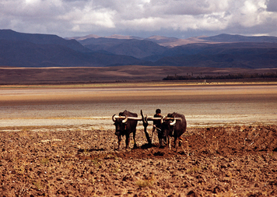
Civilizations need a stable food supply. A complex society can thrive only if its members have the food they need to survive.
The Sumerians invented two key things to help them create a stable food supply. One of these inventions was their complex irrigation systems. The Sumerians built networksof canals, dams, and reservoirs to provide their crops with a regular supply of water.
Their second invention was the plow. A plow is a tool used for tilling, or turning, the soil to prepare it for planting. Before the plow was invented, farmers used animal horns or pointed sticks to poke holes in the earth. Then they would plant seeds in the holes. This was a very slow way to farm. Farmers needed a faster way to prepare the land for planting.
The Sumerians made the first plow out of wood. One end of the plow was bent for cutting into the ground to turn the soil. Farmers themselves pushed and pulled the plow along the ground, or they used animals such as oxen to pull it.
5.4 Social Structure
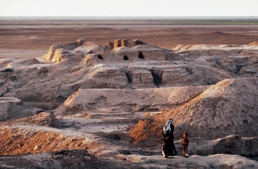
Civilizations have a complex organization, or social structure. A social structure includes different jobs and social levels. People at higher levels have greater status than others.
Archaeologists have found evidence that several classes of people lived in Sumer. At the top level were priests, landowners, and government officials. These people had the largest and most luxurious homes, near the center of the city. Their houses were two stories high. Evidence suggests that these mud houses had whitewashed walls.
At the middle level were merchants and artisans. Among the artisans were skilled metalworkers. They worked with such metals as gold, silver, tin, lead, copper, and bronze. Out of these materials, they made swords and arrowheads for the army. They made tools, like plows and hoes, for farmers. They also made luxury items, such as mirrors and jewelry, for the upper class.
The middle class also included farmers and fishers They lived in small, mud-brick houses at the edge of the city. Farmers often worked to build or repair the irrigation systems. In times of war, they were forced to serve in the army.
At the bottom level of the social structure were slaves. They lived in their owners' homes and had no property of their own.

5.5 Government
All civilizations have a system of government to direct people's behavior and make life orderly. Sumerian city-states were ruled by kings. The Sumerians believed that their gods chose these kings. This belief made kings very powerful. It also helped to reinforce the social order, because obeying the will of the gods was one of the Sumerians' strongest beliefs.
Sumerian kings enforced the laws and collected taxes. They built temples and made sure irrigation systems were maintained.
A king also led his city-state's army. All the city-states needed armies because of constant fighting over land boundaries and the use of water. Leading the army was one of the king's most important jobs.
A Sumerian army included both professional soldiers and temporary citizen-soldiers. Some were foot soldiers. Others drove chariots, which were wheeled vehicles pulled by horses.
Kings appointed officials to help with certain duties. Governors ruled the outlying towns. Scribes helped record laws. The Sumerians were the first people to develop a system of written laws.
One special group of officials patrolled the canals. They looked for damage and made sure that farmers did not take water illegally.

5.6 Religion
All civilizations have some kind of religious system. A religious system includes both a set of beliefs, usually in a god or gods, and forms of worship.
In Sumer, religious beliefs influenced every part of daily life. The Sumerians tried to please their gods in all things, from growing crops to settling disputes. Religion bound the people together in a common way of life.
The ancient Sumerians expressed their religious beliefs by constructing temples and religious towers called ziggurats (ZIHG-guh-rats). It was the king's duty to build and maintain these ziggurats. The towers were platforms made of mud bricks, with shrines on the highest tier. Ziggurats were so large that they could be seen from 20 miles away. Some were as high as 8 stories and as wide as 200 feet.
The Sumerians believed that their gods lived in the ziggurats, most likely in the special shrines at the top. Attached to the outside walls of each ziggurat was a long staircase that the gods could use to climb down to Earth. Kings and priests stood inside the towers to ask for the gods' blessings.
Sumerian statues also expressed religious beliefs. Many of these statues were detailed and lifelike. They showed people worshipping the gods, often with eyes gazing upward. The Sumerians believed that the gods were pleased when people showed these signs of devotion, or love and obedience.
The Sumerians had many kinds of religious ceremonies. Often, musicians played at these ceremonies. Some ceremonies may have involved human sacrifice, the ritual killing of a person as an offering to the gods.

5.7 The Arts
All civilizations have a highly developed culture, including the arts. Arts include creative forms of expression such as painting, architecture, and music.
There were many kinds of artists and artisans in ancient Sumer. Metalworkers made objects, like weapons and cups. They made decorative items, such as mirrors and jewelry, too. Architects designed temples and ziggurats.
Music was another important art in Sumer. The Sumerians believed that music brought joy to gods and people alike. Musicians sang and played instruments during temple ceremonies. They wrote love songs and entertained guests at feasts.
Sumerian musicians played a variety of instruments, including drums and pipes. One favorite was a small harp called a lyre. Lyres were wooden instruments made of a sound box and strings. A wooden bar held the strings in place at the top. Lyre makers often decorated their instruments with precious stones and with carvings made of horn. These decorations show how much the Sumerians valued music.

5.8 Technology
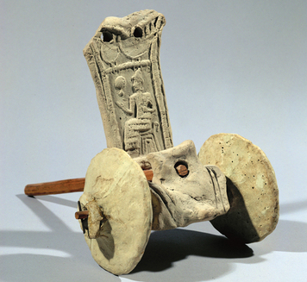
All civilizations create new forms of technology. The Sumerians made several technological advances.
The most important Sumerian invention was the wheel. The earliest examples of the wheel date back to 3500 B.C.E. Sumerian potters, or pottery makers, first used wheels as a surface for shaping clay into pots. Potters' wheels spun, flat side up, on an axle. The Sumerians discovered that a wheel that was flipped onto its edge could be rolled forward. They used this discovery to create wheeled carts for farmers, and chariots for the army. They built the wheels by clamping pieces of wood together.
It would be hard to discover a more powerful invention than the wheel. Before the wheel, people had to drag their goods on flat-bottomed carts called sledges. The sledges often got stuck in mud, and they couldn't support heavy loads. Wheeled carts made it much easier to move goods over long distances. Oxen could pull three times more weight on wheeled carts than on sledges.
Another technological advance was the arch. Sumerian arches were inverted (upside-down) U- or V-shaped structures built above doorways. To build arches, the Sumerians stacked bricks, made of clay and straw, to rise from the walls in steps until they met in the center.
Arches added strength and beauty to Sumerian buildings. They became a common feature of temple entrances and upper-class homes. Some historians say that the arch is the Sumerians' greatest architectural achievement.

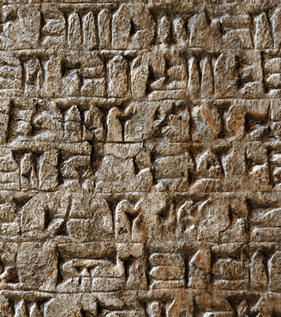
5.9 Writing

A final characteristic of civilizations is a highly developed written language. The Sumerians created a written language called cuneiform. This name comes from the Latin word for “wedge.” The Sumerians used a wedge-shaped stylus (a sharp, pointed tool) to etch their writing in clay tablets.
Sumerians developed cuneiform around 2400 B.C.E. The earliest examples of cuneiform show that it was used to record information about the goods people exchanged with one another. At first, cuneiform writing may have contained as many as 2,000 symbols to stand for ideas and sounds. Over time, this number was reduced to about 700.
Cuneiform was based on an earlier, simpler form of writing that used pictographs.Pictographs are symbols that stand for real objects, such as a snake or water. Scribes used a sharpened reed to draw the symbols on wet clay. When the clay dried, the marks became a permanent record.

