Chapter 2
Early Hominids
EQ: What capabilities helped hominids survive?

2.1 Introduction

Prehistoric humans left clues about their lives in cave paintings. Scientists call these prehistoric humans hominids. In this chapter, you will learn about five important groups of hominids.
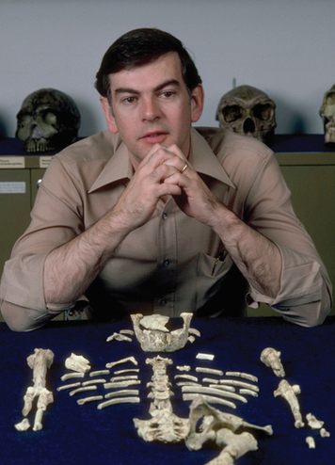
Three kinds of “history detectives” that study the past are archaeologists, historians, and geographers. The study of hominids involves a fourth type, paleoanthropologists.Paleoanthropologists specialize in studying the development and culture of the earliest hominids. (Paleo means “ancient.”)
In 1974, an American paleoanthropologist named Donald Johanson made an exciting discovery. While searching for artifacts under a hot African sun, he found a partial skeleton. The bones included a piece of skull, a jawbone, a rib, and leg bones.
After careful study, Johanson determined that the bones had come from a female hominid who had lived more than 3 million years ago. She is one of the earliest hominids ever discovered. Johanson nicknamed her “Lucy,” from the Beatles' song “Lucy in the Sky with Diamonds,” which was playing at his celebration party.
What have scientists found out about Lucy and other hominids? How were these hominids like us? How were they different? What abilities did each of the five hominid groups have? Let's find out.

2.2 Australopithecus Afarensis : Lucy and Her Relatives
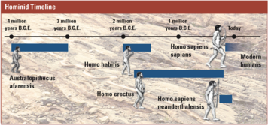

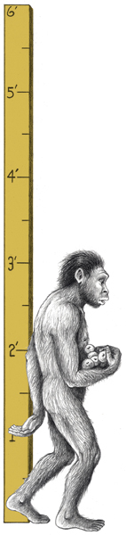
Scientists usually give Latin names to groups of living things.(Latin was the language of the ancient Romans who ruled a great empire for a thousand years, starting about 500 B.C.E.) An anthropologist in Africa called the earliest known group of hominids Australopithecus (aws-tray-loh-PIH-thuh-kuhs), meaning “southern ape.” Donald Johanson called Lucy's group Australopithecus afarensis. The second part of this name refers to the Afar Triangle, the part of Africa where Lucy was found.
Through their studies of Lucy, scientists have learned a lot about early hominids. By assembling her bones, they know something about what she looked like. Lucy was short compared with humans today—between 3 and 4 feet tall. She had a mix of ape and human features. Her arms were long, but her hands and feet were similar to a modern human's.She had a large head, and her forehead and jaw stuck out from her face.
The remains of other hominids like Lucy have been found in the same area. Scientists guess that Lucy's relatives lived in Africa, about 3 to 4 million years ago.
How are hominids like Lucy related to later hominids and to us? Anthropologists often disagree about the answer to this question. One reason may be that anthropologists have so few clues to work with. Bones as old as Lucy's are very hard to find. Even so, most anthropologists agree that Lucy and her relatives were very early forms of humans.
One discovery about Lucy was especially exciting. By studying her skeleton, scientists found out that she was a biped.That means she had the capability to walk on two feet. This gave Lucy and her relatives many advantages compared with animals such as gorillas and chimpanzees. With their hands free, the hominids could gather and carry food more easily. They could also use their hands to defend themselves and their children.
This biped trait was one key way in which Lucy resembled us. But in other ways, hominids like Lucy were quite different from modern humans. Lucy's brain was only about one-third the size of ours. Scientists have not found any remains of tools from Lucy's time. The study of Lucy’s remains indicates that these early hominids likely could not speak.

2.3 Homo Habilis: Handy Man

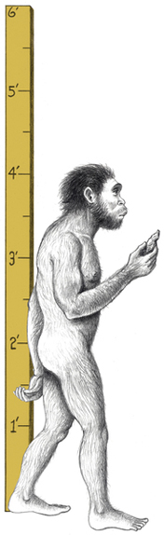
A second group of hominids was discovered by the husband and wife team of Louis and Mary Leakey. When the Leakeys were searching for evidence of early hominids in Africa, they discovered some hominid bones. The bones were scattered among artifacts that looked like tools. The Leakeys named their discovery Homo habilis (HA-buh-lis), or “Handy Man,” in honor of this hominid group's ability to make tools.
Handy Man lived a little closer to our time than Lucy did, about 1.5 to 2 million years ago. Like Lucy, this group combined ape and human features. They also walked on two feet. But they were taller than Lucy. Their features were slightly more humanlike, and their brains were twice the size of hers.
Scientists have discovered Handy Man remains only in Africa. Sometimes, the bones of more than one Handy Man were found together. It is likely that these hominids lived in groups. This would have helped them survive. They could have worked together to protect themselves against animal attacks. They also could have collected food over larger areas of land.
The tools found by the Leakeys were an important clue about this hominid group. Their larger brains and their ability to use tools were key differences between the Handy Man group and hominids like Lucy. These traits show that Handy Man was more advanced and more like modern humans than Lucy was.
Handy Man's tools were very simple. These hominids used animal bones as digging sticks and rocks as chopping tools. They also made sharp pieces of stone for cutting.
Making a tool, even a simple one, takes thought and effort. First, the hominids had to think about what kind of tool was needed. Then, they had to plan how to make it. Finally, they had to craft the tool themselves and try using it.Handy Man may even have passed these early skills on to others.

The ability to make tools helped Handy Man live better and longer than Lucy and early hominids like her. The use of cutting tools allowed these later hominids to tear the meat from dead animals. Crushing tools may have helped them crack animal bones, to eat the marrow inside. Handy Man hominids may even have dug or made traps for small animals.
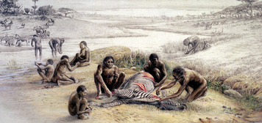

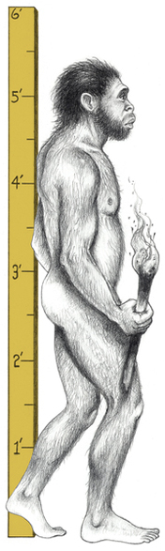
2.4 Homo Erectus: Upright Man

A third type of hominid was discovered in 1891 by a Dutchman named Eugene Dubois (doo-BWAH). While he and his team were searching for artifacts on the island of Java, off the southern coast of Asia, they found a new type of hominid skull.
In time, Dubois' team discovered the bones of many more hominids. As scientists assembled the bones, they observed that these hominids stood up straight. Dubois named this hominid group Homo erectus (UH-rek-tuhs), or “Upright Man.” (At this time, Lucy and Handy Man had not yet been discovered.)
Upright Man lived on Earth longer than any other hominid group, from 1.8 million to 200,000 B.C.E. Scientists believe that they were the first hominids to migrate out of Africa. Their remains have been found in both Asia and Europe.
It is no wonder that scientists have found the bones of Upright Man in many places. This group of hominids was well-suited for traveling. They were taller and thinner than earlier hominids—some even reaching the height of modern humans. Their bones were very strong. And they were good walkers and runners.
The facial features of Upright Man looked more like those of modern humans than the faces of earlier hominids.Upright Man hominids had foreheads that were round and smooth. But they still had a large ridge above the eyes, a thicker skull, and a jaw that stuck out.
Like Handy Man, hominids in the Upright Man group were toolmakers. But their larger brains enabled them to invent more complex tools, including strong hand axes made of stone.

One of Upright Man's greatest advantages was the ability to use fire. Anthropologists have found burned animal bones in the same places as Upright Man remains. This is a clue that Upright Man may have used fire to cook animal meat.
Scientists aren't sure whether these hominids were hunters or merely gatherers, finding dead animals to eat. But studies of their tools and teeth show that they ate more meat than earlier hominids did. They feasted on red deer, elephant, rhinoceros, goat, boar, and oysters.
The remains of an ancient campsite found in France have offered additional clues about how Upright Man lived. Scientists guess that this group built oval huts by covering posts with tree branches. The group kept a fire burning in the center of the hut. It is likely that group members sat and slept on animal skins.

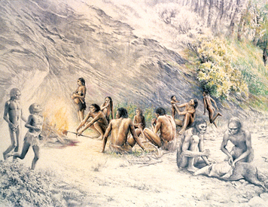
They may have decorated their bodies with yellow-colored mud called ocher.
Scientists believe that Upright Man groups moved from place to place, building shelters with tools, and using fire to keep warm. These capabilities helped them travel farther and survive for longer periods than earlier hominids could. The ability to construct shelters allowed Upright Man to adapt to colder climates and live in areas without caves or other natural shelters. The ability to control fire helped them survive the cold, cook animal meat, and protect themselves from predators.

2.5 Homo Sapiens Neanderthalensis: Neanderthal Man
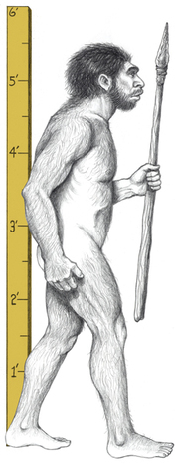

In 1856, some mine workers in Germany's Neander Valley found a skeleton. It had thick bones and a ridge above the eyes, but was also very humanlike. Today, most scientists consider this fourth group of hominids to be a distinct type of Homo sapiens (“Wise Man”), the large-brained group that modern humans belong to. Scientists call this group Homo sapiens neanderthalensis, or Neanderthal (nee-AN-der-tahl) Man.
Neanderthals lived after Upright Man, from 200,000 to 28,000 years ago. Neanderthals lived in Africa, Europe, and parts of western Asia.
The appearance of the skeleton found in Germany led scientists to believe that Neanderthals walked hunched over, with their hands dragging on the ground. As it turned out, the skeleton was of an older man who had a bone disease. In reality, Neanderthals walked upright. They were shorter and stockier than modern humans, but they were also much stronger.
Most important, Neanderthals had large brains. They used their intelligence to become skilled toolmakers. More than 60 types of Neanderthal tools have been found. These tools required much more planning, skill, and knowledge than the tools made by earlier hominids. Neanderthals created knives, scrapers, and spear points. They learned how to make sharp, thin blades by breaking off the top of a rock and then chipping two or three sharp flakes from the original piece.
The ability to make better tools improved Neanderthals' chances for survival. But their ability to work together helped even more. Neanderthals lived and traveled in groups. And they were the first early hominids to hunt in an organized group.
Scientists believe that Neanderthals may have had a sense of community. When members of a group died, their bodies were laid in burial mounds, along with hunting tools and flowers. This is a clue that Neanderthals cared about one another and had a sense of ritual.
When on a hunt, Neanderthals worked together to surround and trap an animal. Then they would close in and kill it with spears. Evidence suggests that if some hunters were injured, other group members would help them.
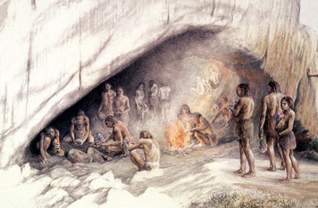

Paleoanthropologists have found some Neanderthal bones showing signs of serious breaks that had healed. These clues lead them to think that Neanderthals helped members of their group who were hurt or sick.
Scientists interpret these indications that Neanderthals cared for each other to mean that Neanderthals lived as a community. This capability would have given them benefits in surviving. For example, they would have been able to learn from the experience and the wisdom of older members of the group.
How exactly are Neanderthals related to the early modern humans? Scientists aren't sure. Judging from the remains that have been found of both groups, Neanderthals existed side by side with early modern humans for about 10,000 years. No one knows the reason why Neanderthal populations disappeared. All we know for certain is that only one type of Homo sapiens survived to become early modern humans.

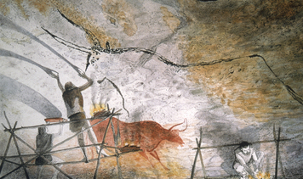
2.6 Homo Sapiens Sapiens: Doubly Wise Man

In 1879, an eight-year-old Spanish girl named Maria was off exploring a cave with her father when she made an amazing discovery. She found a cave room filled with ancient paintings of deer, bison, wild horses, and boars. They were the first prehistoric cave paintings ever discovered.
The people who created these ancient cave paintings were the earliest members of our own group, Homo sapiens sapiens (SAY-pee-enz), or “Doubly Wise Man.” Homo sapiens sapiens first appeared about 150,000 years ago.Most scientists believe that they originated in Africa. From there, they spread to Europe, Asia, and Australia.Eventually, they migrated to North and South America, probably traveling across land bridges, which were later covered by water.
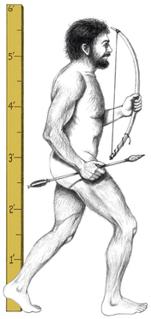
The first modern humans looked more like us than the Neanderthals did. They had high, rounded skulls, large brains, small teeth, and slender bones. But their bodies were not as well adapted to the cold as those of Neanderthals. Early modern humans may have survived because of their ability to create better tools, shelter, and clothing.
As toolmakers, early modern humans were even more skilled than Neanderthals. They attached thin blades to bone, antler, and stone to create a wide variety of tools. They made tools used for engraving and sculpting. They fashioned needles for sewing animal skins together. They also built shelters of earth and stone.
These prehistoric humans were also better hunters than earlier hominids. They made hooks and spears to catch fish. Most important, they invented the spear thrower and the bow and arrow. Armed with these weapons, they could hunt from a distance, making hunting much safer.

Through their artwork, early modern humans left behind a fascinating record of their lives. They left paintings on the walls of their caves. Artists also carved and shaped images out of clay, bone, flint (a hard mineral), and ivory. They even created musical instruments.
Prehistoric artists created a variety of images. Some images came from the world around them, like the animals they hunted. Some images came from their imaginations, such as mythical creatures. These early artists also made patterns using shapes. Paleoanthropologists think the artists may have signed their work with handprints.
Why did early modern humans create art? Many scientists believe that they painted to express themselves. Some think that pictures were used to teach children. Others think that images had religious purposes.
One thing is certain. These early humans did not merely exist in their world. They had many feelings about it and created images to communicate those feelings. They had the ability to express thoughts to others through pictures and symbols. Some scientists believe that these abilities were able to contribute to the development of complex language, one of the capabilities that make us fully human.

