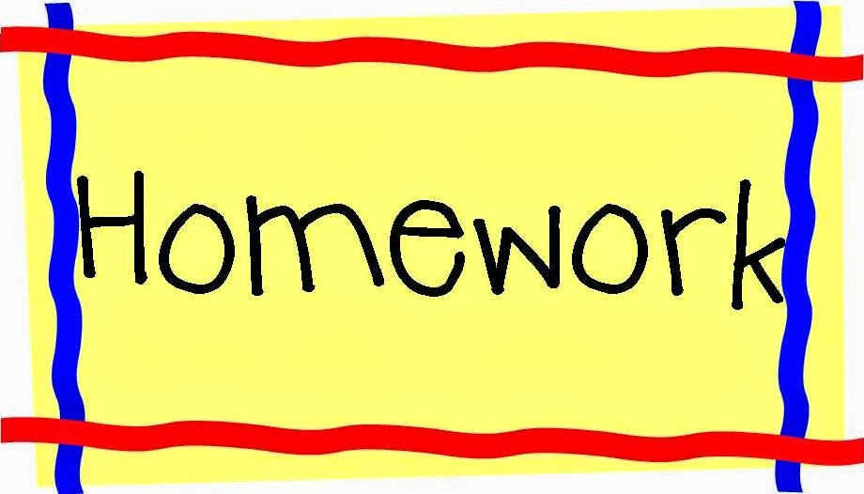


September 9-13, 2019
Room 27(1st)
Assignments Spelling List
1. man 5. cat
2. can 6. mat
3. gap 7. rap
4. up 8. down
*+3 cold words on test day

Monday
READ Poems
Math Worksheet
*NWEA Reading
Media

Tuesday
READ Treasure bk
Math Worksheet
Music
Challenge words
plan sand

READ Big R bag
Math Worksheet
*NWEA Math
Wednesday
Art
READ Little R bag
Spelling Words 3X
*5:30 Parent meeting
*6-7:30 Open House
Thursday
Gym
Students are trying to make an object that makes noise.
Art
*Spelling Test
Enjoy your
Weekend
Friday
Library
Music

