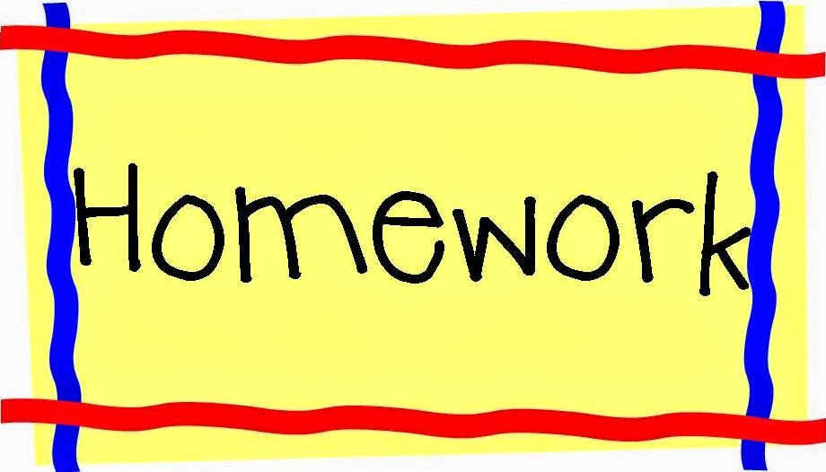

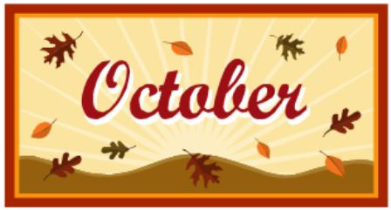
October 15-19, 2018
Room 27(1st)
Assignments Spelling List
1. land 5. sand
2. fast 6. list
3. sink 7. ant
4. help 8. very

Monday
READ Poems
Math Worksheet
Media
Art

READ Treasure bk
Math Worksheet
Tuesday
Gym
Challenge
standing plant

READ Big R bag
Math Worksheet

Wednesday

Art
READ Little R bag
Spelling Words 3X
Math Worksheet
Thursday
Music

*Picture Day
*Science Test
*Howard”een” Bash 5-7:30

Friday
Library
Music

