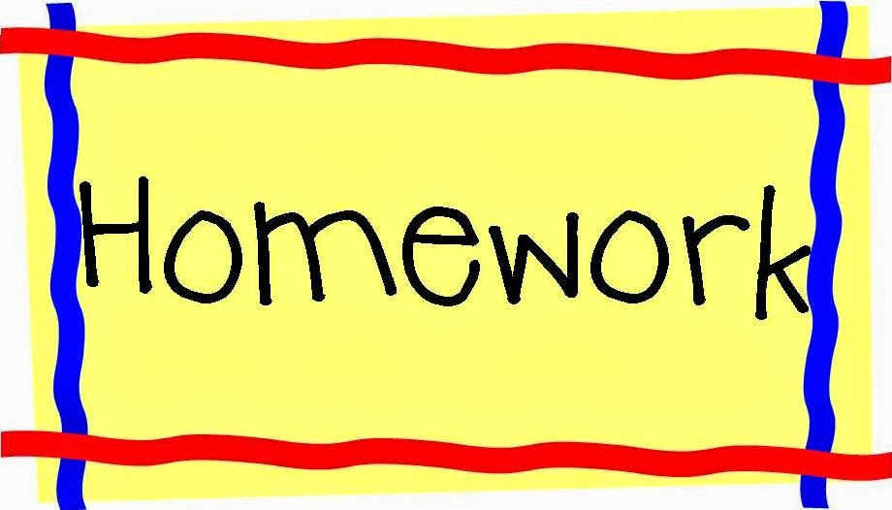

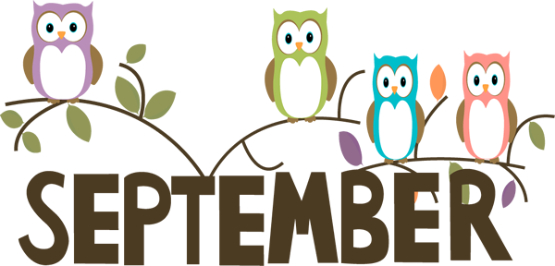
September 17-21, 2018
Room 27(1st)
Assignments Spelling List
1. man 5. cat
2. can 6. mat
3. ran 7. hat
4. up 8. down

Monday
READ Poems
Math Worksheet
Media
Art
*Picnic
READ Treasure bk
Math Worksheet
Tuesday
Gym
Challenge words
plan sand

READ Big R bag
Math Worksheet
*NWEA Reading
Wednesday
*Late Start
Art
READ Little R bag
Spelling Words 3X
Math Worksheet
Thursday
Music
Students are trying to make an object that makes noise.

Enjoy your
Weekend!
Friday
Library
Music

