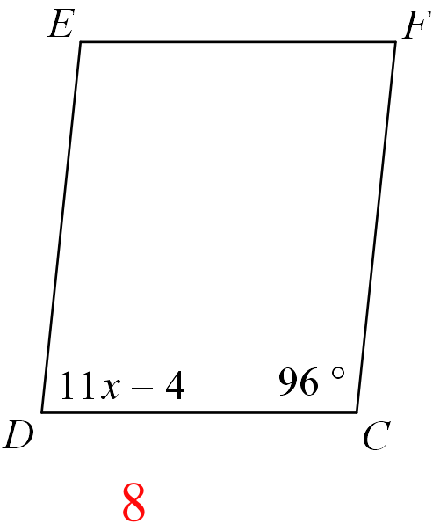Quadrilaterals – Parallelograms Proof 1

Given: Parallelogram CDEF with $m∠D=11x-4 and m∠C=96°$



Prove: x = 8



|  |  |
| --- | --- |
| **Statements** | **Justifications (Reasons)** |
| 1. | 1. |
| 2. $∠C and ∠D are supplementary$ | 2. |
| 3. $$m∠C+m∠D=180°$$ | 3. |
| 4. $96°+11x-4=180°$ | 4. |
| 5. $92°+11x=180°$ | 5. |
| 6. $11x=______$ | 6. |
| 7. $x=______$ | 7. |

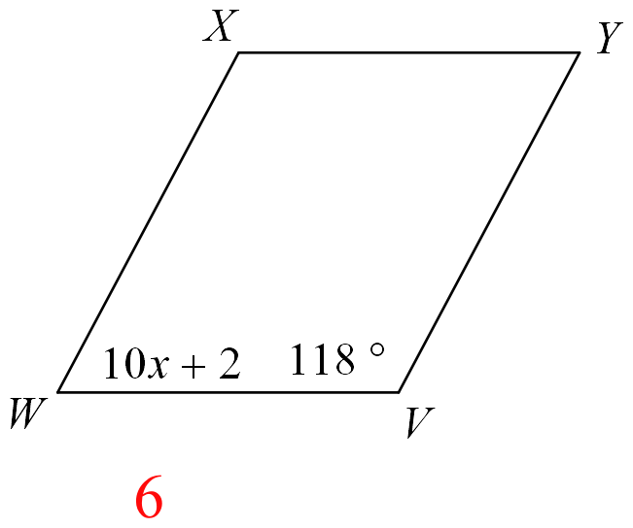Quadrilaterals – Parallelograms Proof 2

Given: Parallelogram VWXY with $m∠W=10x+2 and m∠V=118°$

Prove: x = 6

|  |  |
| --- | --- |
| **Statements** | **Justifications (Reasons)** |
| 1. | 1. |
| 2. $____ and ____ are supplementary$ | 2. |
| 3. | 3. |
| 4. | 4. |
| 5. | 5. |
| 6. | 6. |
| 7. | 7. |

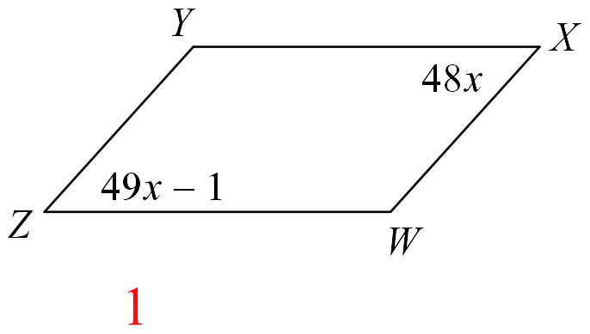Quadrilaterals – Parallelograms Proof 3

Given: Parallelogram WXYZ with $m∠Z=49x-1 and m∠X=48x$



Prove: x = 1

|  |  |
| --- | --- |
| **Statements** | **Justifications (Reasons)** |
| 1. | 1. |
| 2. $∠Z≅∠X$ | 2. |
| 3. $m∠Z=m∠X$ | 3. |
| 4. | 4. |
| 5. | 5. |
| 6. | 6. |
| 7. | 7. |



Quadrilaterals – Parallelograms Proof 4

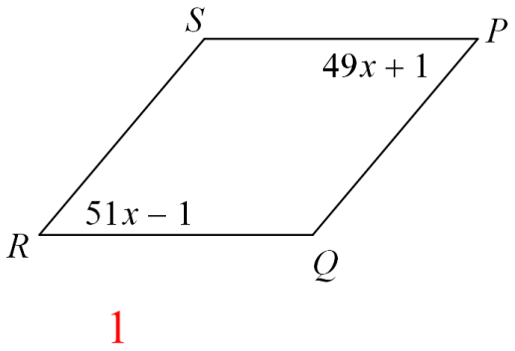

Given: Parallelogram PQRS with $m∠P=49x+1 and m∠R=51x-1$

Prove: x = 1

|  |  |
| --- | --- |
| **Statements** | **Justifications (Reasons)** |
| 1. | 1. |
| 2. | 2. |
| 3. | 3. |
| 4. | 4. |
| 5. | 5. |
| 6. | 6. |
| 7. | 7. |

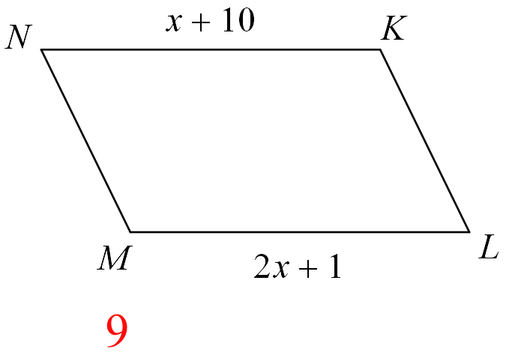Quadrilaterals – Parallelograms Proof 5

Given: Parallelogram KLMN with

*KN* = x + 10 and *ML* = 2x = 1

Prove: x = 9

|  |  |
| --- | --- |
| **Statements** | **Justifications (Reasons)** |
| 1. | 1. |
| 2. $\overline{KN}≅\overline{ML}$ | 2. |
| 3.  *KN = ML* | 3. |
| 4. | 4. |
| 5. | 5. |
| 6. | 6. |
| 7. | 7. |

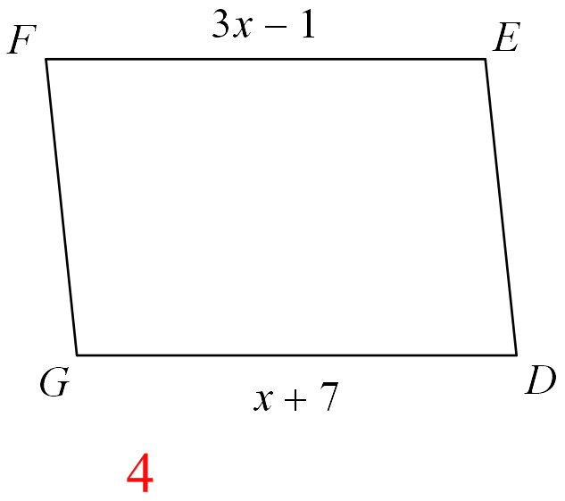

Quadrilaterals – Parallelograms Proof 6

Given: Parallelogram DEFG with

*EF = 3x – 1*  and *DG = x + 7*

Prove: x = 4

|  |  |
| --- | --- |
| **Statements** | **Justifications (Reasons)** |
| 1. | 1. |
| 2. | 2. |
| 3. | 3. |
| 4. | 4. |
| 5. | 5. |
| 6. | 6. |
| 7. | 7. |

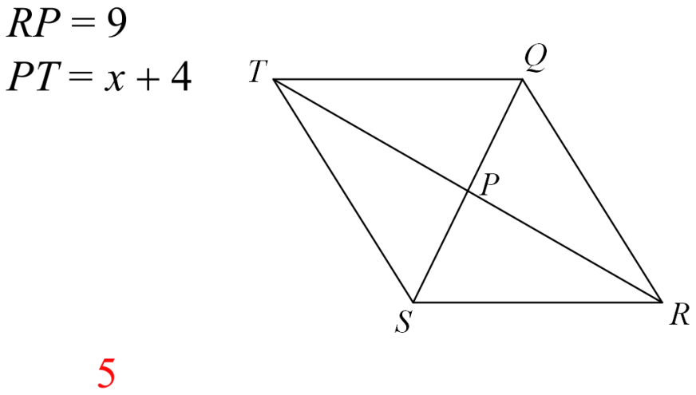Quadrilaterals – Parallelograms Proof 7

Given: Parallelogram QRST with *RP = 9* and *PT =*  x + 4



Prove: x = 5

|  |  |
| --- | --- |
| **Statements** | **Justifications (Reasons)** |
| 1. | 1. |
| 2. $\overline{QS} and \overline{RT} bisect each other.$ | 2. |
| 3. $\overline{RP}≅\overline{PT}$ | 3. |
| 4.  *RP = PT* | 4. |
| 5. | 5. |
| 6. | 6. |
| 7. | 7. |

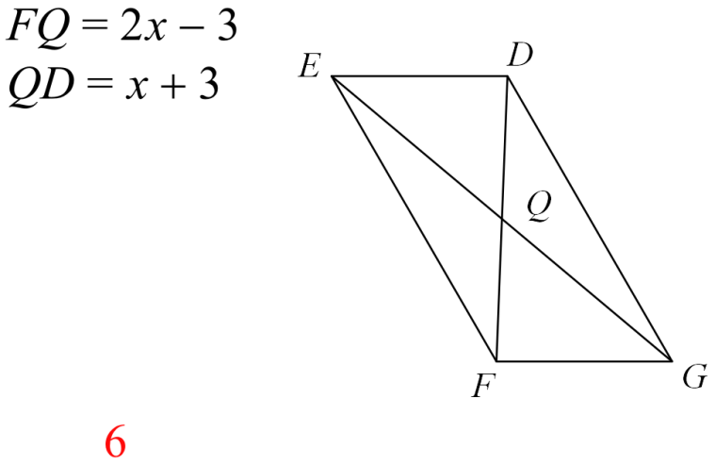Quadrilaterals – Parallelograms Proof 8

Given: Parallelogram DEFG with

$FQ=2x-3 and QD=x+3$

Prove: x = 6

|  |  |
| --- | --- |
| **Statements** | **Justifications (Reasons)** |
| 1. | 1. |
| 2. | 2. |
| 3. | 3. |
| 4. | 4. |
| 5. | 5. |
| 6. | 6. |
| 7. | 7. |