Polynomial Functions Unit Review Name:

Directions: please show your work for all problems. It will be expected on your test! NC – No Calculator

Simplify the following polynomial expressions, name your resulting polynomial. PUT ALL ANSWERS IN STANDARD. FORM.

|  |  |
| --- | --- |
| **NC**  1. (2x4 – 7x3 + 4x – 7) + (2x2 – 4x + 8)  2x4 – 7x3 + 2x2 + 1 Quartic Polynomial | **NC** 2. (-4x3 + 7x – 6) – (7x4 + 3x3 – 2x – 4)  -7x4 – 7x3 + 9x – 2 Quartic Polynomial |
| **NC** 3. (3x3 + 2x + 7)(x2 – 4)  3x5 – 10x3 + 7x2 – 8x – 28 Quintic Polynomial | **NC** 4.  x3 – 3x + 2 + 0/(x-4)  Write answer as quotient + remainder/divisor |

**NC** 5. Which of the above polynomials have the same end behavior as f(x) = ax2 + bx + c when a<0? Explain how you know.

This is an even degree polynomial with negative leading coefficient, so #2 would have the same end behavior (#1 would be both ends up, #3 & #4 are odd degree).

Solve the following polynomials, show your work!

|  |  |
| --- | --- |
| 6. x2 + 6x + 8 = 0  {-4, -2} | 7. x4 – 12x2 + 27 = 0  {-3, +3, +, -} |
| 8. x4 – 225 = 0  {} | 9. x3 + 9x2 + 6x – 56 *Hint: Use the calculator to get 1 root, use synthetic division to break down into a quadratic  {-7, -4, 2} |

10. Graph the polynomial f(x) = x3 – 2x2 – 9x + 18, showing end behavior, relative max/min, and zeros.

|  |  |
| --- | --- |
| http://mathforthemiddle.com/attachments/Image/coordinate_plane.gif | Label the relative max/mins on the graph. List them below  (-1.2, 24.2) and (2.5, -1.4) |
| List the coordinates of the zeros:  _(3,0)__, _(-3, 0), (2, 0) |
| What is the coordinate of the y-intercept? ___(0, 18)______ |
| as x🡪+, f(x) 🡪____+∞_____  as x 🡪-, f(x) 🡪____-∞_____ |
| Make sure your graph has the above points accurately graphed, the shape is continuous, and you put arrows on the end of the graph. |

11. Use the graph above to write f(x) = x3 – 2x2 – 9x + 18 in factored form.

(x-2)(x+3)(x-3)

**NC** 12. Use division and the remainder theorem to determine which of the following statements are true for $f\left(x\right)=4x^{3}-2x^{2}-x+2$. Explain how you know.

1. f(2) = 24 Yes, the remainder is 24 when doing synthetic division with 2.
2. The point (1, 12) is on the graph No, the remainder isn’t 12 when you do synthetic division with 1.
3. f(-6) = -928 Yes, see A
4. The point (0, 2) is on the graph. Yes, this is the y intercept, which is the constant term.
5. (x + 2) is a factor of the polynomial. No, the remainder is not 0 when dividing by (x+2).

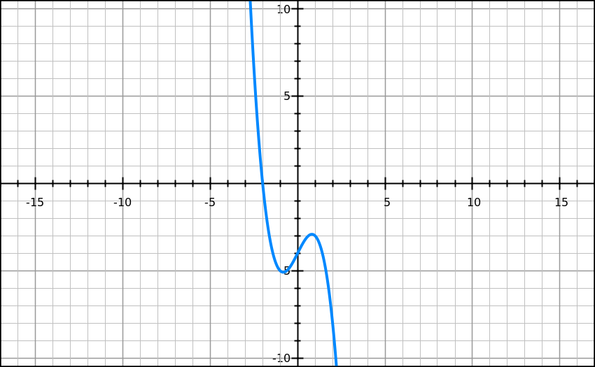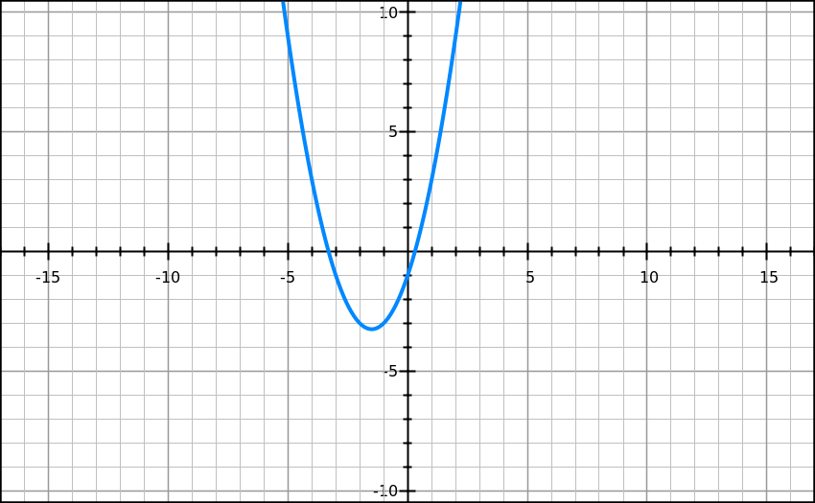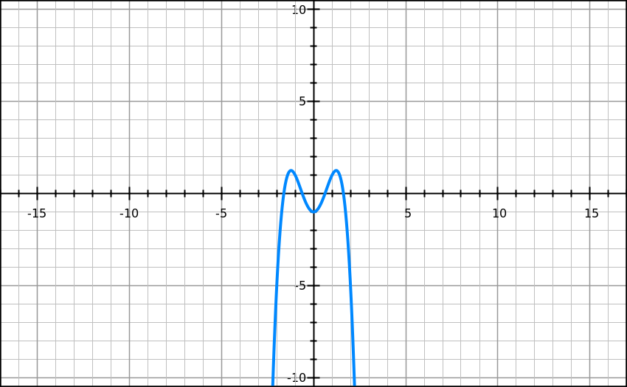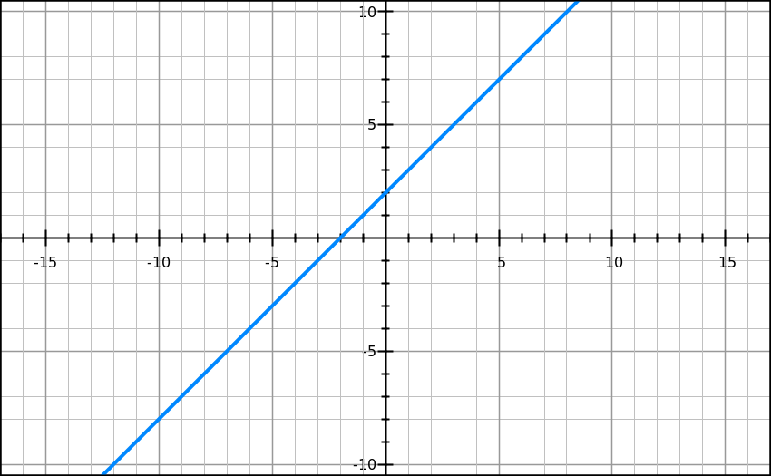

D

C

B

A

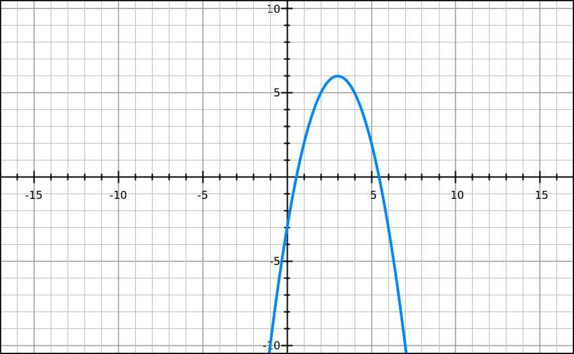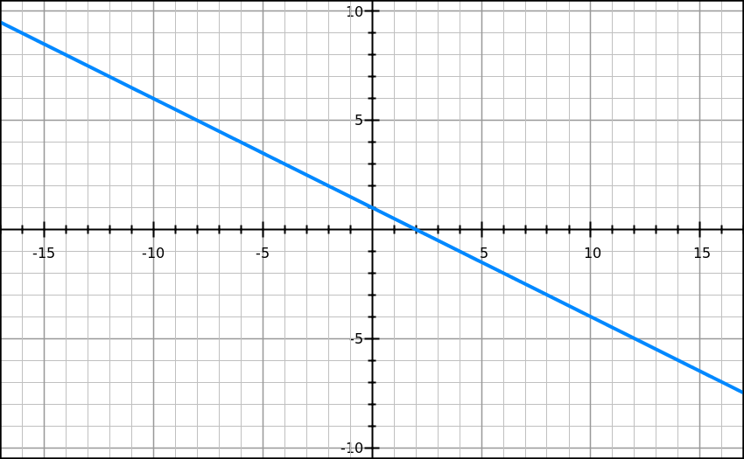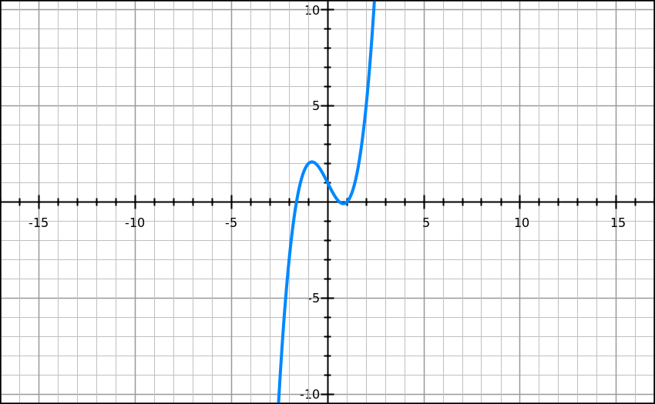

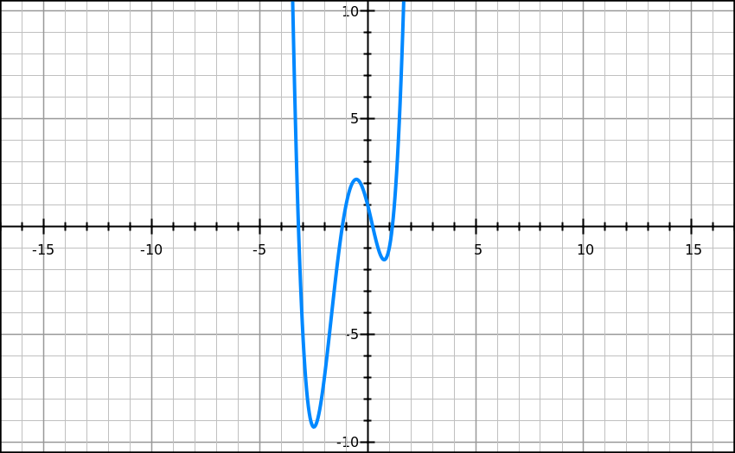

H

F

G

E

**For questions 17-20, match each of the graphs above.**

**NC** 13. Which graph(s) have the form f(x)= ax+b? How do you know? What name do we give a polynomial of this degree?

a> 0 a<0

__A_____ _G____

**NC** 14. Which graph(s) have the form $f\left(x\right)=ax^{2}+bx +c$? How do you know? What name do we give a polynomial of this degree?

a> 0 a<0

___C____ __E___

**NC** 15. Which graph(s) have the form $f\left(x\right)=ax^{3}+bx^{2}+cx+d$? How do you know? What name do we give a polynomial of this degree?

a> 0 a<0

__F_____ __D___

**NC** 16. Which graph(s) have the form $\left(x\right)=ax^{2}+bx +c$ $f\left(x\right)=ax^{4}+bx^{3}+cx^{2}+dx+e$? How do you know? What name do we give a polynomial of this degree?

a> 0 a<0

___H____ __B___