**Teachers:** Kendra Lytle/Kelly Berry/Caryn Schultz **Email:** [lytlek@dearbornschools.org](mailto:lytlek@dearbornschools.org)

**Website:** <http://iblog.dearbornschools.org/lytlek/> [berryk@dearbornschools.org](mailto:berryk@dearbornschools.org)

[schultc@dearbornschools.org](mailto:schultc@dearbornschools.org)

**Planning Period**: 4th hour **Room Numbers**: G207/A116/B206

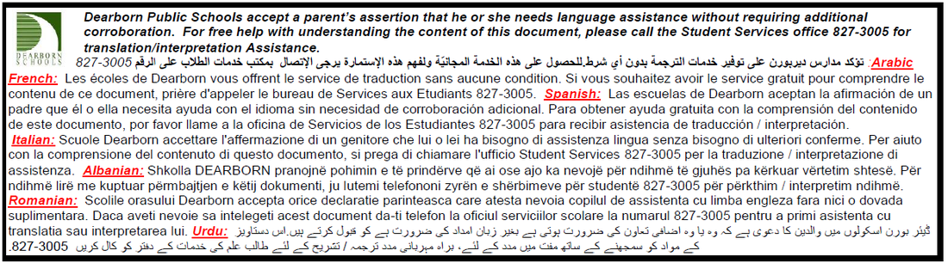

**Materials:**

* Composition Notebook ~ Two pocket folder ~ Pencils/erasers ~ Loose Leaf Paper
* Colored Pencils/Markers ~ Glue Stick ~ Scissors

**Daily Schedule**:

* Slot
* 60 Seconds
* Lesson
* Exit Ticket

**Grading**:

All of the following will be taken into account for your grade:

* 80% of your grade includes summative assignments:
  + Quizzes, Tests, Final Exam
* 20% of your grade includes formative assignments:
  + Daily assignments/Homework, Responsibility Form, Formative Assessments

Please do not ask whether assignments are formative or summative. If you do, you will be referred back to this syllabus.

93-100% A 87-89% B+ 77-79% C+ 67-69% D+ 0-59% E

90-92% A- 83-86% B 73-76% C 63-66% D

80-82% B- 70-72% C- 60-62% D-

**Attendance:**

Fordson’s attendance/audit policy is strictly followed in this class. In addition to this policy, students will lose participation points from SLOT anytime they are absent, tardy or late to class whether you have a pass or not.

*Note*: It is the policy of the Mathematics Department at Fordson High School that no student will be permitted to take his or her final exam early. In addition, all missing assignments incurred as a result of leaving school before the official end of the semester will be marked as zeroes in the grade book. Lastly, the Dearborn Public Schools audit policy will be applied to all absences that occur prior to the official end of the school year.

**Khan Academy: Retakes:**

****\*In order to retake a test, the following must be completed:

1. Complete the retake contract.
2. Completion of the retake within 2 weeks.
3. End of semester exams cannot be retaken.

*Cheating will not be tolerated and will result in a zero on any test or assignment.

*Per district policy if you are caught cheating you will not be eligible for valedictorian or salutatorian.

**Late Work**:

Late work will only be accepted from the current marking period. (For example: once we get to marking period two you may no longer turn in work from marking period one.)

**Classroom Expectations:**

* Come prepared and on time to class each day.
* Participate in class.
* Be respectful and work cooperatively in groups.
* Complete the assigned work and ask questions.
* Follow both classroom and school-wide rules.
* No food please, it is a distraction and it attracts critters.
* **Phones/Electronic devices**: There is no tolerance for these in class.
  + You will have a summative electronics quiz each card marking this semester. Each quiz will be worth 30 points. At the end of the card marking we will count how many infractions you have for your phone. Each infraction will be minus 10 points.
* **There are damage fees for classroom equipment. (Example: classroom calculator has a $130 replacement fee if damaged.)**

**Where to go for extra help**:

* Homework and notes will be posted on the blog. There are also links to helpful websites.
  + <http://iblog.dearbornschools.org/lytlek/>
* See us before school or after school if you have questions.
  + Make sure to let us know ahead of time when you plan to come in.
* After school tutoring. (Schedule will be posted in the classroom.)

Name:________________

Hour:__________

Date:__________

Subject:________________

**Please sign and return this sheet.**

You must keep your syllabus in your binder. Returning this sheet signed will be your first homework assignment.

**Due Date: 2.5.16**

I have read and understand the expectations of this class and agree to follow the rules and policies.

____________________________ ______________________________

Student Name (Printed) Student Signature

____________________________ ______________________________

Parent Name (Printed) Parent Signature

**Parents:** please leave any information you would like us to have regarding communication of your student’s achievement in this class.