Quadratic Regression Using the Nspire Graphing Calculator Name: ________________

We will use the following data to do a regression equation on our graphing calculator: A golf ball is hit down a straight fairway. The following table shows the height of the ball with respect to time. The ball is hit at an angle of 70 degrees with the horizontal with a speed of 40 meters/sec.

|  |  |  |  |  |  |  |  |  |  |  |
| --- | --- | --- | --- | --- | --- | --- | --- | --- | --- | --- |
| Time | 0 | .5 | 1 | 1.5 | 2 | 2.5 | 3 | 3.5 | 4 | 4.5 |
| Height | 0 | 17.2 | 31.5 | 42.9 | 51.6 | 57.7 | 61.2 | 62.3 | 61.0 | 57.2 |

First, let’s graph the data by hand:

A) What should we label our x-axis and y-axis?

B) Plot the points.

C) Does this appear to be a linear function? Explain.

1) Using the NSpire Graphing Calculator to Enter and Graph Data.

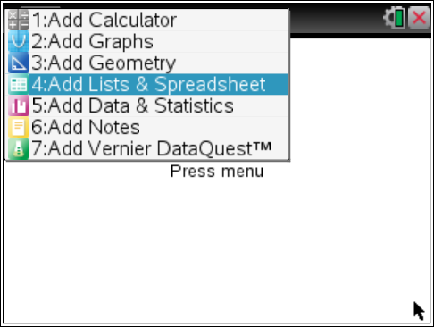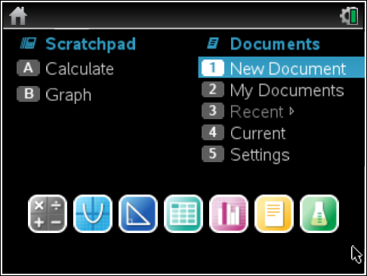 Select 1: New Document

Press Enter.

Select 4: Add Lists & Spreadsheet

Press Enter.

2) Make sure that as you type in the headings of each column you are in the very top part of the columns. Press Enter after each heading is complete. Put the cursor in the first row of the spreadsheet to start entering the data.

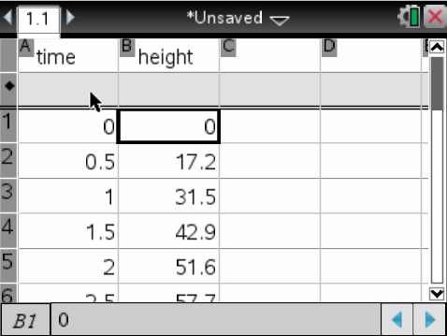

Enter all the data from your table.

Please Note: You cannot see all the data in the screen shot.

3) Making a Scatter Plot of the Data on the NSpire Graphing Calculator

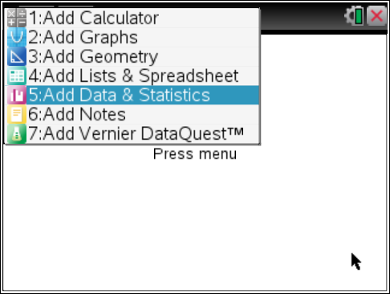

Insert a new page by pressing the Control Key (ctrl) and the Doc Key.

Select 5: Add Data & Statistics

Press Enter.

Notice the message at the bottom of the screen and the left part of the screen: “**Click or Enter to add variable**”.

|  |  |  |
| --- | --- | --- |
| Move the cursor to this message on the x-axis.  Press Enter.  Select time.  Press Enter. | Move the cursor to this message on the y-axis. The message may not appear right away until the cursor gets close to it.  Select height. | Press Enter. |

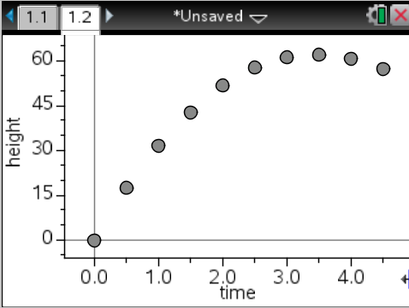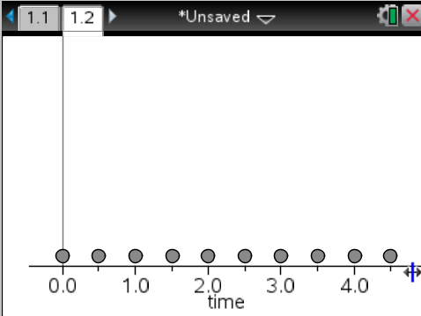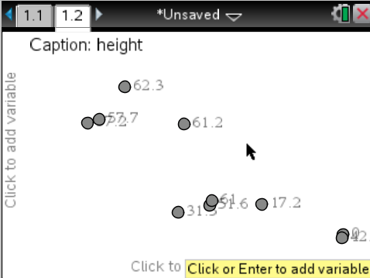

4) What type of function does this appear to be?__________________________________

5) Finding a Regression Equation on the Calculator – showing on the graph

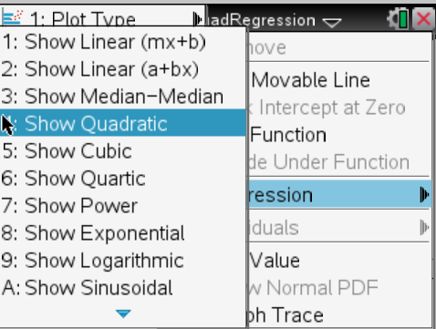 Press Menu.

Select 4: Analyze

Use the right arrow on the Touch Pad and select 6: Regression.

Use the right arrow on the Touch Pad and select

4: Show quadratic

Press Enter.

Write out the calculator’s function (round to the nearest tenth).

________________________________

6) **Showing a residual Plot on the Ti Nspire.**

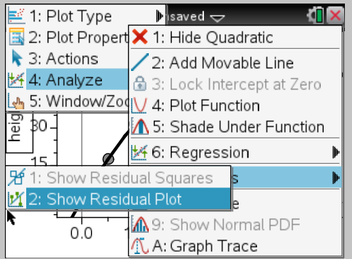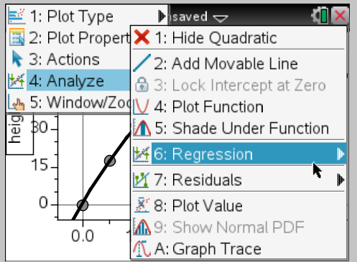 Push Menu

Choose 4: Analze

Choose 7: Residuals

Choose 2: Show Residual Plot

What should be true about the residuals? _______________________________________________________

__________________________________________________________________________________________

7) Finding a Regression Equation on the Calculator using the Lists and Spreadsheets

|  |  |
| --- | --- |
| Push “Ctrl” “left arrow” to get back to page 1.  Place the cursor in the first row of column c  Press Menu  Choose 4: Statistics  Choose 1: Stat Calculations  Choose 6: Quadratic Regression | A pop up menu will appear (see below)  Choose: time for x list  Height for y list  Everything else should be fine – click ok, or enter. |

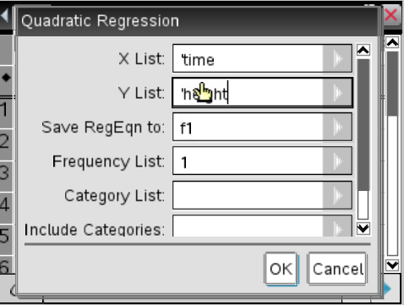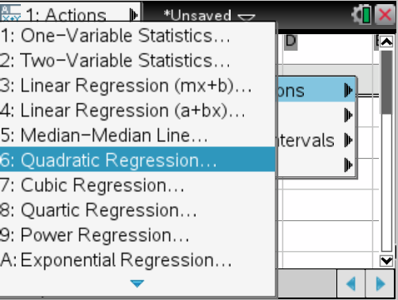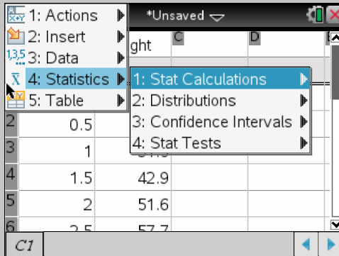

8. Record the equation from the data – remember f(x) = ax2 + bx + c

______________________________________________________________________