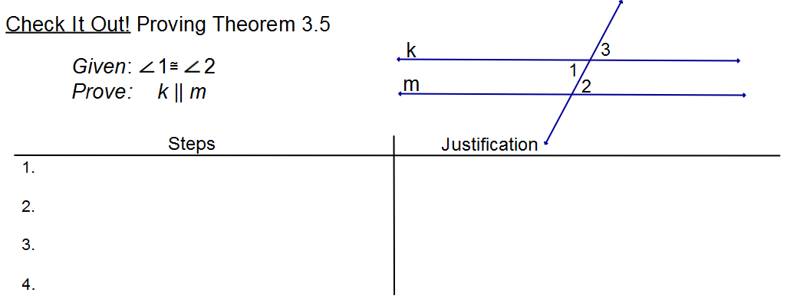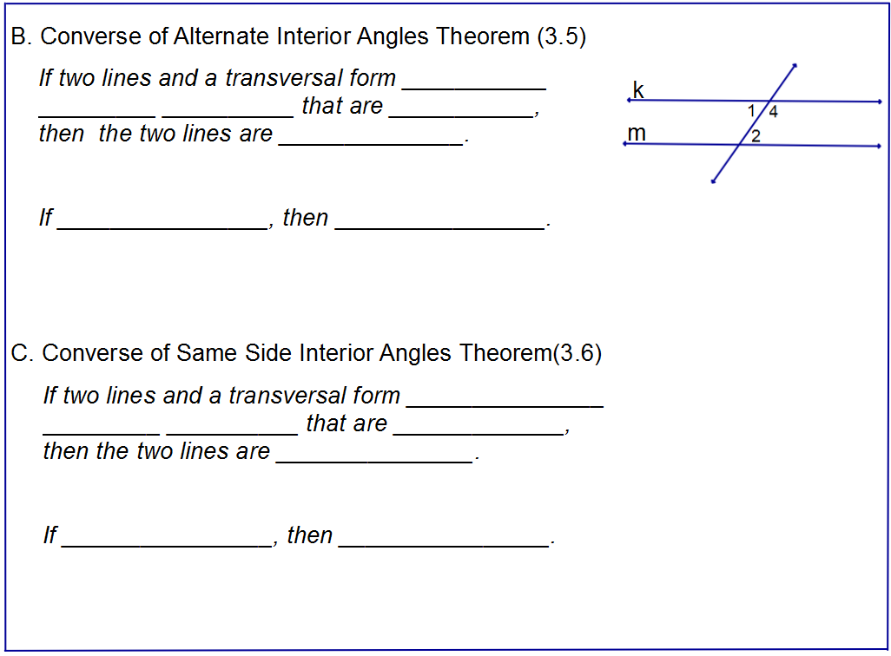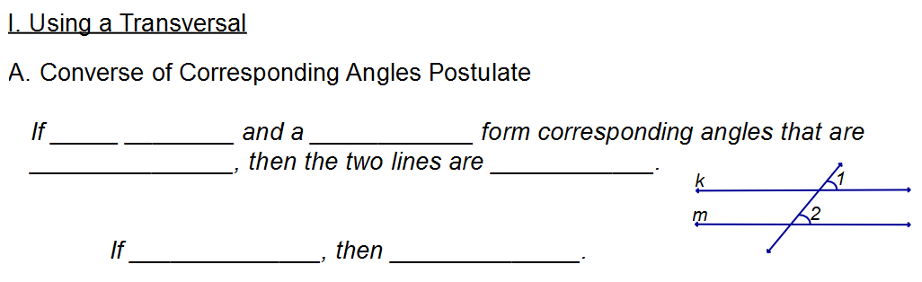

Name___________________________________Hr______

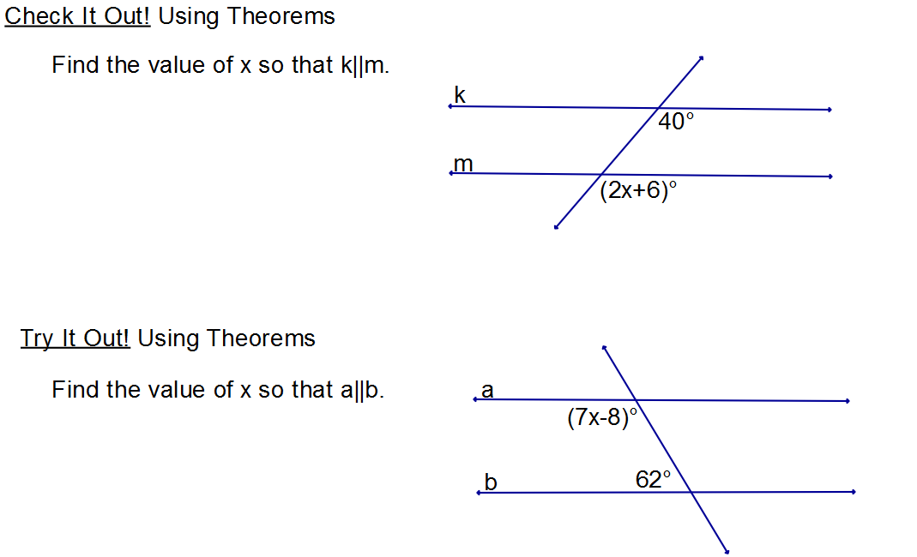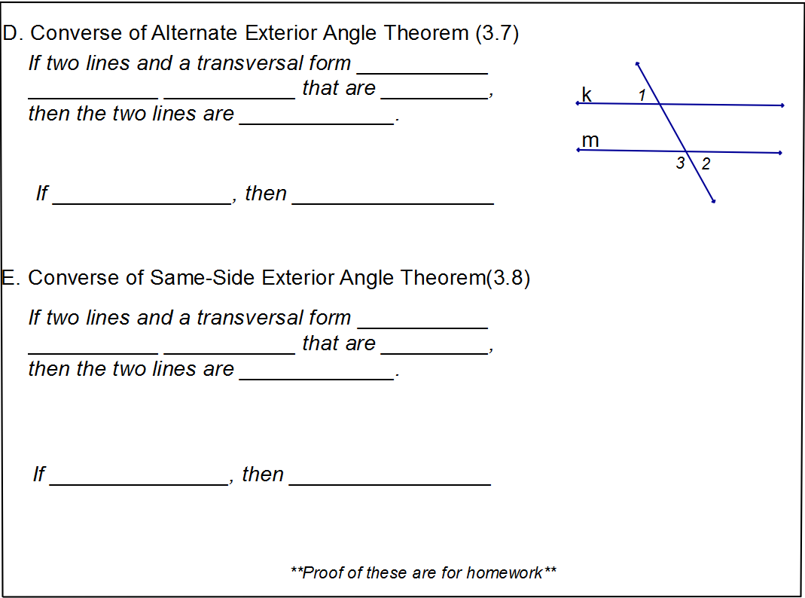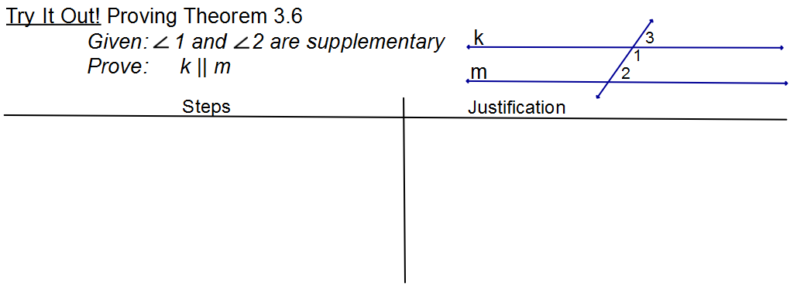

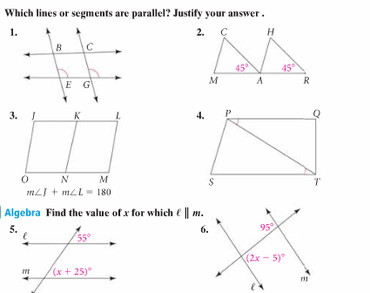

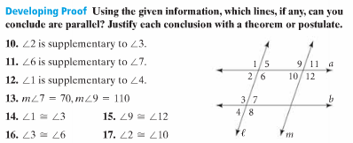

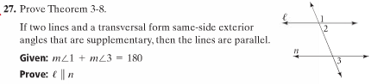

Also prove Theorem 3-7. Identify the given and the prove statements from the theorem in your notes.

Theorem :

Given:

Prove: