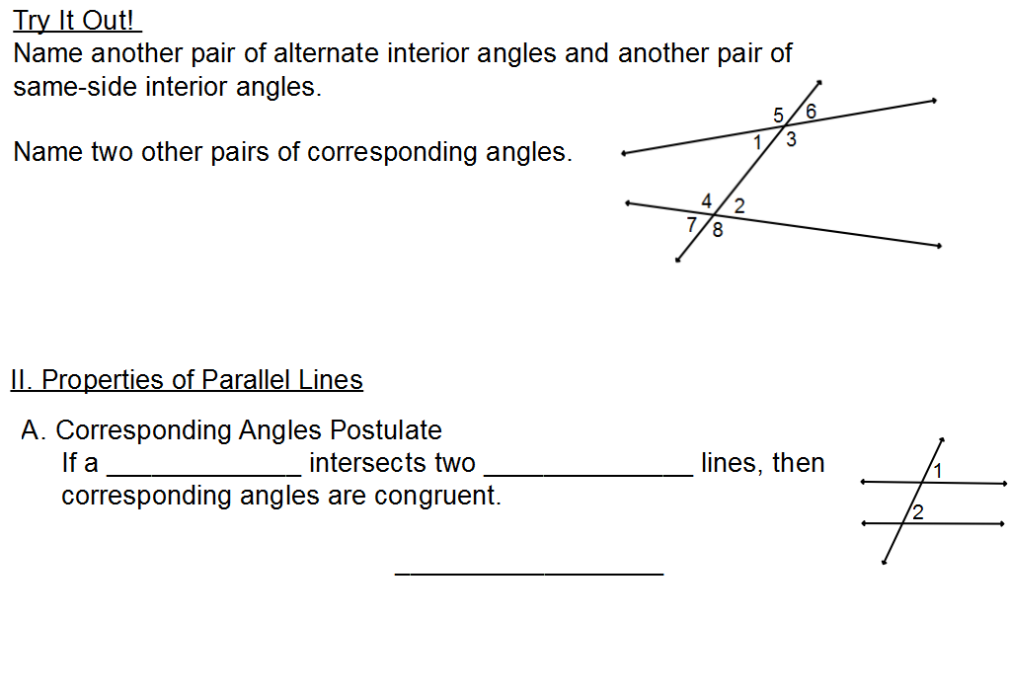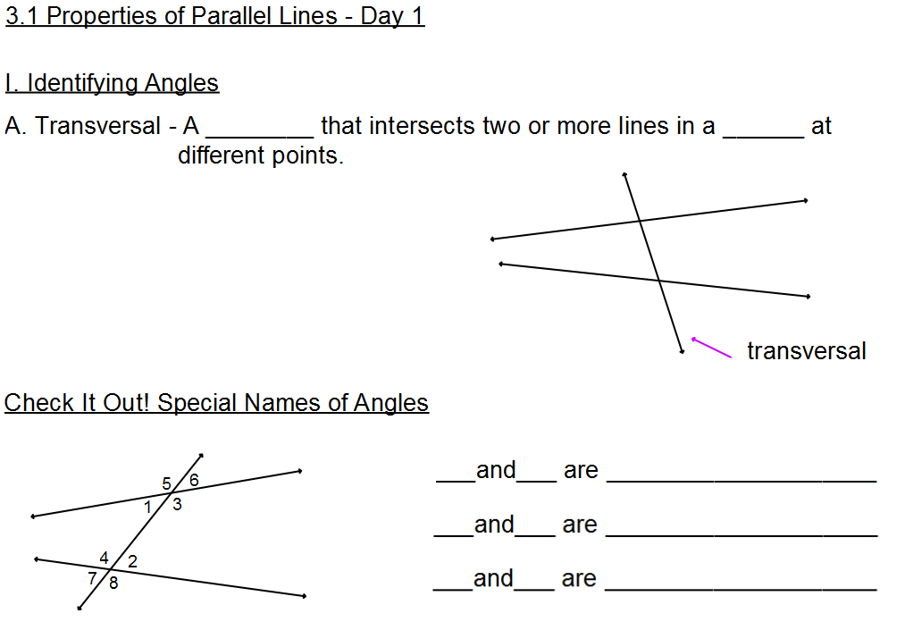

Name_______________________________Hr___________

