Name:________________________________Date:_________________Hour:
Circle Practice.
Directions: Annotate each diagram using the definitions and conjectures from the circle unit and from previous units. Your annotations should include definitions, conjectures, and markings. Show all work.
If m of $∠BAC=46.93 °$ find the m of $∠BGC$.

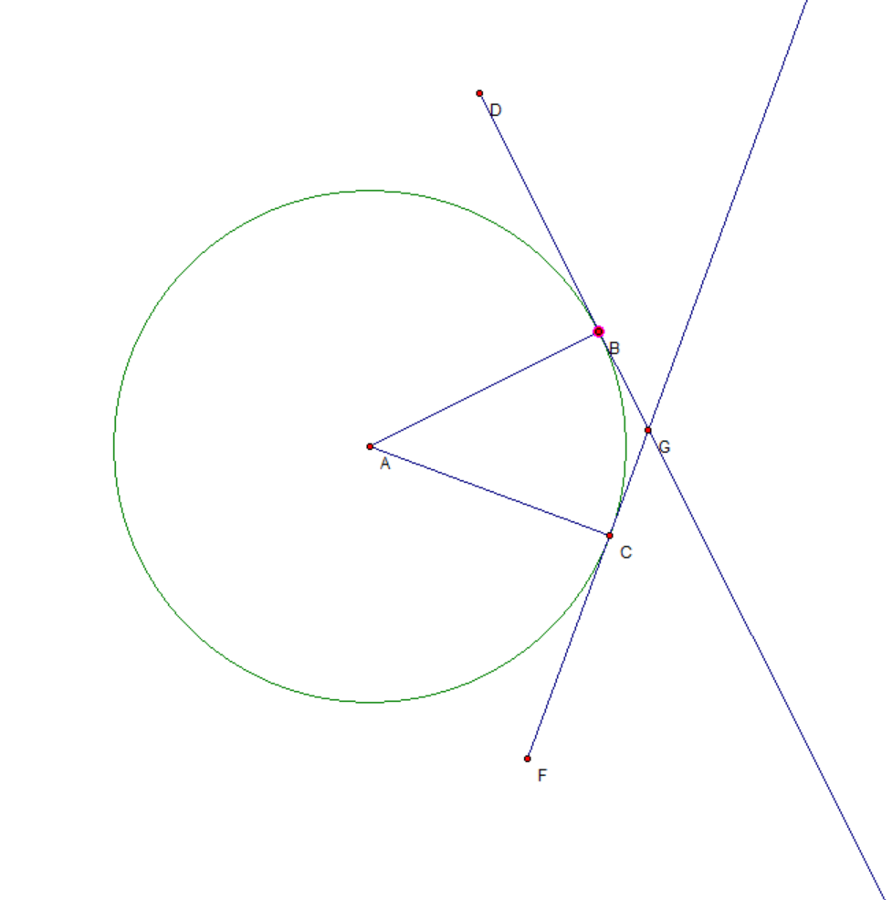

If m of $∠BAC=129.21°$ find the m of $∠BGC$.

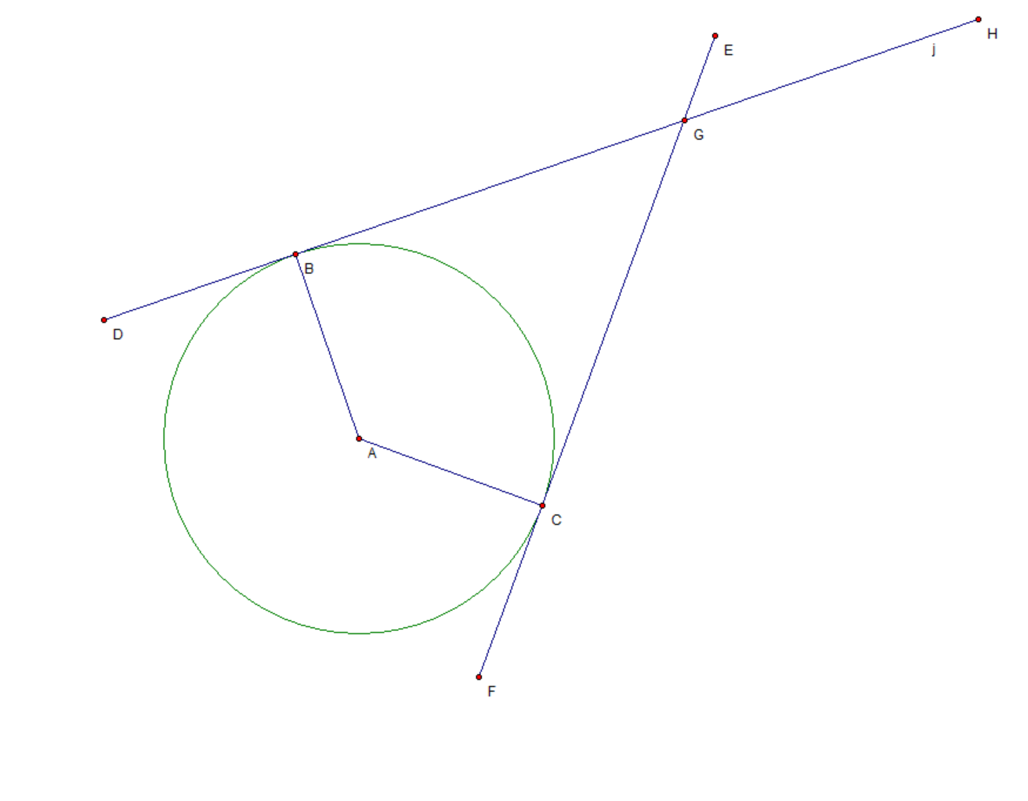

If m of $∠BAC=98.44°$ find the m of $∠BGC$.

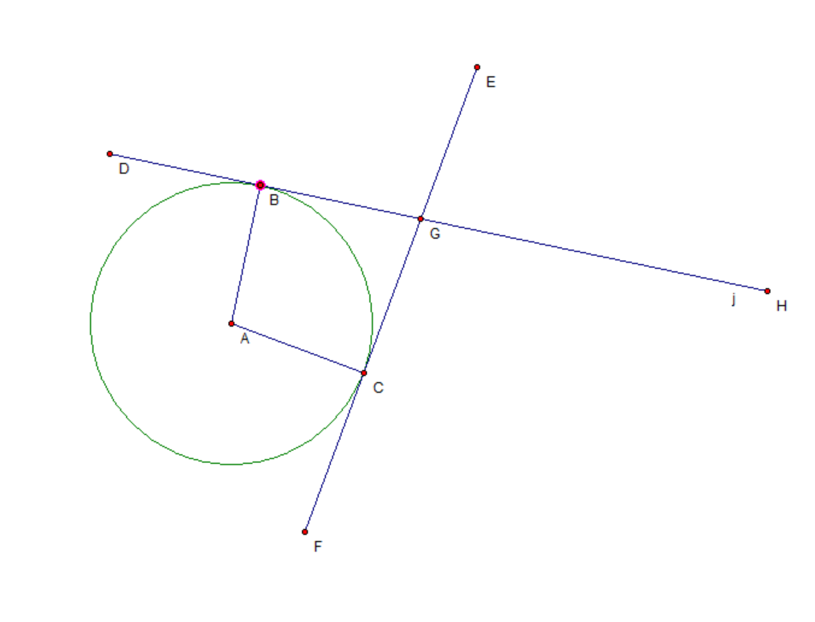

If m of $∠BGC=54.73°$ find the m of $∠GBC$.

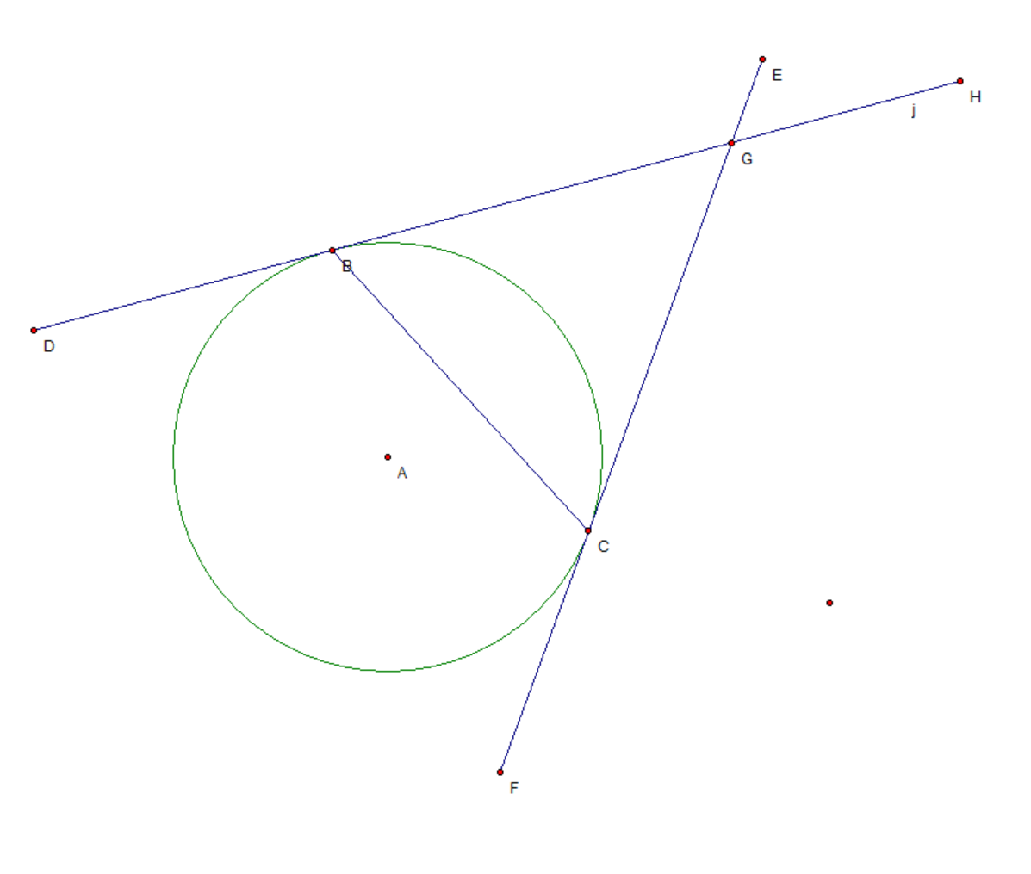

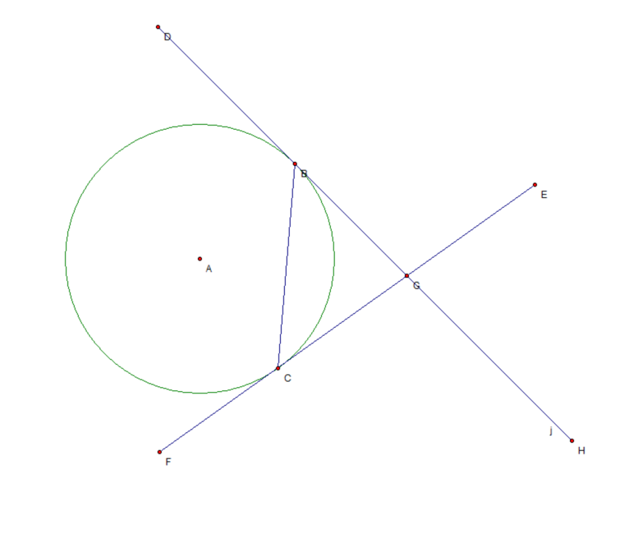
If m of $∠BGC=80.49°$ find the m of $∠GBC$.

If m of $∠BGC=51.05°$ find the m of $∠GBC$.

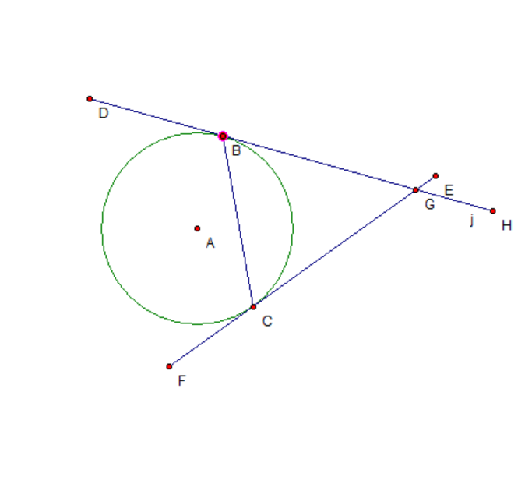

If m of $arc AB=112.71°$ find the m of $∠ABC$.

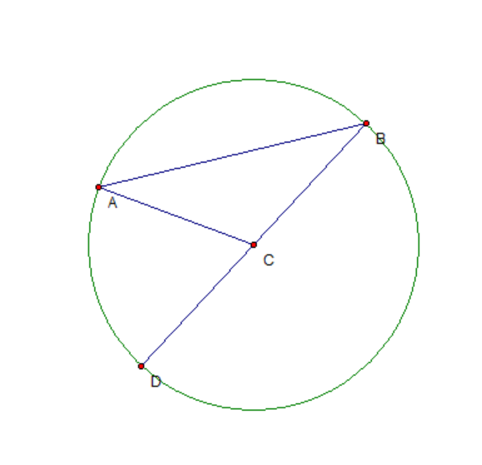
If m of $arc AB=44.71°$ find the m of $∠ABC$.

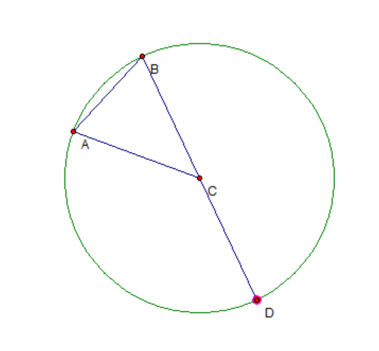

If m of $arc AB=149.1°$ find the m of $∠ABC$.

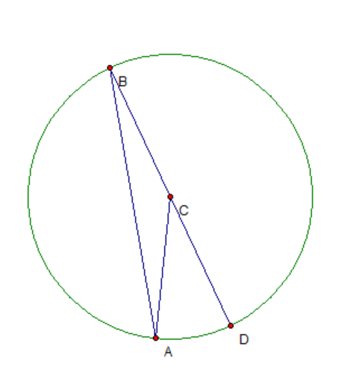

If m of $∠ACD=75.45°$ find the m of $∠ABC$.

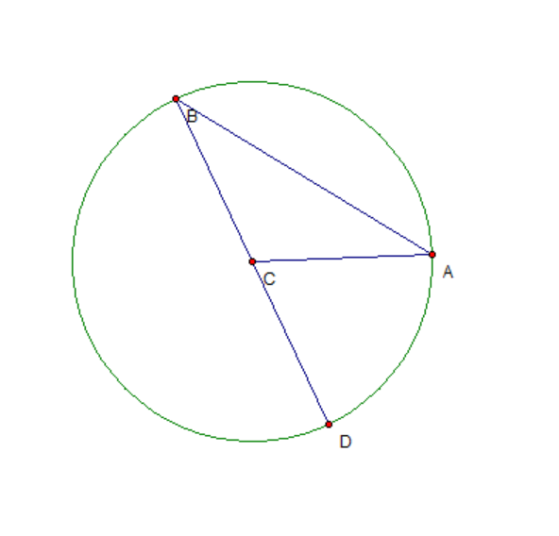

If m of $∠ACD=124.70°$ find the m of $∠ABC$.

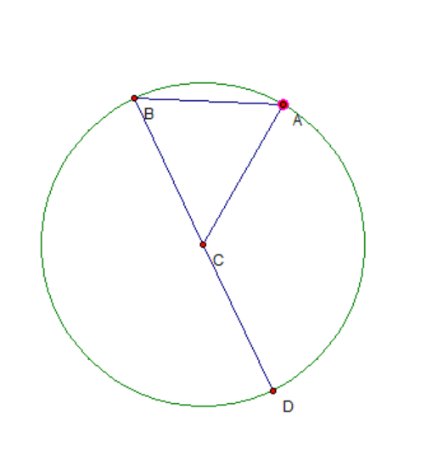
If m of $∠ACD=37.82°$ find the m of $∠ABC$.
