**Exploring Exponential Growth and Decay Functions**

Exponential functions have this general form: $y=ab^{x}$

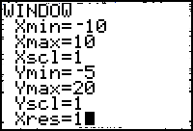You are going to explore a variety of exponential functions and discover how the value of **b** affects the graph. Use a TInspire calculator with the graph window set to the values shown below to answer the following equations.

Graph each following exponential equation and answer a-e. For each graph, you must use at least THREE exact points. (One may be the y-intercept) **Do not change the scale of the graph – they should all be the same for comparison.**

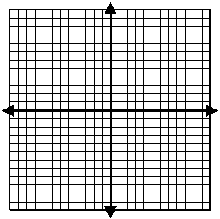**1. y = 2x**

a. y-intercept ________

b. increasing, decreasing or neither (circle one)

c. a = ________ d. b = ________

e. Three points: ____________________________

**2. y = 3x**

a. y-intercept ________

b. increasing, decreasing, or neither (circle one)

c. a = ________ d. b = ________

e. Three points: ____________________________

3**. y = 10x**

a. y-intercept ________

b. increasing, decreasing, or neither (circle one)

c. a = ________ d. b = ________

e. Three points: ____________________________

**4. y =1x**

a. y-intercept ________

b. increasing, decreasing, or neither (circle one)

c. a = ________ d. b = ________

e. Three points: ____________________________

5. y = (1/2)x

a. y-intercept ________

b. increasing, decreasing, or neither (circle one)

c. a = ________ d. b = ________

e. Three points: ____________________________

6. y = (1/3)x

a. y-intercept ________

b. increasing, decreasing, or neither (circle one)

c. a = ________ d. b = ________

e. Three points: ____________________________

7. y = (1/10)x

a. y-intercept ________

b. increasing, decreasing, or neither (circle one)

c. a = ________ d. b = ________

e. Three points: ____________________________

8. What point do these graphs all have in common? __________

9. List the equations that are increasing: __________________________________________________________________

10. List the equations that are decreasing: ________________________________________________________________

11. When an exponential graph is increasing, it shows exponential growth . What are the similarities of all the equations that produce such graphs?

12. When an exponential graph is decreasing, it shows exponential decay. What are the similarities of all the equations that produce such graphs?

13. Are there any graphs that were not reflecting exponential growth or decay? Why?