Name____________________________________________Date_____________________Hour_________

Probability Notes #3

Dependent Events ___________________________________________________________________________________

__________________________________________________________________________________________________

Independent Events _________________________________________________________________________________

_________________________________________________________________________________________________

Example 1) Classify and explain each set of events as dependent or independent:  *Roll a number cube. Then toss a coin.  *Spinning a 4 and then a 4 again on a spinner.  *Selecting two Aces from a deck of cards when the 1st one is not replaced. | Your Turn 1) Classify and explain each set of events as dependent or independent:  *Selecting two Aces from a deck of cards when the 1st card is replaced.  *Flipping a coin twice and it is heads both times.  *Select a marble from a bag that contains marbles of 2 colors. Put the marble aside ands then select another marble.

Probability of A and B given the two events are independent:

__________________________________________________________________________________________________

Example 1) If P(A) = $\frac{3}{4}$ and P(B) = $\frac{1}{3}$ then  P(A and B) = __________________________ | Your Turn 1) If P(A) = $\frac{1}{4}$ and P(B) = $\frac{2}{5}$ then  P(A and B) = __________________________
Example 2) Find the probability of getting a red on the 1st spin and a green on the 2nd spin.  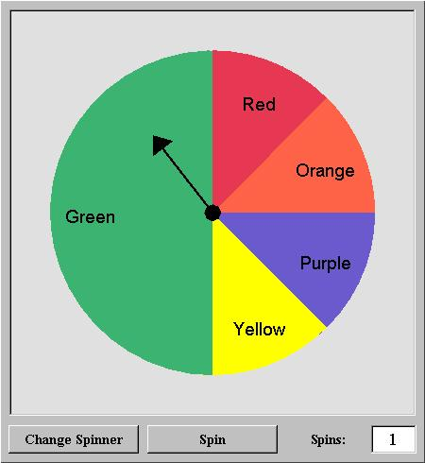 | Your Turn 2) Find the probability of getting a green on the 1st spin and a purple on the 2nd spin.  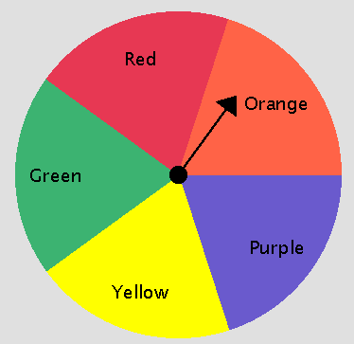
Mutually Exclusive (M.E):____________________________________________________________________________

__________________________________________________________________________________________________

Not Mutually Exclusive (N.M.E): ______________________________________________________________________

_________________________________________________________________________________________________

Probability of A or B

Mutually Exclusive:_________________________________________________________________________________

Not Mutually Exclusive:______________________________________________________________________________

Example 3) A drink company applies one label to each bottle cap: “free drink”, “free meal” or “try again”. A bottle cap has a $\frac{1}{\text{10}}$ probability of being labeled “free drink” , a $\frac{1}{\text{25}}$probability of being labeled “free meal”, and a $\frac{\text{43}}{\text{50}}$ probability of being labeled “try again”.

- Are the events free drink and free meal mutually exclusive and why?___________________________________

b) What is the probability that a bottle cap is labeled free drink or free meal?

Your Turn 3)
.
- Are the events free drink and try again mutually exclusive and why?___________________________________

b) What is the probability that a bottle cap is labeled free drink or free try again?

Example 4) For the set of events state whether they are mutually exclusive and then find the probability.

Rolling a 5 or an odd on a # cube:

Your Turn 4) For the set of events state whether they are mutually exclusive and then find the probability.

Rolling a prime or an odd on a # cube:

