Name_______________________________________________Date_____________________Hour_________
Probability Notes (Real World Connection & Geometric Probability)

Example 1) Fold your hands so your fingers interlace. Do you naturally place your left or right thumb on top? Placing your left thumb on top is a dominant genetic trait.
Suppose a child has parents who both have just one dominant gene. Make a table. Let G represent the dominant gene (left thumb on top) & let g represent the recessive gene (right thumb on top). What is the theoretical probability that a child will naturally place the left thumb on top?

Gene from Mother

Gene from Father

Your Turn 1)
Suppose a child has a father whose gene pair is gg and the mother has Gg. Make a table. What is the theoretical probability that a child will naturally place the left thumb on top?

Gene from Mother

Gene from Father

Example 2) Suppose all the points on the dartboard are equally likely to be hit by a dart you have thrown. Find the probability of scoring at least ten points.
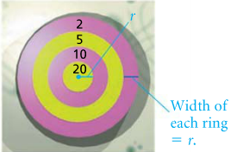
Your Turn 2) Suppose all the points on the dartboard are equally likely to be hit by a dart you have thrown. Find the probability of scoring five points.
Assignment: Answer the following questions. Box up your answer. Make sure work is neat.
1) Find the sample space and the theoretical probability that a child will naturally place the left thumb on top if the father has the gene pair gg and the mother has GG.
Gene from Mother

Gene from Father

2) Suppose that a dart lands at random on the dartboard. Find the theoretical probability of if the dart lands in the bull’s-eye. | Use dartboard to answer #2-4  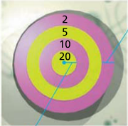
3) Suppose that a dart lands at random on the dartboard. Find the theoretical probability of if the dart lands in the lighter-shaded region. | 4) Suppose that a dart lands at random on the dartboard. Find the theoretical probability of if the dart scores less than 20 points.
For #5-6) In a class of 147 students, 95 are taking math (M), 73 are taking science (S), and 52 are taking both math and science. One student is picked at random.
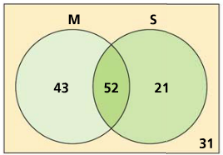
5) Find P(taking math or science or both) | 6) P(not taking math)

