***Directions:*** *Determine the end behavior and x-intercepts of each function. Then sketch a rough graph.* ***Check your work with a calculator.***

1. 2. 3.

Degree: ______ Degree: ______ Degree: ______

End behavior: (even/odd, +/–) End behavior: End behavior:

x-intercepts: ________________________ x-intercepts: _______________________ x-intercepts: _______________________

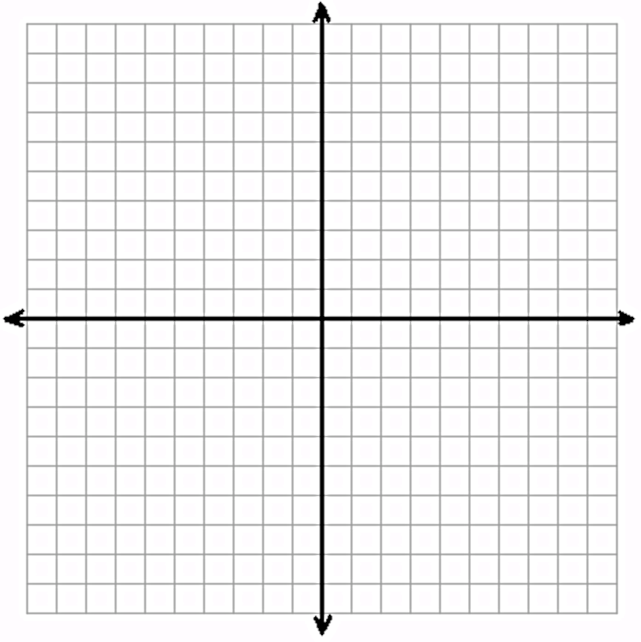  

4. 5. 6.

Degree: ______ Degree: ______ Degree: ______

End behavior: End behavior: End behavior:

x-intercepts: ________________________ x-intercepts: _______________________ x-intercepts: _______________________

  

7. 7b. In **2-3 sentences**, explain how you created the graph in #7.

Degree: ______

End behavior:

x-intercepts: ________________________



8. 8b. What do you notice about graphing this equation that is different from the others below?

Degree: ______ How do you think you could make this graph work? Use a graphing calculator to check your idea.

End behavior:

x-intercepts: ________________________

