**Lichocki Article of the Week #7 Week of 1/8-1/12**

**Study Finds Kids Must Take 112 Tests by 12th Grade; Obama Looks for Limits**

**By Jennifer C. Kerr & Josh Lederman, Associated Press 10.29.15**

WASHINGTON, D.C. — Students, parents and teachers have complained about the number of hours that kids spend taking standardized tests, especially since the introduction of the Common Core academic standards. But just how much time each year is it?

A. Between 10 and 15 hours.

B. Between 20 and 25 hours.

C. Between 30 and 35 hours.

The correct answer is "B," according to a comprehensive study of 66 of the nation's big-city school districts by the Council of the Great City Schools. It said that the average public school eighth-grader spends about 2.3 percent of classroom time on testing. Between pre-K and 12th grade, students took about 112 standardized exams, which were required by the federal government, state or local district.

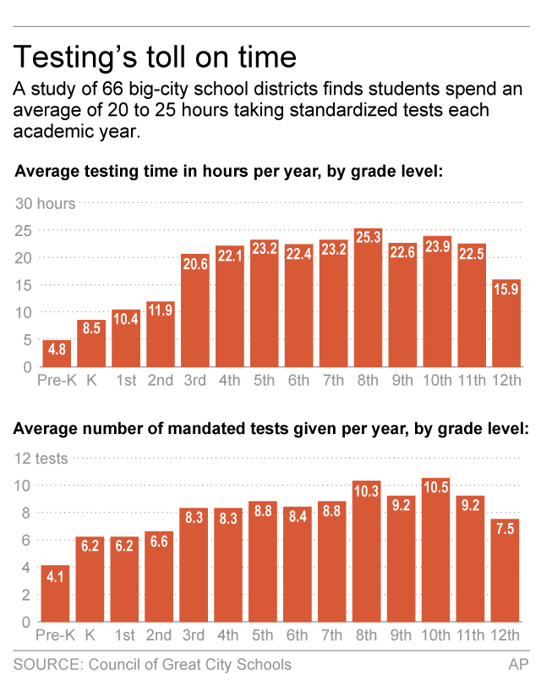

The study analyzed the time spent actually taking the tests, but it did not include the hours devoted to preparation ahead of the tests. It also did not include regular day-to-day classroom quizzes and tests in subjects such as reading, math, science and foreign languages.

**President Says 2 Percent of School Time Is Enough**

In connection with the study's release Saturday, President Barack Obama called for limiting standardized testing to 2 percent of classroom time. He acknowledged that the government shares some responsibility for an overemphasis on testing. The president went on to say that federal officials would work with states, schools and teachers to "make sure that we're not obsessing about testing." The Obama administration still supports annual standardized tests to determine how schools are performing. Also, an update to the No Child Left Behind law is being discussed in Congress and would continue the testing. The 2002 law was intended to close educational gaps between rich and poor districts. It required yearly testing in reading and math for students in grades 3 through 8 to make sure that children were learning what they were supposed to learn. The rewritten legislation would let states decide how to use test results to determine what to do with struggling schools. Congress still needs to discuss some parts of the legislation before taking a vote on it.

**More Than "Filling in the Right Bubble"**

"Learning is about so much more than just filling in the right bubble," Obama said in a video released on Facebook. "So we're going to work with states, school districts, teachers, and parents to make sure that we're not obsessing about testing." To drive the point home, Obama and Education Secretary Arne Duncan are meeting Monday with teachers and school officials working to reduce testing time. How much testing is too much is hard to answer, said Michael Casserly, the council's executive director. He said the study found plenty of repetition in required testing — supporting concerns from teachers and other critics about the tests taking up too much teaching and learning time. For example, Casserly said that some states and school districts required not only end-of-year tests, but also end-of-course tests in the same subjects, in the same grades.

**Some Tests Seen As "Unnecessary"**

Casserly said that states and school districts should jointly review their testing requirements, which "will be an important step in reducing unnecessary assessments." The council reviewed testing for more than 7 million students in about three dozen states during the 2014-15 school year. A "testing action plan" released by the Education Department over the weekend said too many schools have unnecessary testing. The department pledged to work with states and schools on ways to reduce time spent on testing. The federal government is expected to give guidance to the states in January. The plan also said the agency has adjusted its policies to let states have more of a say in how much weight to give student test results in evaluating teachers. Educators around the country have protested that it is not fair to grade their performance based on the test results. In some areas, teacher pay raises depend in part on how well their classes do on the tests.

**12 Million Take New Common Core Exams**

This past spring saw new tests based on the Common Core college-ready academic standards in reading and math. The standards, which have been adopted by most states, outline what a child should know and be able to do in each grade. About 12 million students in 29 states and the District of Columbia took the new tests. They were developed by two groups — the Smarter Balanced Assessment Consortium and the Partnership for Assessment of Readiness for College and Careers (PARCC). The council also found that the most tests were required in 8th and 10th grades; the fewest were in pre-K, kindergarten and first grade. Also, 4 in 10 districts reported having to wait between two and four months before getting state test results. The lack of timely results meant that teachers began the new school year without knowing if a student was having a problem.