Former Secretary of State Hillary Rodham Clinton, left, poses with her daughter Chelsea at a Clinton Global Initiative America event in Chicago.
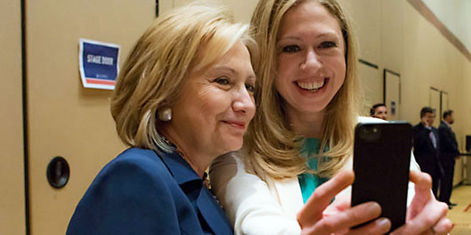

“Selfie” is the Word of the Year”
Associated Press

Michelle Obama shared one with her "first dog" Bo. Hillary Clinton tweeted one with her daughter Chelsea. Now "selfie" — the smartphone self-portrait — has been declared word of the year for 2013, according to Britain's Oxford University Press.
The publisher of the Oxford dictionaries said Tuesday that "selfie" saw a huge jump in usage in the past year. It burst from the confines of Instagram and Twitter to become mainstream shorthand for any self-taken photograph.
Researchers behind the renowned dictionaries pick a prominent word or expression in the English language each year that best reflects the mood of the times. Previous words of the year have included "unfriend" in 2009, "credit crunch" in 2008, "carbon footprint" in 2007 and "Sudoku" in 2005.
Judy Pearsall, the editorial director for Oxford Dictionaries, said "selfie" appeared to have been first used in 2002 on an Australian online forum. The hashtag #selfie appeared on the photo-sharing website Flickr in 2004.
"But usage wasn't widespread until around 2012, when 'selfie' was being used commonly in mainstream media," she said.
Australian English sometimes uses the suffix "-ie" — such as barbie for barbeque and tinnie for a can of beer — which helps to explain where "selfie" may have come from, Pearsall added.
Oxford usually assigns a separate word of the year to the U.S. and to the U.K. It said "selfie" captured the imagination on both sides of the Atlantic this year.
Also making the shortlist was "binge-watch." This is a verb that describes watching many episodes of a TV show in rapid succession.
The words were chosen by a research program that monitors online content and collects around 150 million words of English in use.
"Selfie" was added to the online version of the Oxford dictionary in August. It is being considered for future inclusion in the more traditional Oxford English Dictionary.
- Posted on November 19, 2013 Teen Tribune

