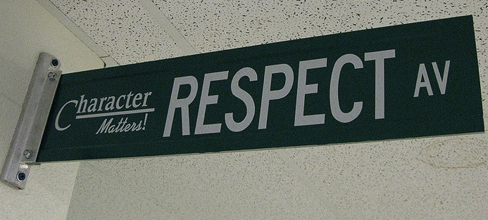

Welcome to 8th grade Language Arts!! The goal for the year is to continue developing your reading and writing. we believe in you and your ability to do so, How do we know so, because you are here.

Here is where you will read engaging, thought-provoking texts and novels you won’t want to put down. Here you will build your skills as a writer and communicator. Here your vocabulary and grammar will grow. How do we know, because you will set goals for yourself, push yourself and be accountable for yourself.

You will work hard, struggle, triumph and see the results of your efforts. We look forward to being here with you!!!

.

## Homecourt

Meeting classroom expectations and behaving appropriately in class helps to create a learning environment where you and your classmates feel welcome, safe, and respected. Home court allows us to do that.

This is OUR TEAM, OUR CLASSROOM and OUR “HOMECOURT”. We are here to cheer and help each other be successful. Together we will share victories and when roadblocks arise we will work together to overcome them. That’s what Bryant Eagles do. Together we will soar!

Eagle etiquettes and contact home can be earned for exhibiting positive behaviors. Behaviors that keep us or others from reaching their potential behaviors can earn detention and contact home.

# Course Description

#### Be kind & be respectful.

### Class Expectations

#### Follow directions the first time they are given.

#### Raise your hand and wait to be called on before speaking.

All school rules also apply.

#### Ask permission to leave your seat.

#### Be on time & be prepared.

8th Grade Language Arts

**YOU WILL NEED:**

* A composition book for SSR
* Writing utensils (pens or pencils)
* A set of colored highlighters
* Sticky Notes 3X3
* A 1 ½ inch binder or accordion portfolio
* Paper
* A positive attitude, a sense of humor, & an open mind

DUE BY: Tuesday 9/4

## Communications

* **Blog** gives the outline of what we are doing in class each week.
* **Mi-Star** provides grades and allows monitoring of your progress. Be sure to check weekly so adjustments can be made
* **Google Classroom** contains some assignments and reminders
* **Gmail-** best way to communicate when not in class



Retake Policy: You may retake a summative assessment one time, when you meet the following requirements:

* You did the assessment and all assignments leading up to it and received a grade lower than 69%.
* You meet with me to before or after school to request a retake and discuss your original score.
* You schedule and take your retake within 1 week of the return of the assessment.

Bryant Grading Scale:

A+ = 100% C+ = 79-78%

A = 99-93% C+ = 77-73%

A- =-92-90% C- = 72-70

B+ = 89-88% D+ = 69-68%

B = 87-83% D = 67-63%

B- = 82-80% D- = 62-60%

E = 59% and below

**Entering Class:** Gather any necessary materials, quickly find your seat, and begin working on the warm-up posted on the board before the bell rings. Then read the book you brought to class or the day’s assigned reading.

**During Class:** Do your best and allow your classmates to do their best. Encourage and have empathy for each other.

**Food & Electronic Devices:** Food and drink are not permitted outside of the cafeteria for sanitary reasons. Electronics should not be seen or heard in the classroom.

**Exiting Class:** In the last five minutes of class, you will wrap up what you are working on, return materials to the appropriate locations, and complete an exit ticket which will be handed in on your way out the door. The teacher, not the bell, dismisses you upon completion of these tasks.

**Grades**: **Grades are a direct reflection of where you are at in the learning process**. Each piece of graded work will receive points and is weighted according to the type of work**. 80% of your grade is summative** (they are the assessment of skills in formats of tests, quizzes, projects, formal papers and presentations) **20% of your grade is formative** (they are the practice of skills in homework and classwork

**Late work:** Is any work that is turned in after it is expected. For example, homework is due when you walk in the door. Any work turned in after it is due will receive ½ credit. Late work is not accepted the last week of the cardmaking and will be graded when I get to it. I encourage you to do it as zeros can significantly impact your grade. Late assessments (formal papers/presentations, etc) will receive 1 grade lower for each day late. Test and quizzes are not taken late.

**Absences:** If you are absent, it is your responsibility to get and makeup up missed assignments. See the “While You Were Out Binder” for handouts and check the blog. You have 1 day for each day you were out.

## Classroom Policies, Procedures, & Grading