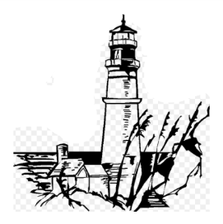Unit One Study Guide

Name:

Class: Date:

For questions 1-6, be prepared to offer examples from the stories we read in this unit.

You need to know the stories, and the concepts we learned.

The stories in this unit were:

“Shells”, “The Dinner Party”, “Seventh Grade”, “Breaking the Ice”, “Dirk the Protector”,

and “Names/Nombres”.

1. What are the three elements of a narrative story?
2. What are the five parts of plot?
3. What is the visual model used for explaining plot? How does it work?
4. What is internal conflict? What is external conflict?
5. What is inference? Give an example of an inference you could make from a story we read.
6. What is a double bubble? What is a Brace map? What is argumentative writing?
7. What is a proponent?
8. What is an opponent?
9. What is a counterargument?
10. What are the rules for writing numbers according to the MLA format?
11. Be prepared to write a one-paragraph summary of one of the stories. What five things must be included in a full-credit summary?