**Building Background**

**Directions:** *Use this sheet to take notes from the “Building Background” PowerPoint slides on Day 1 of the investigation.*

|  |
| --- |
| **1. Hammurabi: Who, Where, & When** |
| * Who was King Hammurabi? List 1-2 facts about him. * What is the relationship between Babylon & Mesopotamia? Where were they located? * When did Hammurabi rule Babylon? |

|  |
| --- |
| **2. Video: The Law Code Stele of King Hammurabi** |
| * What is a stele? Describe what the Law Code Stele looks like. * List the three parts of the Law Code Stele * Who are the two figures carved into the top of the stele? * What are the laws about? List some topics. |

|  |
| --- |
| **3. Religious & Social Beliefs in Mesopotamia** |
| * The people of Mesopotamia believed in __________ different gods. Some examples are: * What were the three social classes in Mesopotamia? |

**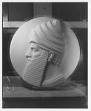*Laws of Hammurabi* (Source 1)**



…people… relationships…?

*Headnote: The Laws of Hammurabi are Babylonian laws from ancient Mesopotamia. They are carved on a tall, black stone monument and were created around 1750 B.C.E. Hammurabi was the sixth ruler of the First Dynasty of Babylon. As King, he expanded the Babylonian empire and organized a government and military. The Laws include an introduction (or, prologue), around 275 laws, and a conclusion (or, epilogue). A few of the laws are listed below.*

**Prologue**

…at that time, the gods Anu and Enlil, for the well-being of the people, named me by my name: Hammurabi, the holy prince, who respects the gods, to make justice triumph in the land, to stop the wicked and the evil, to prevent the strong from oppressing the weak, to rise like sun-god Shamash over all humankind, to illuminate the land.

**Laws**

**1.** If a man accuses another man and charges him with murder but cannot bring proof against him, his accuser shall be killed.

**25.** If a slave woman curses someone acting with the authority of her mistress, they shall scrub her mouth with one sila (~1 liter) of salt.

**55.** If a man opens an irrigation gate and releases waters and allows the water to carry away whatever work has been done in his neighbor’s field, he shall measure and deliver 3,000 silas of grain per 18 ikus (acres).

**195.** If a child should strike his father, they shall cut off his hand.

**196.** If an *awilu* (nobleman) should blind the eye of another *awilu*, they shall blind his eye.

**198.** If he should blind the eye of a commoner or break the bone of a commoner, he shall weigh and deliver 60 shekels of silver.

**Epilogue**

…Let any wronged man who has a lawsuit come before the statue of me, the king of justice, and let him have my laws read aloud to him. Thus may he hear my precious pronouncements and let my laws reveal the lawsuit for him; may he examine his case, may he calm his troubled heart, and may he praise me…

***Attribution:*** *Adapted excerpt from the* Laws of Hammurabi*, created around 1750 B.C.E. in Babylon. Translated in 1995 by Dr. Martha Roth, Professor of Near Eastern Languages & Civilizations at the University of Chicago. From her book,* Law Collections from Mesopotamia and Asia Minor*, pp. 72-142.*

**AFTER YOU READ*…***

**(1) How reliable is this source for understanding what was important to King Hammurabi?**

***Reliable –***

***Unreliable –***

**(2) What do Hammurabi’s Laws help you understand about what was important to him? ______________________________________________________________________________**

**______________________________________________________________________________**

**(3) Box the parts of the source that help you think about the central question.**

*****Hammurabi Steles* (Source 2)**

*Headnote: There were several texts about Hammurabi carved on stone steles and set up in cities around Mesopotamia. These talked about Hammurabi as a warrior and conqueror.*

1. Hammurabi, king, mighty warrior, exterminator of enemies, flood of battles, destroyer of enemy lands, who puts an end to wars, who resolves disputes, who destroys soldiers like figurines of clay.

2. I am the hero among heroes, the furious one among the proud, perfect in youth and heroism. I beat down with my mighty weapon the land that does not submit to [the god] Marduk.

3. I am the great dragon among kings…, I am the net that is stretched over the enemy, I am the fear-inspiring, who, when lifting his fierce eyes, gives the disobedient the death sentence, I am the great net that covers evil intent, I am the young lion, who breaks necks and scepters, I am the battle net that catches him who offends me.

*Attribution: Steles in Sippar and Ur and a hymn from Hammurabi, reported in the chapter “Hammurabi’s legacy” in* King Hammurabi of Babylon: A Biography *written by Marc van de Mieroop in 2005.*

**AFTER YOU READ*…***

**(1) How reliable is this source for understanding what was important to King Hammurabi?**

***Reliable –***

***Unreliable –***

**(2) What do other Hammurabi steles help you understand about what was important to Hammurabi? ______________________________________________________________________________**

**______________________________________________________________________________**

**(3) Box the parts of the source that help you think about the central question.**

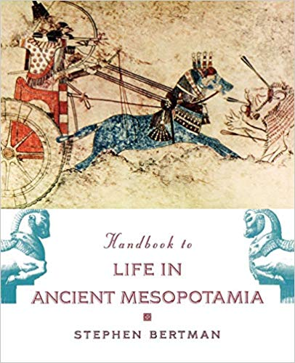***Handbook to Life in Ancient Mesopotamia* (Source 3)**

*Headnote: The Handbook to Life in Ancient Mesopotamia brings together geography and archaeology to tell the story of ancient civilizations between 3500 and 500 B.C.E. The author, Stephen Bertman, was a professor at the University of Windsor and his work focused on world literatures, world cultures and ancient civilizations.*

In the Code of Hammurabi, penalties were assessed based on one’s social class: the same act committed against a member of a lower class resulted in a lighter punishment; but against a member of a higher class, a heavier one. The penalty system reinforced the social order.

But the fines the rich paid were higher than the fines the poor paid. Mesopotamia law also encouraged quality work by severely punishing professional incompetence. A boatman whose negligence sank a boat was responsible for the cost of the boat and its entire cargo… And if a building collapsed and its owner died, the builder had to pay with his life.

*Attribution: Excerpt modified from* Handbook to Life in Ancient Mesopotamia, *written by Stephen Bertman in 2003.*

**AFTER YOU READ*…***

**(1) How reliable is this source for understanding what was important to King Hammurabi?**

***Reliable –***

***Unreliable –***

**(2) What does Bertman’s handbook help you understand about what was important to Hammurabi? ______________________________________________________________________________**

**______________________________________________________________________________**

**(3) Box the parts of the source that help you think about the central question.**

*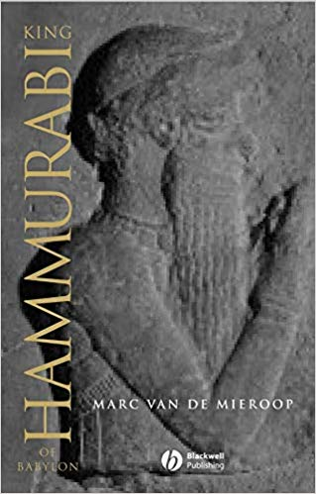****Hammurabi’s biography* (Source 4)**

*Headnote: Marc van de Mieroop is a professor of history at Columbia University with a PhD in history from Yale. He specializes in ancient Near East history and his recent work focuses specifically on the history of ancient Babylon. Van de Mieroop says that it is difficult to write a biography about Hammurabi because he lived thirty-eight centuries ago and there is a lot of basic information missing about his life.*

In the epilogue the king explains the intended use of the stela. He had two audiences in mind: the people of his own time and future kings… Hammurabi guaranteed that his country was correctly ruled. He protected the weak from abuse by the powerful, he sheltered the widow and the orphan, and his stela announced that to all. The second audience of the stela which was explicitly acknowledged was the future king. To him, Hammurabi says: “Forever in the future may a king who rules this land see the words of justice I wrote on my stela.”… Hammurabi was the King of Justice, a title he uses repeatedly in his epilogue. He was the shining example in this respect for all future generations, and he proclaimed his own greatness on his stela. That is why several copies of the stela were most likely erected in various cities.

*Attribution: Excerpt from* King Hammurabi of Babylon: A Biography*, written by Marc van de Mieroop in 2005.*

**AFTER YOU READ*…***

**(1) How reliable is this source for understanding what was important to King Hammurabi?**

***Reliable –***

***Unreliable –***

**(2) What does van de Mieroop’s biography of Hammurabi help you understand about what was important to Hammurabi? ______________________________________________________________________________**

**______________________________________________________________________________**

**(3) Box the parts of the source that help you think about the central question.**

**Your Writing Assignment: Email to the Louvre Museum**

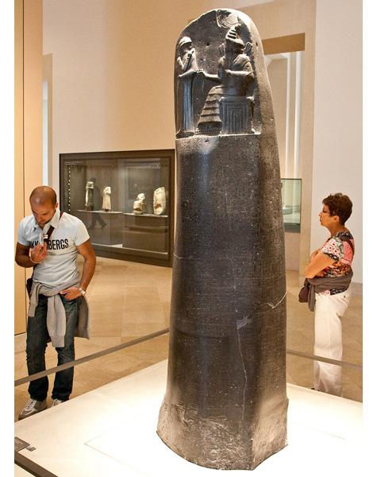Background: Hammurabi’s Laws are on permanent display at the **Louvre Museum** in Paris, France. The museum curators have written information about the Laws that [viewers can read when they visit the exhibit.](http://www.louvre.fr/en/oeuvre-notices/law-code-hammurabi-king-babylon)

However, the curators want to add a new section to their exhibit that explains what was important to King Hammurabi using various sources as evidence.

Your Task: Read the argument the museum makes about **what was important to Hammurabi.** In an email, critique any problems you see with the argument. Include evidence and reasoning in your critique.

**LOUVRE ARGUMENT**

Fairness was important to King Hammurabi, the ruler of ancient Babylon. For example, one of his laws is “If a child should strike his father, they shall cut off his hand.” This shows that Hammurabi wanted his punishments to be equal to the crime. This is reliable because these are Hammurabi’s own words.

Also, in other steles about Hammurabi, it says he “resolves disputes.” This shows that he cares about judging crimes fairly. We can also trust this source because it was displayed in cities all over Mesopotamia, so it must be true.

**MENTOR TEXT:**

**Sample Email to the Louvre**

**Another argument from the Louvre**

One thing that was important to Hammurabi was family. We know this because he has laws about parents and children. For example, in Hammurabi’s biography from Marc van de Mieroop, he says Hammurabi “sheltered the widow and the orphan.” This shows that he wanted to protect children. Van de Mieroop is a reliable source because he specializes in ancient history.

***Mark the CLAIM, EVIDENCE, and REASONING in this email:***

Dear Louvre,

You should not include the argument that family was important to Hammurabi in your exhibit. One problem with the argument is the evidence you use about parents and children. You use the example with the widow and orphan, but one of Hammurabi’s laws is “if a child should strike his father, they shall cut off his hand.” This does not show someone who cares about children. This evidence is reliable because it is in Hammurabi’s own words from his laws.

Therefore, you should use a different claim about what was important to Hammurabi.

Sincerely,

Babs Ylon

**Planning Graphic Organizer**

Guidelines: Your email is a critique of the Louvre’s argument. It should have a Claim, Evidence to support the claim, and your Reasoning about how the evidence supports the claim. Before you begin writing, think about the sources and decide which parts of the sources help explain what was important to King Hammurabi in 1750 B.C.E.

Take brief notes to plan your writing below. Use the useful language chart to help you turn your notes into sentences in your critique.

|  |
| --- |
| **Claim**  Does the Louvre have a strong argument for what was important to Hammurabi? |
|  |

|  |
| --- |
| **Sub-Claim #1**  What is one problem with the argument you want to raise to support your claim? |
|  |
| **Evidence #1**  What information from the source(s) supports your claim? |
|  |
| **Reasoning #1**  Explain how the evidence supports your claim. Also, why might the argument not be reliable? |
|  |

**USEFUL LANGUAGE for writing your critique:**

**Making a claim:**

*You should not use the argument that fairness was important to Hammurabi because…*

*There are problems with your argument because…*

*There are problems with the claim/evidence/reasoning in your argument.*

**Writing a sub-claim:**

*One problem with your argument is…*

*The argument says…, but… (why that is a problem as evidence/for reliability)*

*In the argument you say “…” even though… (why that’s a problem as evidence/for reliability*

**Providing evidence:**

*Hammurabi's Law X, for example, says that "...."*

*For example, the biography of Hammurabi says “…..”*

*Another example is that Hammurabi’s Laws X and X both refer to “…”*

*The headnote tells me that “….”*

**Reasoning:**

*This means that …..*

*This makes me think that …..*

*This shows that …*

*The source might not be reliable because….*

**REFLECTION GUIDE**

|  |  |  |  |  |  |
| --- | --- | --- | --- | --- | --- |
| **GOALS** | |  |  |  | **THINGS YOU MIGHT BE GOOD AT OR NEED TO WORK ON…** |
| **DONE?**  **(✓)** | **I AM GOOD AT…** | **I AM WORKING ON…** |
| **CLAIM** | I wrote a **claim** that states a critique. |  |  |  | - The claim states a critique.  - The claim focuses on problems with the Louvre’s argument.  - The claim makes sense given the evidence. |
| **EVIDENCE** | I included information from the source(s) as **evidence** to support my claim (e.g., from the headnote or attribution). |  |  |  | - The evidence relates to my claim.  - The evidence is persuasive.  - The evidence is specific.  - The evidence is accurate. |
| I included a quotation from a text as **evidence** to support my claim. |  |  |  | - I include quotation marks around the quotation.  - I say where the quotation comes from (author/date).  - The quotation helps someone understand my claim. |
| **REASONING** | I shared my **reasoning** to explain how or why my evidence supports the claim or to explain how reliable the source(s) are. |  |  |  | - I say what the evidence tells us.  - I explain why the evidence is reliable or unreliable.  - I explain how the evidence supports my claim. |