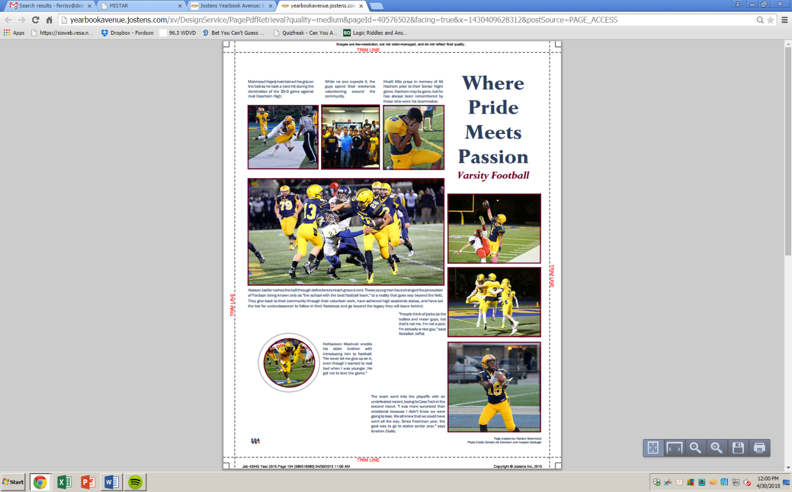

Platinum

- $275

- Name on yearbook staff t-shirts

- Name on 4’ x 12’ banner hung at all major sporting and school events

- Page Sponsor (you select the page you would like to sponsor-first come, first served)

- Business name & contact information featured in business index

- Certificate of appreciation

Gold

- $175

- Name on 4’ x 12’ banner hung at all major sporting and school events

- Page Sponsor

- Business name & contact information featured in business index

- Certificate of appreciation

Silver

- $100

- Page Sponsor

- Business name & contact information featured in business index

- Certificate of appreciation

Bronze

- $75

- Business name & contact information featured in business index

- Certificate of appreciation

Page Sponsorship Example:

Ms. Monica Kubitz, Yearbook Adviser

Fordson High School

13800 Ford Rd.

Dearborn, MI 48126

313.827.7350

kubitzm@dearbornschools.org

Benefits:

- Year-round exposure instead of being buried in the back of the yearbook.

- Increased business exposure throughout FHS and the community.

- Allows for the yearbook to be less expensive for students.

Did you know…

- We sell sponsorships to keep the cost of our 175+ page yearbook reasonable for our students.

Sponsor a book for a child in need!

- $70

- Yearbooks can be expensive, but every student deserves one at least once in their high school career.

Page Sponsored by: (business name here)

Fordson High School *Fleur de Lis* Yearbook

**Business Sponsorships**

Order Form and Contract

*Please make checks payable to Fordson High School*

Mail/e-mail or deliver to:

Ms. Monica Kubitz, Yearbook Adviser

Fordson High School

13800 Ford Rd.

Dearborn, MI 48126

[kubitzm@dearbornschools.org](mailto:kubitzm@dearbornschools.org)

**Customer Data (please print clearly)**

**__________________________________________________________________________________________________**

Business Name

**__________________________________________________________________________________________________**

Contact Name (first and last name)

**__________________________________________________________________________________________________**

Street Address

**__________________________________________________________________________________________________**

City, State, ZIP

**__________________________________________________________________________________________________**

Business Contact Signature

**____________________________________________ ______________________________________________**

Daytime Phone Evening Phone

**__________________________________________________________________________________________________**

**Advertising Data –** Check the Package size requested

*Please refer to the informational flyer on the back*

Platinum package: $275 _____

Gold package: $175 _____

Silver package: $100 _____

Bronze package: $75 _____

**__________________________________________________________________________________________________**

**WOULD YOU LIKE TO SPONSOR A BOOK FOR A STUDENT IN NEED? YOU CAN ADD THIS TO ANY PACKAGE OR CHOOSE THIS OPTION ALONE.** _____ **YES, I’d like to sponsor a student for $70 (**payment included)

**_____ NO, thank you**

**__________________________________________________________________________________________________**

**Payment** (please check the appropriate payment option)

Check included-Check Number: _____

Cash included: _____