Welcome to your 5th Grade Virtual Scavenger Hunt!

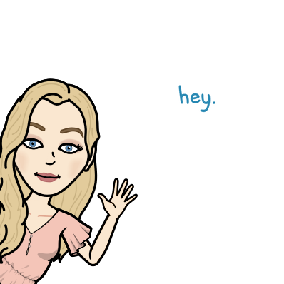Directions: Answer the questions below the best you can.

1. Take a selfie and attach it here ([Click here to watch a video on attaching pictures to a document](https://drive.google.com/file/d/1snYv1P7sdUGfnfg8ANLviPUHmtd8C1OS/view?usp=sharing)):
2. Take a picture of your virtual learning space and attach it here:
3. Email your teacher, Mrs. Kronk, your favorite candy at [kronkd@dearbornschools.org](mailto:kronkd@dearbornschools.org) from your **district email address**.
4. Where do you find the student portal on the [District Website](http://dearbornschools.org)?
5. Subscribe to your home school’s blog ([Duvall](https://duvall.dearbornschools.org/), [Henry Ford](https://hford.dearbornschools.org/), [Lindbergh](https://lindbergh.dearbornschools.org/), [McCollough](https://mcunis.dearbornschools.org/), [Nowlin](https://nowlin.dearbornschools.org/school-news/), [William Ford](https://wford.dearbornschools.org/)) and attach a screenshot here ([Click here to watch a video on how to take a screenshot from your chromebook](https://www.youtube.com/watch?v=NWRtnw3YIsw)):
6. Have your parents email Mrs. Kron at [kronkd@dearbornschools.org](mailto:kronkd@dearbornschools.org) from their email address, make sure they include your first and last name in the subject line.
7. Make sure that you AND your parents have signed up for my **REMIND** account. Class code is @ecfd6c7
8. Tell me what you miss about being at school.
9. What do you look forward to this year, starting the year virtually?

1. What is something new in technology you would like to learn more about?

1. Anything you want your teacher to know about you?
2. What was your favorite technology activity you did last year?
3. Lastly, what is schoology and where can you find it? (Hint, check the [District Website](http://dearbornschools.org))
4. **Bonus Question:** What time does school start for 5th grade virtual learning students?