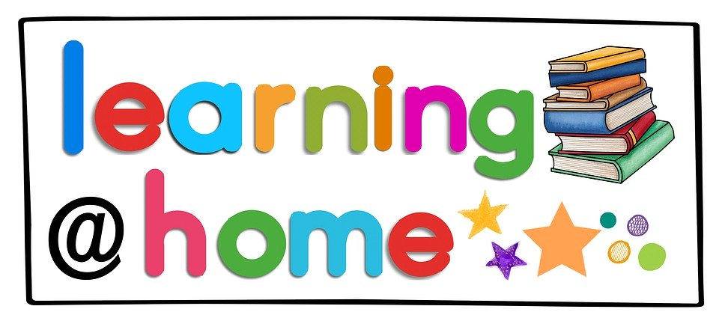

Dearborn School Parents,

Welcome back to a new and exciting year with Dearborn Public Schools! We look forward to another year of working together for the academic and social success of your student!

Please view the important information below on the methods we will use for communication, instruction, and a description of our resources.

|  |  |
| --- | --- |
| COMMUNICATION | Communication will be done via REMIND, Zoom conferencing, or email. I am available for meetings during the hours of 8:30am and 4:15pm and will schedule times to accommodate your needs. Schoology will be our shifted platform of communication. Information on that is forthcoming.  Please do subscribe to my blog - <https://iblog.dearbornschools.org/kronk/>  Reach out by email:  [kronkd@dearbornschools.org](mailto:kronkd@dearbornschools.org)  And also make sure you are signed up on REMIND. **Both** scholars and parents should be signed up on either a smart phone or computer. The **REMIND code is @ecfd6c7** |
| INSTRUCTION | Daily instruction will consist of live lessons through zoom, small groups, and one-on-one instruction as needed. Students will participate in specials (more information will be coming on that) as well and follow a schedule.   * What to expect for the first week - We will be meeting on 8/31 at 8:55am to say hello and discuss a little bit more about what to expect. The first week will be a soft opening as we get used to virtual learning. Please check your school’s blog/website to see when your resource pick-up day is. Our orientations will be scheduled virtually all next week. Please do reach out on REMIND to tell me what your availability is. Both parents and students will need to attend our virtual orientation, and these meetings will only hold a few families at a time to ensure understanding. **Translation services can be provided. Please do let me know if they are needed.** * Schoology can be accessed from the Dearborn student portal. * Access to live lessons will be available for you AS LONG AS YOU ARE LOGGED IN WITH YOUR STUDENT EMAIL. Our meetings can be accessed through the Zoom link on the Dearborn home page, or by clicking the following link: <https://dearbornschools-org.zoom.us/j/81894311270?pwd=cTI0andEaWh0Sm9PeGE3SGNYRFFWUT09> You will need to enter the passcode to join: **821261** * ELA Block will consist of a new curriculum called Benchmark. This will encompass reading and writing. Science and social studies are also embedded, and we will continue to use Mystery Science, Generation Genius, and our Social Studies books for further instruction. * Math will be a review of the ZEARN lesson students completed THE DAY BEFORE. We will work on application problems as a whole group and practice problems together, or in groups. Students will complete the “homework” portion during asynchronous learning time at the end of the day as well as the NEXT ZEARN lesson. * Assignments - Daily assignments are given for synchronous and asynchronous learning. Homework will not be assigned. * Grading is back to regular grading pre-pandemic. Scholars EARN their grades and are graded according to their efforts. * Attendance - taken twice daily. Once in the morning and again after lunch. If your child is going to be absent for any reason, you MUST call it into school like you normally would. |
| RESOURCES | * Eureka Math (websites, student resources for at home(workbooks), available videos, what assessments will look like etc..)<https://eurekamath.greatminds.org/en-us/eureka-math-in-sync>, <https://embarc.online/> * ZEARN: Find our ZEARN class at [www.zearn.org](http://www.zearn.org) (sign in with school google account) and join with the Class Code: **GP9T2B** * Benchmark (student online access, student resources for at home (work books), website, etc. <https://dearbornpsd.benchmarkuniverse.com/> * Science and Social Studies- embedded into the new ELA resource, but we also have Mystery Science <https://mysteryscience.com/> or Generation Genius Science <https://www.generationgenius.com/> for Science and Open Book for Social Studies- online textbook <http://textbooks.wmisd.org/index.html> * Suggested Grade Level Supply - Ensuring you have a whiteboard, markers, pencils, erasers, 4 notebooks, multiplication flashcards (if not mastered, they are needed for practice) dictionary (if you’d like). |
| BUILDING COMMUNITY AND CULTURE | * Your HOME school is STILL your HOME school. Please do follow their communication for information pertaining to the school year. |

**It is imperative that we stay open and honest with each other as we embark on this year of learning. Staying positive and calm during this new and exciting time is detrimental to our success, and we are all in this together. It is important to remain flexible while we all navigate this new platform. Please communicate often with your questions, comments, or concerns as teaching your child is my number one concern. Our ability to communicate and build relationships will set the tone for this successful year!**

**Together in teaching, education, and learning,**

**Mrs. Kronk**

*In a world where you can be anything, be kind!*