**Biome Project**

***Exploring the World’s Biomes***

**Step 1-**There are different biomes in the world… select a biome from the following list to research:

Choices: Aquatic, Desert, Forest, Grassland, Tundra

Check out the website below to help you decide on your biome (below).

<http://www.ucmp.berkeley.edu/exhibits/biomes/index.php>

Below are more personalized websites once you make your selection. **You are ONLY CHOOSING 1 BIOME TO RESEARCH**

**Aquatic**

1. *Freshwater*[Definition](http://www.merriam-webster.com/dictionary/freshwater) of freshwater  
   Enchanted Learning: [Freshwater biome](http://www.enchantedlearning.com/biomes/marsh/freshwater.shtml)   
   [The Freshwater biome](http://www.ucmp.berkeley.edu/exhibits/biomes/freshwater.php)  
   Freshwater [images](http://www.google.com/search?q=freshwater+animals&hl=en&client=firefox-a&sa=X&rls=org.mozilla:en-US:official&biw=1366&bih=538&prmd=imvns&tbm=isch&tbo=u&source=univ&ei=kQKjTqqOE9CFsAKP_fGxBQ&ved=0CGkQsAQ)  
   Kids Do Ecology: [Freshwater Biome](http://www.idiotica.com/cranium/encyclopedia/content/Freshwater.htm)  
   [What is a freshwater biome?](http://www.wisegeek.com/what-is-the-freshwater-biome.htm)  
   Freshwater Biome [Description](http://www.bioexpedition.com/freshwater-biome.html)  
   Planet Earth [Freshwater Biome](http://www.kidcyber.com.au/topics/biomewater.htm)  
   Information about [Freshwater biomes](http://lib.colostate.edu/wildlife/freshwater_biome.html)  
   Biomes of the World: [Freshwater](http://rrms-biomes.tripod.com/id10.html)  
   Freshwater [Biome](http://www.idiotica.com/cranium/encyclopedia/content/Freshwater.htm) Information  
   Freshwater [Video](http://www.neok12.com/php/watch.php?v=zX466d047304046105745367&t=Ecosystems) from NeoK12
2. *Ocean*  
   [Definition](http://www.merriam-webster.com/dictionary/ocean) of Ocean  
   Enchanted Learning: [Ocean Biome](http://www.enchantedlearning.com/coloring/oceanlife.shtml)  
   Ocean [Topics](http://www.mbgnet.net/salt/oceans/index.htm)  
   Ocean biome [information](http://www.bioexpedition.com/ocean-biome.html)  
   The [marine biome](http://www.ucmp.berkeley.edu/exhibits/biomes/marine.php)  
   Ocean Biome [information](http://www.idiotica.com/cranium/encyclopedia/content/Oceans.htm)  
   Ocean [images](http://www.google.com/search?q=ocean+biome&hl=en&client=firefox-a&hs=WY1&rls=org.mozilla:en-US:official&prmd=imvns&tbm=isch&tbo=u&source=univ&sa=X&ei=xwSjTvSMJ6_HsQLA09S4BQ&ved=0CFgQsAQ&biw=1366&bih=538)  
   Ocean [Food Chain](http://www.mbgnet.net/)  
   Coral Reef [Video](http://www.neok12.com/php/watch.php?v=zX075c05445e570b5c577f59&t=Ecosystems) from NeoK12

**Desert**  
[Definition](http://www.merriam-webster.com/dictionary/desert) of Desert  
Desert Blue [Planet Biome Information](http://www.blueplanetbiomes.org/desert.htm) (maps, plants, animals, climate)  
Enchanted Learning: [Desert Biome Animal Printouts](http://www.enchantedlearning.com/biomes/desert/desert.shtml)  
Desert [Animals and Wildlife](http://www.desertusa.com/animal.html)  
Desert [Images](http://www.google.com/search?q=desert&hl=en&client=firefox-a&hs=iBg&rls=org.mozilla:en-US:official&prmd=imvns&tbm=isch&tbo=u&source=univ&sa=X&ei=PvqiTr7qJJOGsgLdmtTCBQ&ved=0CHkQsAQ&biw=1366&bih=538)  
Desert Biome [Information](http://www.ucmp.berkeley.edu/exhibits/biomes/deserts.php)  
Desert [Topics](http://mbgnet.net/sets/desert/)   
Sahara Desert [Video](http://www.neok12.com/php/watch.php?v=zX5e5b5250754a535c447b55&t=Deserts) from NeoK12  
Desert Wildlife [Video](http://www.neok12.com/php/watch.php?v=zX05704e74437542704f4051&t=Deserts) from NeoK12  
Desert Cacti [Video](http://www.neok12.com/php/watch.php?v=zX414c550266617360665906&t=Deserts) from NeoK12  
Desert Plants and Cactus[Video](http://www.neok12.com/php/watch.php?v=zX771573005d560c54476f67&t=Deserts) from Neo K12  
Desert Biome [Video](http://www.neok12.com/php/watch.php?v=zX745e4e646f47794e6d4367&t=Deserts) from Neo K12  
Plant Growth of Tropical Flowers in the desert [Video](http://www.neok12.com/php/watch.php?v=zX48097f77597a7179734f41&t=Deserts) from NeoK12  
How desert insects, scorpions and snakes survive [Video](http://www.neok12.com/php/watch.php?v=zX784860677376005a797b02&t=Deserts) from NeoK12

**Forest**

1. *Tropical Rainforest*  
   [Definition](http://www.merriam-webster.com/dictionary/rainforest) of Rainforest  
   Rainforest Blue Planet Biome [Information](http://www.blueplanetbiomes.org/rainforest.htm) (map, plants, animals, climate)  
   Rainforest [Facts](http://www.rain-tree.com/facts.htm)  
   What is a [Rainforest](http://www.srl.caltech.edu/personnel/krubal/rainforest/Edit560s6/www/what.html)?  
   Rainforest [Animals](http://www.rainforestanimals.net/)   
   Enchanged Learning: [All About Rainforests](http://www.enchantedlearning.com/subjects/rainforest/)   
   [Tropical Rainforests](http://kids.mongabay.com/) for kids  
   Tropical Rainforest [Video](http://www.neok12.com/php/watch.php?v=zX4555737a03605c1b186451&t=Ecosystems) from NeoK12  
   Life in the Tropical Rainforest[Video](http://www.neok12.com/php/watch.php?v=zX6b6d43741a71677f067377&t=Ecosystems) from NeoK12
2. *Temperate Forest*[Definition](http://www.merriam-webster.com/dictionary/temperate%20rain%20forest) of Temperate Forest  
   Temperate Forests [Glossopedia](http://www.globio.org/glossopedia/article.aspx?art_id=3" \t "_blank)   
   Deciduous Forest [Blue Planet Biome Information](http://www.blueplanetbiomes.org/deciduous_forest.htm) (maps, plants, animals, climate)  
   [Enchanted Learning](http://www.enchantedlearning.com/biomes/tempdecid/tempdecid.shtml): Temperate Deciduous Forest  Animal Printout  
   Temperate/Deciduous Forest [Information](http://www.marietta.edu/~biol/biomes/tempded.htm)  
   Kids Do Ecology: [Temperate Forest](http://kids.nceas.ucsb.edu/biomes/temperateforest.html)   
   Temperate Deciduous Forest [Topic Information](http://mbgnet.net/sets/temp/index.htm)   
   Land Biomes: [Temperate Forest](http://biology.about.com/od/landbiomes/a/aa052506a.htm)  
   [Images](http://www.google.com/search?q=temperate+forest&hl=en&client=firefox-a&hs=P2f&rls=org.mozilla:en-US:official&prmd=imvns&tbm=isch&tbo=u&source=univ&sa=X&ei=_feiTumbCPCCsgKSvv2UBQ&ved=0CDUQsAQ&biw=1366&bih=538) for Temperate Forest  
   Temperate Forest [Video](http://www.neok12.com/php/watch.php?v=zX07015f516455547e7b7473&t=Ecosystems) from NeoK12  
   Temperate/Deciduous Forest [Video](http://www.neok12.com/php/watch.php?v=zX704e0f62665b7b7850556b&t=Ecosystems) from NeoK12

**Grasslands**   
[Definition](http://www.merriam-webster.com/dictionary/savanna) of Savanna  
Savanna [Blue Planet Biome Information](http://www.blueplanetbiomes.org/savanna.htm) (map, plants, animals, climate)  
Enchanted Learning: [Savanna Animal Printouts](http://www.enchantedlearning.com/biomes/savanna/savanna.shtml)  
Tropical [Savanna](http://www.radford.edu/swoodwar/CLASSES/GEOG235/biomes/savanna/savanna.html)   
Savanna Biome [Information](http://www.plantzafrica.com/vegetation/savanna.htm)  
Grassland Biome [Information](http://www.ucmp.berkeley.edu/exhibits/biomes/grasslands.php)  
Savanna [Images](http://www.google.com/search?q=savanna&hl=en&client=firefox-a&hs=cHg&rls=org.mozilla:en-US:official&prmd=imvns&tbm=isch&tbo=u&source=univ&sa=X&ei=rPuiTtHuDcWRsALCg8DIBQ&ved=0CHUQsAQ&biw=1366&bih=538)  
Savanna [Video](http://www.neok12.com/php/watch.php?v=zX664d5d187d6515415b5002&t=Ecosystems) from NeoK12  
Grassland [Video](http://www.neok12.com/php/watch.php?v=zX7372445454755764606341&t=Ecosystems) from NeoK12

**Tundra**  
[Definition](http://www.merriam-webster.com/dictionary/tundra?show=0&t=1319301109) of Tundra  
[Blue Planet Tundra Biome](http://www.blueplanetbiomes.org/tundra.htm) information (map, plants, animals, climate)  
[National Geographic](http://environment.nationalgeographic.com/environment/habitats/tundra-profile/) Tundra Information  
[Tundra Animal Printouts](http://www.enchantedlearning.com/biomes/tundra/tundra.shtml) (information of tundra animals)  
Tundra biome[information](http://www.ucmp.berkeley.edu/exhibits/biomes/tundra.php)  
Taiga and Tundra [Video](http://www.neok12.com/php/watch.php?v=zX450f7a5b7f5d427f78706b&t=Ecosystems) from NeoK12

**Below are the directions for the Biomes project and the rubric that will be used to score the project.  Please look carefully at the rubric to make sure you are including all of the elements needed.**

**Step 2-** Research about your biome.  Please refer to biomes project directions (above) so you know what questions you need to research.**Please be sure and use reliable resources when doing your research.**

**Step 3**-Complete a brainstorm of all the different components of your chosen Biome. This step will be collected with your final project. You will use this brainstorm to complete a poster. If getting a poster isn’t possible, you may turn in each part on a separate piece of paper. You will need to complete a:

1. A background drawing (printed picture accepted)
2. A world map indicating the biome regions (either create your own, or print one out)
3. A description of the climate in a complete paragraph
4. A description of 3 plants in the form of a complete paragraph
5. A description of 5 animals in the form of a complete paragraph
6. A picture of a labeled food chain (be sure to begin with the sun and end with decomposers)
7. A description of human interference in the form of a complete paragraph

Here is an example of what the poster would look like

**Tropical Rainforest**

**Biome Regions Plants**

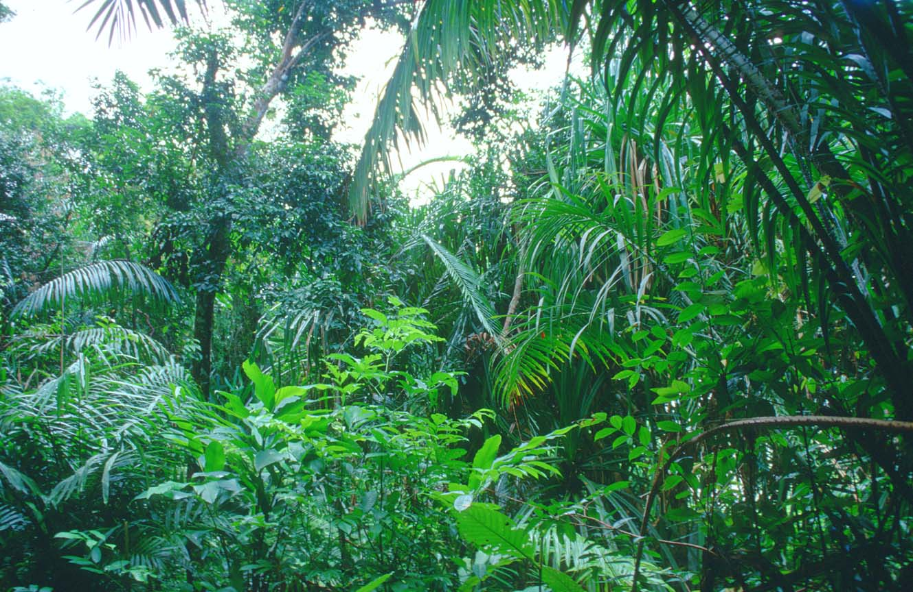

[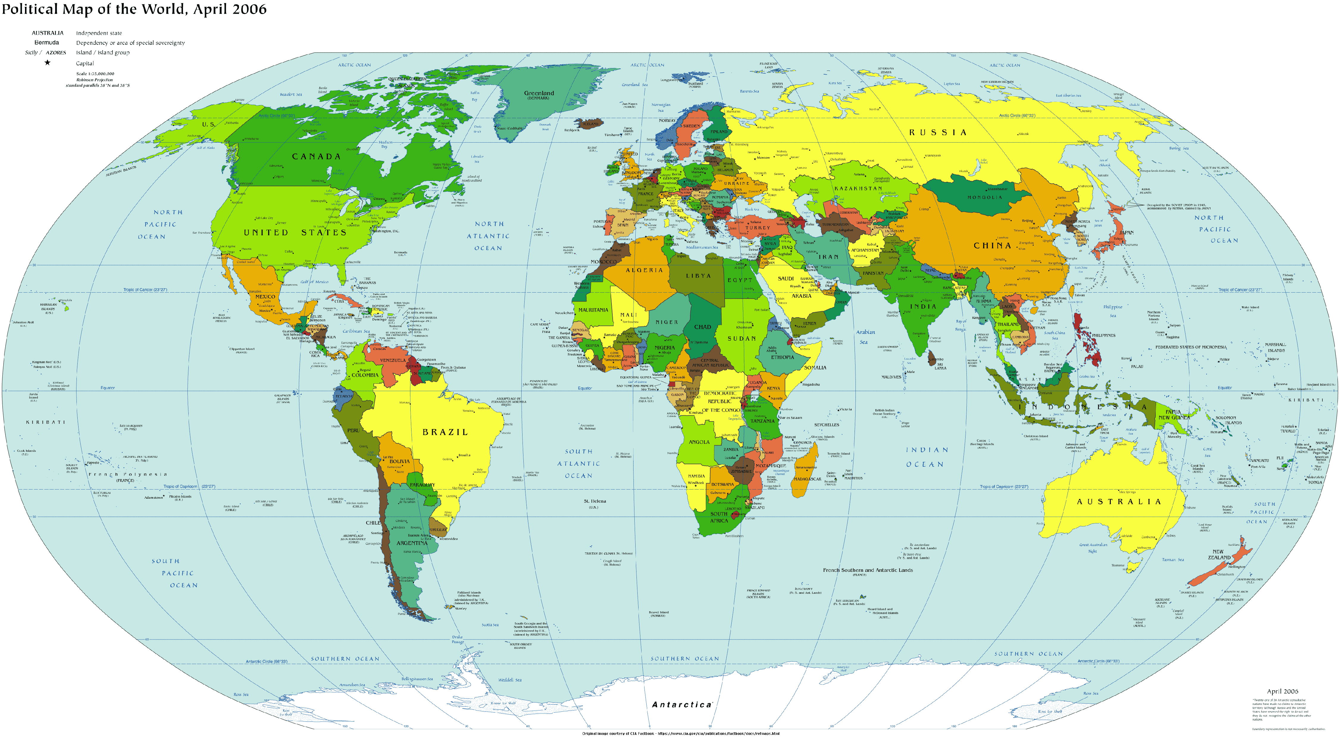](http://www.worldmapnow.com/images/2011/01/world-map.gif) **1. 2. 3.**

**Climate Animals**

1. **2. 3.**

**4. 5.**



**Food Chain**

**Human Interference**

****

**Step 4**- Create a terrarium (using a shoebox) to display your chosen biome. Look at the examples below.

|  |  |  |  |  |
| --- | --- | --- | --- | --- |
| **Requirements** | **1** | **2** | **3** | **4** |
| Research | One source (not reliable) is used to find information on my biome | At least one reliable source was used to find information on my biome | At least two reliable sources were used to find information on my biome | More than two reliable sources were used to find information on my biome |
| Outline | My outline is partially complete, with very little to no details about the ecosystems within my biome; bare minimum | My outline is complete with some details of the ecosystems within my biome, but I lack evidence of deep knowledge | My outline is complete, and I have some details of each of the required elements recorded. There is some deeper knowledge | My outline in thorough and complete, with multiple details showing a deep knowledge of my biomes |
| Poster Focus and Structure | A bit focused but has no real paragraph structure for components; missing parts | Poster somewhat focused with paragraphs, however the paragraphs are not organized by content properly; I have most components done, but not all | My poster is organized into paragraphs by content, and I have clear pictures of plants and animals with appropriate labels. My food chain is done well, but it could be better. | My poster is organized into paragraphs by content that are written well, and I have a beautifully detailed pictures of plants and animals with appropriate labels. My food chain isn’t missing any component and my work is exceptionally neat. |
| Terrarium | I covered most of the required content at bare minimum; no details, an incomplete or sloppy display of knowledge |  |  | I covered the required content, with details, I have a neat and complete display of my chosen biome that shows beautiful detail and is my best work. |

List of resources for my research:

1. \_\_\_\_\_\_\_\_\_\_\_\_\_\_\_\_\_\_\_\_\_\_\_\_\_\_\_\_\_\_\_\_\_\_\_\_\_\_\_\_\_\_\_\_\_\_\_\_\_\_\_\_\_\_\_\_\_\_\_\_\_\_\_\_\_\_\_\_\_\_\_\_\_\_\_\_\_\_\_

2. \_\_\_\_\_\_\_\_\_\_\_\_\_\_\_\_\_\_\_\_\_\_\_\_\_\_\_\_\_\_\_\_\_\_\_\_\_\_\_\_\_\_\_\_\_\_\_\_\_\_\_\_\_\_\_\_\_\_\_\_\_\_\_\_\_\_\_\_\_\_\_\_\_\_\_\_\_\_\_

3. \_\_\_\_\_\_\_\_\_\_\_\_\_\_\_\_\_\_\_\_\_\_\_\_\_\_\_\_\_\_\_\_\_\_\_\_\_\_\_\_\_\_\_\_\_\_\_\_\_\_\_\_\_\_\_\_\_\_\_\_\_\_\_\_\_\_\_\_\_\_\_\_\_\_\_\_\_\_\_

Total rubric points:

16 = A 14 -11= C 7- below = F

15 = B 10-8 = D

**Due Dates:**

Project is introduced and biome is chosen…March 22-25

Research and Outline completion…March 29

Use outline to assemble your poster and create your terrarium…March 30 – April 12

Poster due at school when we return -–April 13

Shoebox terrarium due at school when we return — April 13th

[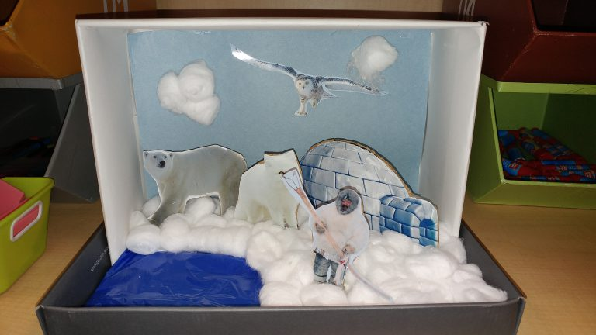](http://connectplus.pasco.k12.fl.us/casmith/wp-content/uploads/2016/09/0920161239.jpg)

[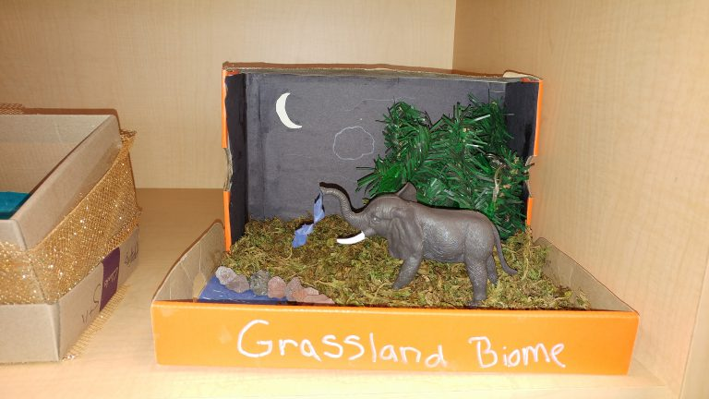](http://connectplus.pasco.k12.fl.us/casmith/wp-content/uploads/2016/09/0920161239a.jpg)[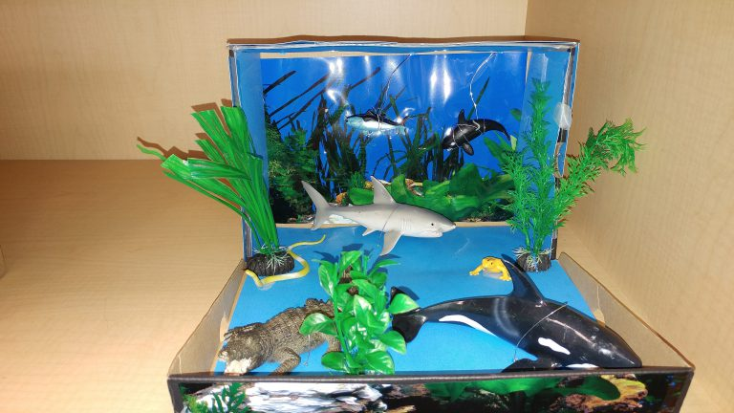](http://connectplus.pasco.k12.fl.us/casmith/wp-content/uploads/2016/09/0920161239b.jpg)[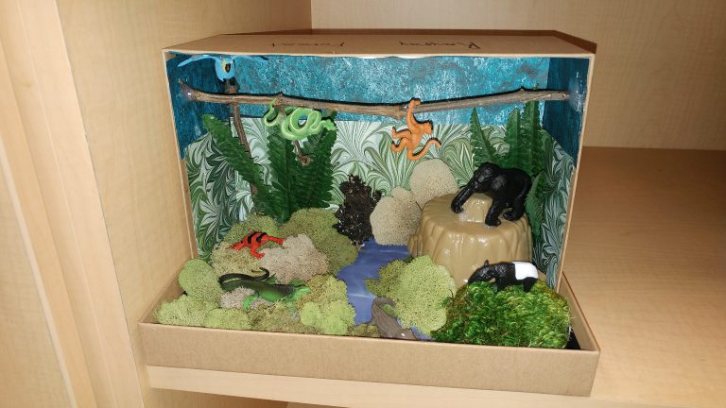](http://connectplus.pasco.k12.fl.us/casmith/wp-content/uploads/2016/09/0920161239c.jpg)[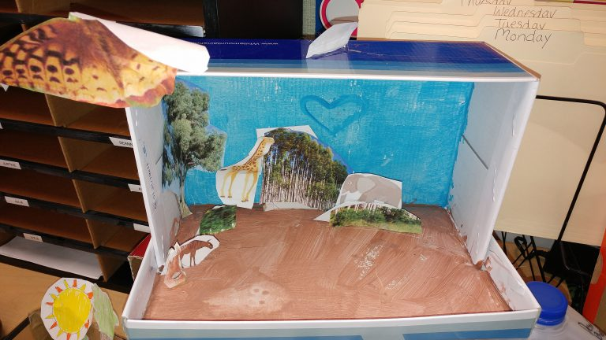](http://connectplus.pasco.k12.fl.us/casmith/wp-content/uploads/2016/09/0920161239d.jpg)