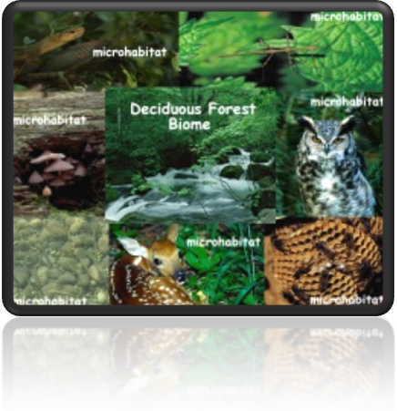
Biome/Ecosystem Project

Name: _______________

Biome: _______________

Due Date: _____________

Instructions: On a large sheet of paper, you need to develop a background drawing that includes key features of your biome. Your background should include:
- A drawing of what the biome looks like, including
- types of trees
- other plants that grow
- animals that may be seen
- Color
- A key that labels the names of your features

Date Due: __________________ Teacher Initials: ______

(Needs to be signed by teacher to indicate that this part of the project was done on time. It will be graded when the entire project is due, the day of the presentation.)

Instructions: Using the provided world map, you must:
- indicate the locations of your biome by coloring the specific areas
- create a label for the map
- attach the map to the display of your biome (the large piece of butcher paper is your display)

Date Due: ___________________ Teacher Initials: ______

(Needs to be signed by teacher to indicate that this part of the project was done on time. It will be graded when the entire project is due, the day of the presentation.)

Instructions: A section of your display must include information about the weather that occurs in your biome. This section must include:
- the average temperature in the summer months
- the average temperature in the winter months
- the amounts of rainfall received in a year
- a paragraph (5-7 sentences) explaining the typical climate: hot, cold, wet, dry, snow, ice, sand, etc.

Date Due: ______________________ Teacher Initials: _____

(Needs to be signed by teacher to indicate that this part of the project was done on time. It will be graded when the entire project is due, the day of the presentation.)

Instructions: A section of your display must include information about 3 specific plants that are particular to your biome. This section must include:
- a drawing/picture of each of the 3 plants
- a paragraph (5-7 sentences) about each plant in which you 1) tell the species name, 2) describe why it is significant to that particular biome, and 3 explain its adaptations that allows it to survive in this particular biome.

Date Due: ______________________ Teacher Initials: _____

(Needs to be signed by teacher to indicate that this part of the project was done on time. It will be graded when the entire project is due, the day of the presentation.)

Instructions: A section of your display must include information about 5 specific animals that are particular to your biome. This section must include:
- a drawing/picture of each animal
- a paragraph (5-7 sentences) about each animal in which you 1) tell the species name, 2) describe why it is significant to that particular biome, and 3) explain its adaptations that allows it to survive in this particular biome.

Date Due: ______________________ Teacher Initials: _____

(Needs to be signed by teacher to indicate that this part of the project was done on time. It will be graded when the entire project is due, the day of the presentation.)

Instructions: A section of your display must include information about one food chain that occurs in your biome. This section must include:
- a labeled drawing/picture of a food chain that has a producer, consumer, herbivore, carnivore, omnivore, and decomposer
- a few brief sentences (2-3) describing what is taking place during this food chain

Date Due: ______________________ Teacher Initials: _____

(Needs to be signed by teacher to indicate that this part of the project was done on time. It will be graded when the entire project is due, the day of the presentation.)

Instructions: A section of your display must include a paragraph (5-7 sentences) of how pollution or human interference can affect your biome. Items to include are:
- what type of pollution/interference occurs
- what happens to the animal and plant life
- whether this interference is good or bad; is it good or bad always or sometimes?

Date Due: _____________________ Teacher Initials: _____

(Needs to be signed by teacher to indicate that this part of the project was done on time. It will be graded when the entire project is due, the day of the presentation.)

Instructions: The day before the presentation, you should review this list and check off each item to indicate that you have completed all aspects of the project:

Title on display Animals

Background drawing Food Chain

World Map Human interference

Climate Names of all group
members
Plants

