Name _________________________ Date __________________ # __________

**Biome Project Description**

* **This is a group project, of 3 or 4 students, that will require the students to research a specific biome and present their findings to the class in the form of a display and an oral presentation. The display will be organized on a large sheet of white butcher paper and will include 7 parts:**

1. **A background drawing**
2. **A world map indicating the biome regions**
3. **A description of the climate**
4. **A description of 3 plants**
5. **A description of 5 animals**
6. **A picture and label of a food chain**
7. **A description of human interference**

**Here is an example of what the display can look like.**

**Tropical Rainforest**

**Biome Regions Plants**

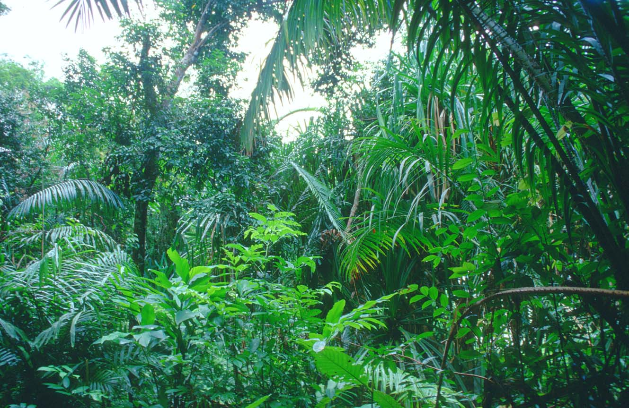

[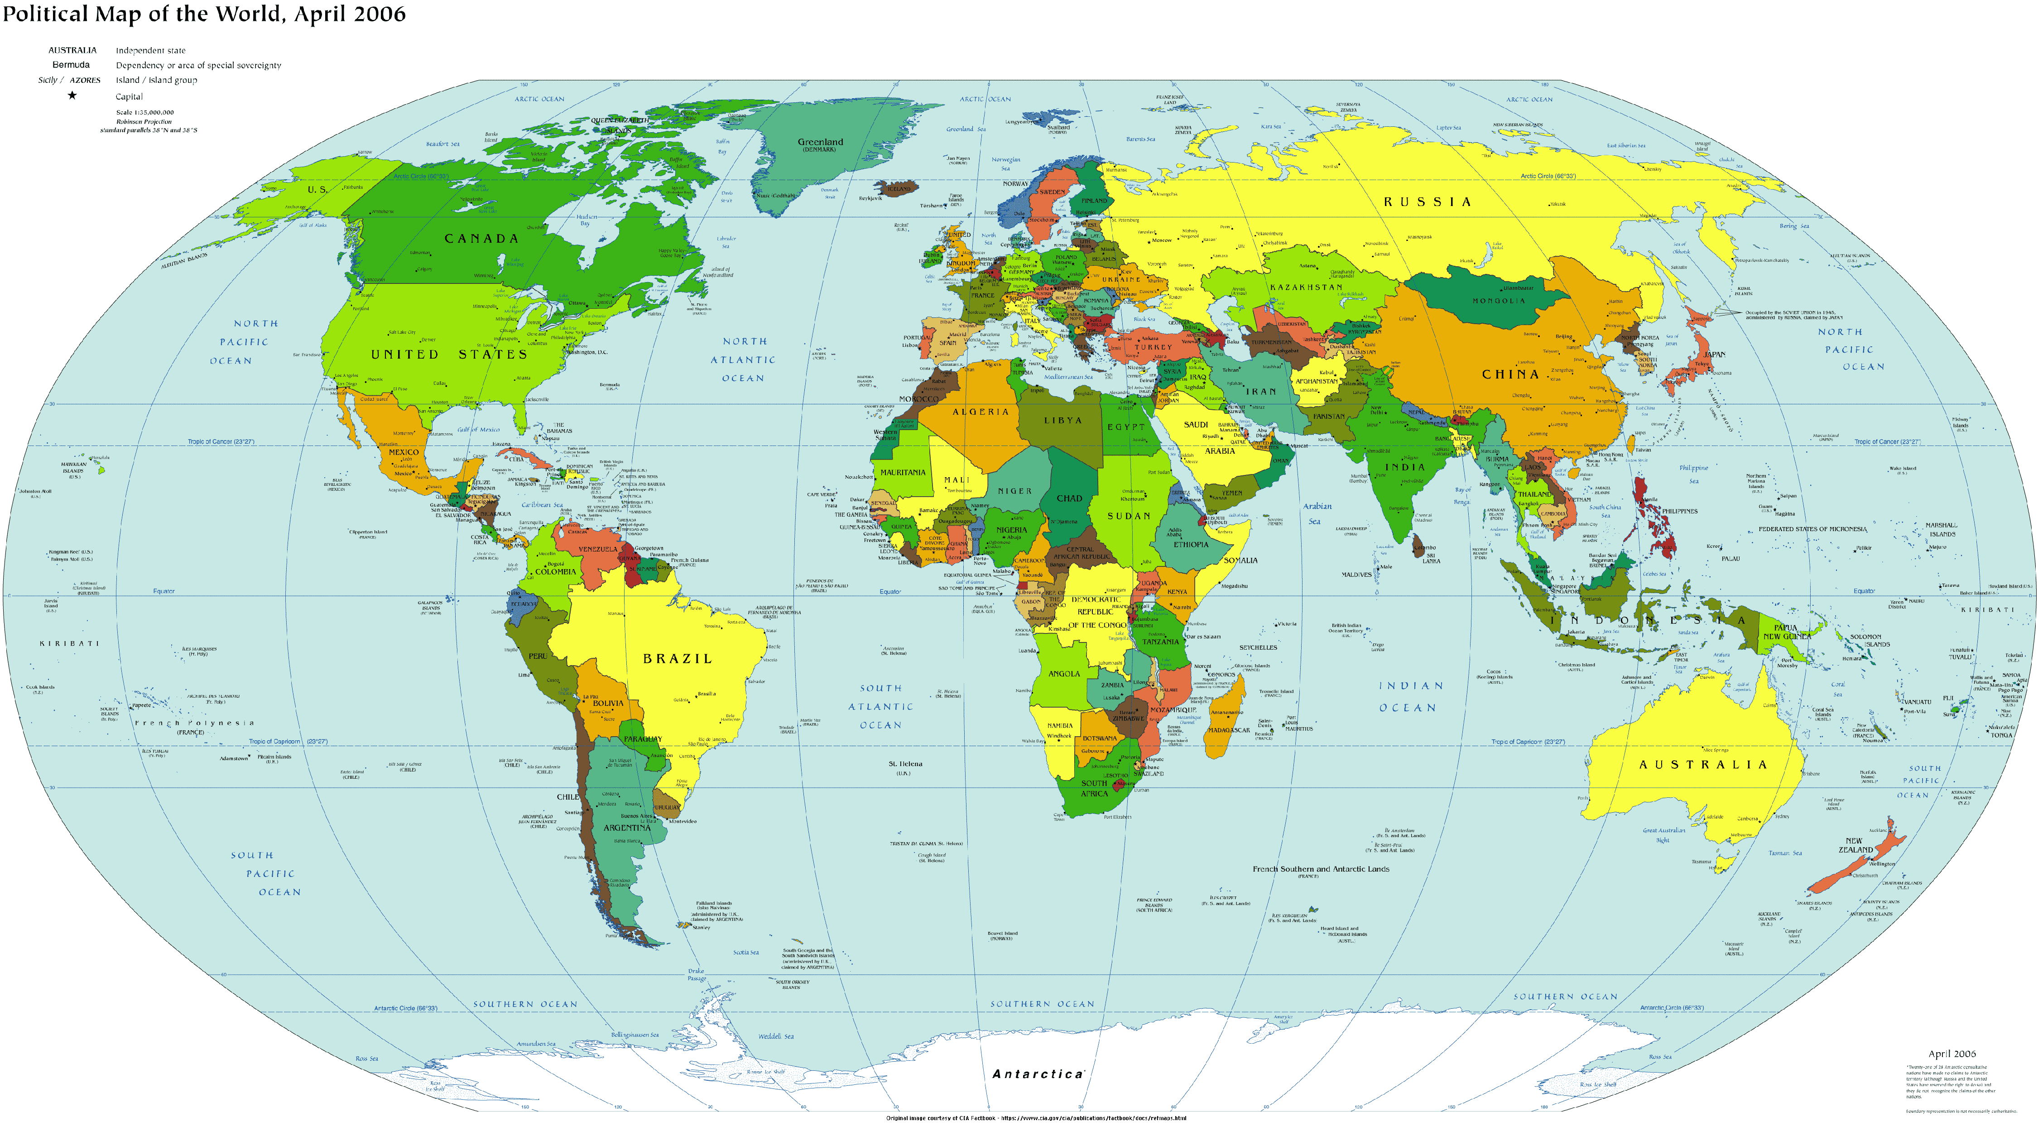](http://www.worldmapnow.com/images/2011/01/world-map.gif) **1. 2. 3.**

**Climate Animals**

1. **2. 3.**

**4. 5.**



**Food Chain**

**Human Interference**

** Names: ______, _______, ______, _______**

* **For the presentation, *every* group member must present at least one of the seven parts on the display. Every section must be shared aloud with the rest of the class since each group will have a different biome; all of the students need to learn a little bit about each area.**