**Biome Weekly SLOT Writing Assignment**

**What is an ecosystem?**   
  
Each individual plant and animal could not exist by itself on planet Earth. All living organisms need millions of other living organisms to survive. How these organisms interact with the sun, soil, water, air and each other in a specific area is called an ecosystem.   
  
An ecosystem describes a specific area where the organisms work together as a unit. It could be any size from a tiny pool of water to hundreds of square miles of desert. Each ecosystem is different and each has established a balance over time that is important to every form of life within the ecosystem.   
  
**What is a biome?**   
  
A biome is way to describe a large group of similar ecosystems. Biomes have similar weather, rainfall, animals, and plants. There are a number of biomes on planet Earth. See the map of the world biomes below. 

[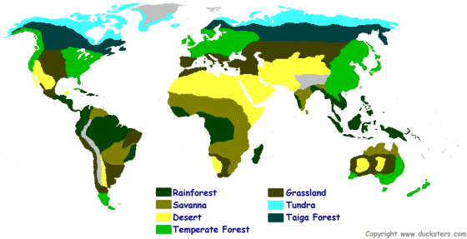](https://www.ducksters.com/science/ecosystems/world_map_biomes.png)

Biome writing Assignment due 12/3

Research your biome and write about the following characteristics:

Divide your paper into three paragraphs and focus on 5 topic questions:

Paragraph 1:

1. Where is your biome located?
2. What is the climate like there?

Paragraph 2:

1. What kinds of plants grow there?
2. What kinds of animals live in the area? Are there any endangered species that are native to your biome?

Paragraph 3:

1. What kinds of human interference does your biome face? (Human impact)